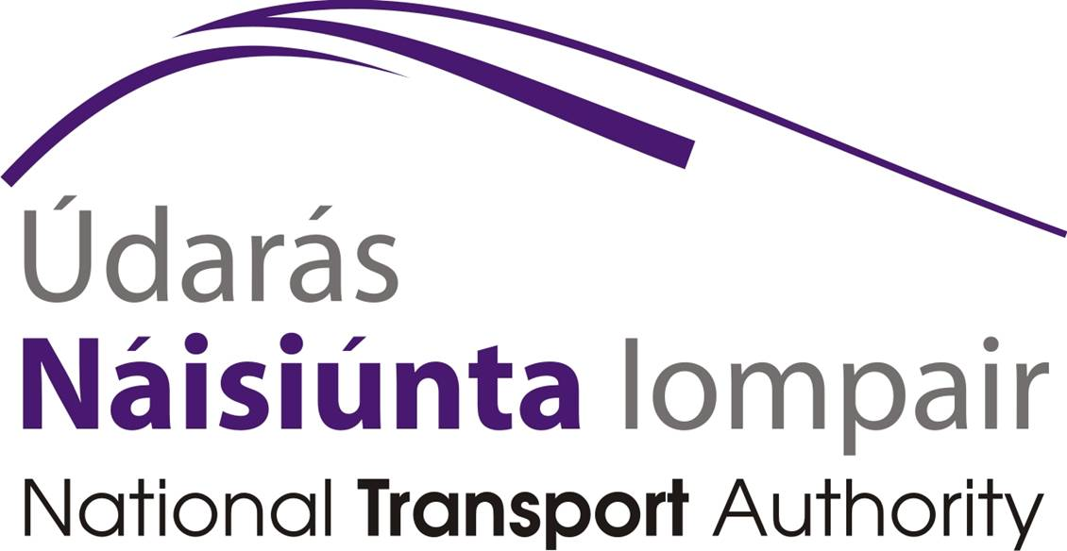

Public Consultation on Transitioning to a Wheelchair Accessible Licensed Bus Sector

National Transport Authority
Dún Scéine
Iveagh Court
Harcourt Lane
Dublin 2
October 2014

Introduction

The commercial bus and coach sector provide public transport services under licence from the National Transport Authority. Such companies include Bus Éireann Expressway services, Aircoach, Dublin Coach and Citylink and also a number of smaller private bus operators using one or two buses to provide their licensed service. This sector supported 7% of all public transport journeys in the State in 2013. The licences for such services are granted by the Authority in accordance with the Public Transport Regulation Act 2009 and a list of these licences is available on www.nationaltransport.ie

The Department of Transport, Tourism and Sport’s document “Access for All” which has been published in accordance with the Disability Act 2005 has set out an objective that licensed bus services be conditioned to provide wheelchair accessible services. The responses to this consultation paper will assist the Authority in carrying out its regulatory role in the provision of licensed public transport services by commercial bus and coach operators. In examining the level of accessibility for the mobility impaired, it should be noted that improvements in wheelchair accessibility would also improve accessibility for people whose mobility impairment does not require them to use a wheelchair.

Consultation Paper
This consultation aims to support the Authority’s research in moving towards a wheelchair accessible licensed bus and coach sector.
A complementary issues paper on objectives, options and international experience in transitioning to a wheelchair accessible licensed bus sector is published as part of this consultation.
This public consultation gives respondents the opportunity to provide the Authority with industry, public and stakeholder opinion on the issues arising in moving to a wheelchair accessible licensed bus sector.
Respondents should indicate which question or issue their text refers to if responding in an alternative format.

Questionnaire

- How adequate is the current level of wheelchair accessibility in the licensed bus and coach sector? Please explain.
- Please explain how the licensed bus and coach sector can meet the demand for wheelchair users?
- Can you describe any foreseeable developments in wheelchair or powered mobility equipment or use which are likely to impact on accessibility standards for buses or coaches?
- If applicable, could you describe your experience of using wheelchair-accessible:
  - Low-floor buses (e.g low-floor urban buses), and
  - Wheelchair-lift on high floor coaches (e.g. wheelchair lift on inter-urban coaches)?
- Your experience of wheelchair accessible low-floor buses (e.g. was it good/bad; what made it good or bad, etc?)

- Your experience of wheelchair lift on high floor coaches (e.g. was it good/bad; what made it good or bad?)

- Please describe any positive developments in the wheelchair accessibility of services operated by the commercial bus and coach sector.
- What are the obstacles in transitioning to a fully wheelchair accessible licensed commercial bus sector?
- Please describe what infrastructure (E.g. bus stop infrastructure, accessibility of adjoining footpaths, etc) need to be developed to support wheelchair accessibility in the licensed bus sector
- Commercial bus operators providing licensed public transport services are not subsidised by the State. They vary greatly in size and most are operators with a small number of vehicles. What licence conditions could the Authority place on commercial bus operators to improve wheelchair accessibility of their services while not placing an unreasonable burden on them?
- With limited resources, please rank what services should be prioritised for wheelchair accessibility (with 1 being the most important priority) :
  - city & town services only to be wheelchair accessible at all times
  - city and town services only to be wheelchair accessible at 24 hours notice or 36 hours notice
  - Commuter services only to be wheelchair accessible at all times.
  - Commuter services only to be wheelchair accessible at 24 hours notice or 36 hours notice
  - rural services only to be wheelchair accessible at all times
  - rural services to be wheelchair accessible at 24 hours notice or 36 hours notice
  - Intercity services only to be wheelchair accessible at all times
  - intercity services to be wheelchair accessible at 24 hours notice or 36 hours notice?

- What accessibility requirements should be placed on tours services (e.g. hop on/hop off, etc) – Please tick one as relevant.
□ Same requirements as regular services.
□ A wheelchair accessible bus service on demand (i.e. need for pre-booking).
□ A voluntary quality standard for wheelchair accessibility.
□ no requirement.
□ Other. Please Explain.

- What other changes, if any, could be made to the current policy and regulations to increase wheelchair accessibility?

- What would you think are appropriate incentives, if any, for commercial operators to increase wheelchair accessibility in the licensed bus/coach sector while ensuring value for money for the tax-payer?
- What would you consider a reasonable leading time for the provision of wheelchair accessible bus services?
□ 0-5 years.
□ 6 -10 years.
□ 11-15 years.
□ 16-20 years.
□ 21-25 years.
□ 26-30 years.
□ Other. Please Explain.

- If you are a bus operator operating a urban bus service, could you describe the advantages and disadvantages of operating:
  - A low floor wheelchair accessible bus
  - A high floor coach with a wheelchair lift
- It is a requirement under EU law for drivers and staff to receive disability awareness training and, for journeys above 250km, disability assistance training. Please outline your views on what training should be required in the commercial bus sector to improve accessibility of public transport services.

- What journey planning tools should be made available to plan for trips where wheelchair accessibility is required?

- What other areas of the wheelchair user’s experience of public transport in the licensed bus sector do you feel require improvement?.

Please complete the questionnaire
-online by clicking here https://www.surveymonkey.com/s/Wheelchair_Accessible_Licensed_Bus
or
- submit by post to
Accessible Licensed buses and coaches
C/O Marianne Cassidy
National Transport Authority
Dún Scéine
Iveagh Court
Dublin 2

The deadline for submission has been extended. Any submissions must be received by the Authority by 5pm on 16th January 2015. The Authority may publish a report on the consultation.

All submissions must include the full name and address of the person making the submission and where relevant the name of the body or organization represented.
NAME:
ORGANISATION REPRESENTED (IF ANY):
ADDRESS:

EMAIL ADDRESS/CONTACT NUMBERS:

All submissions and observations received within the timeframe set out will be taken into consideration.

Please note that submissions are to subject to Freedom of Information so please highlight any items that you consider to be commercially sensitive material

