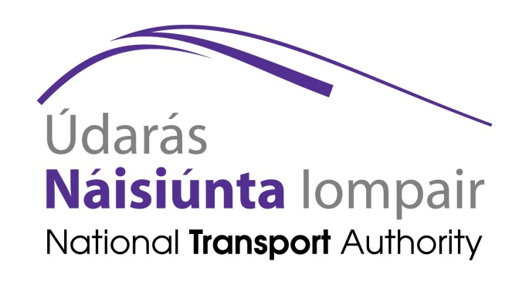

Public Consultation on

The Role of Rail in Ireland and Funding its Delivery

November 2016

Introduction

1.1 Strategic Framework for Investment in Land Transport (SFILT)
In August 2015, following on from a public consultation process, the Minister for Transport, Tourism and Sport published the Strategic Framework for Investment in Land Transport (SFILT). The Framework, which was based on a wide-ranging policy analysis exercise, including a Strategic Environmental Assessment (SEA), establishes key principles and priorities to guide transport investment over the coming decades. The Framework identified that Ireland’s existing heavy rail network accounts for 1%–2% of passenger trip demand, 4%–5% of passenger kilometres and around 1% of freight tonne kilometres. The SFILT put forward a conservative estimate of €1.6 billion per annum for the cost of keeping the full land transport network (i.e. roads and rail) in a steady state – neither deteriorating nor being enhanced. The Exchequer element of the estimate is €1.3 billion (€300 million from other sources e.g. toll receipts) and the steady state requirement for heavy rail network accounts for over 20% of that figure. The Framework pointed to the need to critically examine the extent of the railway network in the context of demand levels on routes.
The Framework focussed firmly on prioritisation of scarce investment resources and highlighted that the scale of the investment requirements (and operational subvention) strongly point to the need for an updated rail policy with value for money as a fundamental feature. The Framework concluded that a new rail policy will be developed following a wide-ranging public consultation, which will address key questions including how to focus rail investment on where rail has, or will have its greatest strength in transport, social and environmental terms, in addition to securing value for money for the State’s investment. The publication of the Rail Review and the launch of this consultation process are important steps towards development of such a policy.

1.2 The purpose of this consultation
In recent years Iarnród Éireann, the company that maintains the national rail network and operates rail services under contract to the National Transport Authority, has come under increasing financial pressure in the context of a significant decline in passenger numbers and a reduction in the level of Government funding due to the economic crisis of 2008 - 2012, and an increase in competition from the private car and from coach buses due to the completion of a national motorway network and the competitive journey times now possible by road. In response to the financial pressure, Iarnród Éireann reduced its cost base in the six years to 2014 by over €70 million per annum and its workforce by over 1,000.
While rail patronage has since 2013 regained some lost ground, the percentage of total travel nationally by rail remains low compared to that by bus. Revenue generated by rail passengers is, and will remain, significantly less than the combined cost of providing services, maintaining infrastructure and capital works. To identify possible financial solutions it is considered timely to review the role of rail in the State and whether the financial support per passenger carried should continue at current levels into the future.
The 2016 Rail Review was undertaken jointly by the National Transport Authority (NTA) and Iarnród Éireann, and is published as part of this public consultation process. The Review looks primarily at the existing rail network, the funding required to maintain the network and provide for necessary capital works, and the gap that exists in the funding. The Rail Review also examines the potential of rail to meet the economic, environmental and social needs of the State in the future and discusses the importance of maintaining a rail network to support strategic sustainable growth in travel demand.
This NTA public consultation paper summarises some of the findings of the 2016 Rail Review and highlights particular areas for discussion in relation to the role of rail in Ireland. The purpose of both documents is to start a national debate on the current and future role of rail in transport in Ireland.
The National Transport Authority will report on the consultation to the Minister for Transport, Tourism and Sport, and the findings of the consultation will be used to inform and assist future decision making in relation to rail.

Overview

2.1 The rail network
The heavy rail network in Ireland comprises approximately 2,400 km of railway track, of which approximately 1,660 km is currently active, and includes 147 passenger stations and 372 platforms. It also comprises 5,100 bridges, 1,240 level crossings, over 4,900 cuttings and embankments and 14 tunnels. The railway is mainly single track, with 886km of double track and 60km of multiple track.

Cumulatively, around 50% of the national population or some 2.3 million people live in settlements served by heavy rail. The network includes main lines, regional lines, Dublin suburban (DART) and commuter passenger routes, and Cork Suburban routes, together with freight-only routes.

The majority of the network is comprised of radial lines focused on Dublin. The network largely provides for inter-urban connections offering strategic transport links at the national level between Dublin and other key cities on the island, namely, Cork, Galway, Limerick, Waterford and Belfast as well as linking to smaller cities and large towns which have strong regional functions in particular Sligo, Tralee and Wexford. In addition there are regional lines, linking smaller settlements to each other and to a number of the regional cities. These include the Galway to Limerick, Waterford to Limerick Junction and Limerick to Ballybrophy lines.

Urban heavy rail is also extensive within the Dublin area with DART providing a core high capacity electrified network of services that is central to the region’s mass transit system. Cork also has a suburban heavy rail network which consists of a line linking from Mallow, through Cork City branching at Glounthane to serve both Midleton and Cobh.

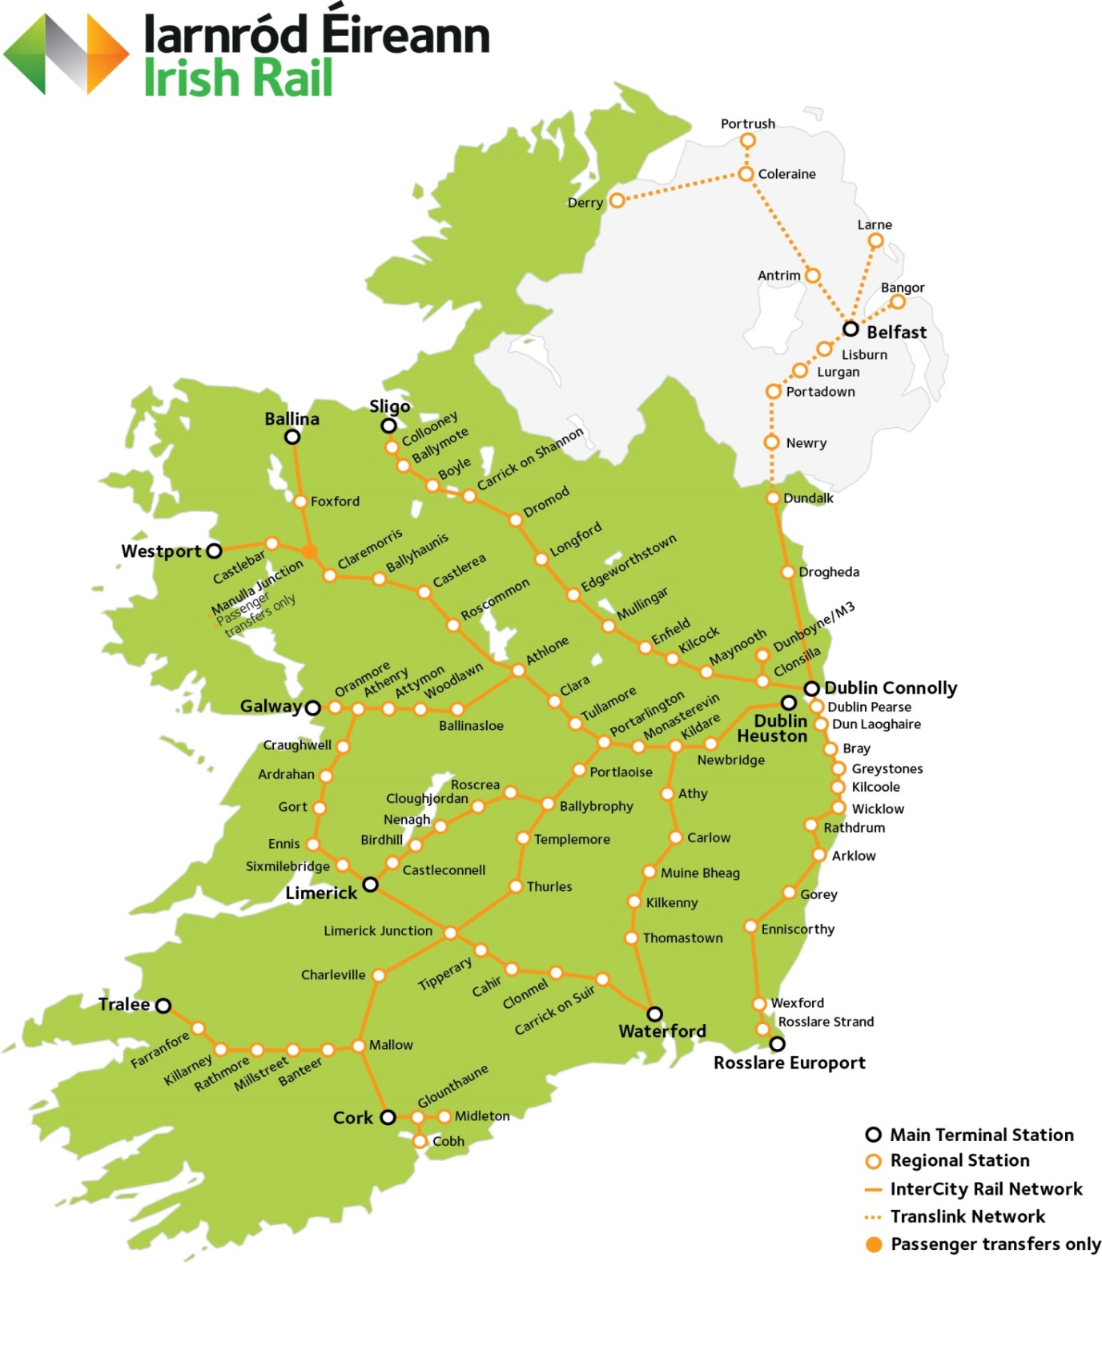

2.2 Passengers
In 2015, a total of 248 million passenger journeys were made across Ireland's public transport network. 16% of those were made by heavy rail, or some 39 million journeys. Of those:
- 70% were on DART and Dublin Commuter Rail networks,
- 26% were on the Inter-City main lines,
- almost 3% were on the Cork Suburban network and
- approximately 0.4% were on regional mainline services.
Heavy rail usage peaked in 2007 when 45.5 million passenger journeys were recorded; however, figures fell year on year until 2012. Since 2012, passenger journeys have increased by approximately 8% and 2016 is expected to record another year of passenger journey growth.
There is a large variation in passenger activity across the 147 stations on the heavy rail network. 28 stations generated less than 100 journeys in a day as recorded on the 2015 rail census. Approximately 84% of the passengers carried used stations in the Greater Dublin Area (Dublin, Kildare, Meath and Wicklow) which had 9 of the 10 busiest stations in the country. The remaining station in the Top 10 was Kent Station, Cork. Section 2.2 of the Rail Review and section 3 of Appendix 1 to the Rail review provides further detail on rail passenger demand .
2.3 Rail’s contribution to transport in Ireland
The current strengths of the heavy rail network are in providing for travel demand within Ireland’s largest urban area (Dublin) serving densely populated areas generating high levels of demand for commuting and in providing for strategic inter-urban links between Dublin and the other cities and regional towns. As demand for travel increases driven by economic and demographic growth, the contribution of rail to meeting this demand sustainably will rise.
Rail also provides wider benefits for society. Rail travel contributes to the control of national greenhouse gas emissions by providing a sustainable and attractive alternative to car travel. It permits greater intensity of land development in cities and towns, enabling more sustainable settlement patterns to evolve. Rail has improved greatly in recent years as a suitable mode for those who are mobility impaired. Furthermore, each year more than 780,000 people benefit from rail travel through the Free Travel Scheme.
Rail travel is a particularly important facilitator of the development of national tourism. Rail also supports economic activity by linking key cities and enabling efficient business-related travel. Rail offers a uniquely efficient freight option for certain products and for raw materials for manufacture.

2.4 Analysis of the costs of providing rail services
In 2013, as required by EU law, two separate divisions were established within Iarnród Éireann – the Infrastructure Manager which is responsible for maintaining and making available the track, signalling, and stations to the Railway Undertaking, the division that operates the rail services.
Recently Iarnród Éireann commissioned international consultants, Roland Berger, to allocate costs and revenues across the whole enterprise. The creation of this comprehensive financial model involved the following:
- Dividing the network into 17 main routes;
- Allocating the revenues to routes to reflect actual travel patterns and volumes;
- Allocating the Railway Undertaking costs to routes by re-definition of cost centres and cost elements;
- Allocating Infrastructure Manager costs from current cost centres (Civil Engineering, Signalling, Electrification, Communications, Infrastructure Managements Operations, and Buildings & Facilities) to individual routes.
The resultant model enables the viewing of the unique costs of operating services that run along a route, the shared costs of services where a route carries a number of services ending in different destinations, the infrastructure maintenance costs for a route, and the proportion of central costs allocated to the services and infrastructure.
Table 1 below sets out the subvention required per passenger carried by route within the network in 2015 (not including Aecom steady-state levels of subvention).
Table 1: Subvention per Passenger Journey by Route, (2015)

Subvention Per Passenger Journey € | Route
< 1 | Dart
1 to 5 | Kildare Suburban
 | Northern Suburban (Dublin – Dundalk)
 | Western Suburban (Dublin – Longford)
5 to 10 | Dublin - Galway
 | Cork Commuter
 | Dublin - Belfast
10 to 20 | Dublin - Waterford
 | Dublin - Tralee
 | Dublin - Limerick
 | Dublin - Sligo
 | Dublin - Cork
20 to 30 | Dublin - Rosslare
 | Dublin - Westport/Ballina
44 | Limerick - Galway
362 | Limerick Junction - Waterford
552 | Limerick - Ballybrophy

NOTE: Subvention means expenditure less receipts from fares and advertising. Cost includes expenditure on fixed costs (e.g. central overheads, buildings, etc), semi-variable costs (e.g. maintenance), and variable costs (e.g. fuel). However it excludes non-cash items such as depreciation, amortization and capitalisation.
The above table shows the subvention that would be paid to break even in 2015. However it does not reflect the figure that is needed to maintain the infrastructure in steady-state condition (Aecom 2016 figures).

Rail’s Future Challenges

3.1 Population, land use and travel demand
Demand for travel by rail, as for all modes, is largely dictated by the relationship between the location of origins and destinations – where people live and where they need to go for their daily needs – accessing work, education, shops, visiting friends and family. In general, there is a strong relationship between rail usage and population density.
The following national population, land use and travel demand characteristics pose significant challenges to the ability of rail to increase its share of total future travel in Ireland:
- Around 38% of Ireland’s population is dispersed throughout rural Ireland. The majority of the dispersed rural population will have limited access to rail, largely only achievable by car travel to/from rail stations. For this group rail is highly unlikely to be a mode of choice in meeting their regular travel demands.

- Approximately 30% of the rail stations on the network are located outside of urban areas or in settlements where the resident population is less than 1,000. As rail relies on a critical mass of population and population density, this significantly limits the potential market for rail now and into the future.

- Travel demand nationally is dominated by short journeys. In total, 41% of all journeys are four kilometres or less, and a further 17% are between four and eight kilometres. Generally, rail is not the best-fit for short-distance travel and, with the exception of parts of the DART in Dublin and, to a lesser extent, the Cork Suburban network, heavy rail cannot compete for these journeys.

- Development and associated demand for travel is also skewed regionally. More than 27% of the country’s population lives in Dublin and 39% live in the Greater Dublin Area. 35% of the jobs are in Dublin and 43% are in the Greater Dublin Area. The volume and characteristics of travel demand generated in relation to Dublin is unique in comparison with the rest of the country due to the size and strengths of the Dublin city region.

- Land-use patterns in Ireland, outside of Dublin, are dominated by low to medium density development in suburban areas, highly dispersed rural populations and the growth in peripheral development of services and employment. This settlement and employment locational context, which dictates travel demand, is difficult to serve by public transport, particularly by rail, as a critical mass of population, employment and education located close to rail stations is required.

- The matching of high capacity public transport with complementary development has not been that well achieved to date in Dublin and Cork. Trip intensive development destinations (retail, employment) have been built that heavily rely on access by the private car.

- Rail offers a unique ability to move freight traffic in larger volumes and/or at higher speeds particularly using existing lines and assets that specifically have direct connectivity between Ports and inland distribution hubs. However, the extent to which further growth in rail freight occurs will depend on both how rail can commercially compete with the road alternative and future policy on how certain material and products, such as biomass and waste, should be transported.

- A further challenge to rail freight is where investment is required in infrastructure to create connectivity with potential new traffic. The return on investment may be challenging due to the volumes of freight traffic required and competition from road hauliers who do not have the same infrastructure investment needs.

3.2 Competition with other modes of transport
Rail must compete for market share with both Car and Bus in terms of cost, journey times, choices of times to travel, reliability and quality of customer experience. There are a number of factors leading to the increase in competition with Car and Bus, as follows:
- Both the car fleet and commercial vehicle fleet have roughly doubled in size compared to their levels in the early 1990’s. The increase in car ownership has had the knock on impact of a decline in use of other travel modes.
- The additional flexibility provided with car travel and the fact that car can provide door to door accessibility explains its continued attractiveness.
- In recent years there has also been a dramatic reduction of approximately 40% in journey times by road between Dublin and other cities (Belfast, Cork, Galway, Limerick, Waterford) as a result of roads investment programmes and the completion of the Major Inter-Urban Motorway programme. This has increased the attractiveness of travel by car and by bus for intercity journeys, in direct competition with Intercity rail.
- The development of the licensed commercial bus market (accounting for over 9% of public transport travel in 2015) has increased the choices available to consumers with a number of operators offering tailored inter-city and commuter travel options.
- Service improvements, for example in the provision of free on-board Wi-Fi and competitive fares have also increased the attractiveness of travel by bus as against rail.
- Bus also benefits from being able to provide more direct access to destinations, for example it can more easily serve suburban residential areas or edge-of-centre employment locations, reducing the need to interchange.
While rail in Ireland has suffered in recent years from competition on road with the completion of the Major Inter-Urban Motorway programme it is likely that any gains in terms of improved journey times by car and bus have peaked. This may now offer an opportunity for rail to become more competitive in the future particularly if improvements can be made to line speeds thereby reducing journey times.

Funding, financial situation and needs

4.1 Sources of rail funding
In 2015 – the most recent full financial year of operation - the rail system cost €550 million for services, maintenance and investment. By contrast, just over €180 million was received in passenger fares with a further €38 million in revenue from commercial activities (e.g. advertising, freight, Rosslare port). Over €320 million was provided to the Company from State sources.

Government funding for rail is allocated for four purposes:
- to maintain the existing infrastructure in its present state so that safe services can be operated at satisfactory journey speeds and that stations and other supporting infrastructure can be kept at an appropriate standard for customers. This funding stream is provided under a Multi-Annual Contract (MAC) between the Department of Transport, Tourism and Sport and Iarnród Éireann;
- to support services that are not commercially viable but are socially necessary and are in the overall public interest. This support is called the Public Service Obligation (PSO) payment and is provided to the company by the National Transport Authority under a contract. The PSO amount in 2015 was €98 million;
- to enhance, and perhaps expand, the infrastructure to meet the needs of a growing society, both in economic and demographic terms. This is called Capital Enhancement and is provided by both by the Department and by the NTA, depending on the project involved. This aspect of the funding tends to vary from year-to-year given the nature of capital projects which are non-recurring; and
- to support the Company carrying passengers who can avail of the Free Travel Scheme of the Department of Social Protection. Iarnród Éireann currently receives almost €15 million in respect of the Free Travel Scheme. Funding of the Free Travel Scheme from the Department of Social Protection has not kept pace in recent years with fare increases and increased passengers. Free Travel Scheme journeys now represent 11.6% of all rail passenger journeys while the funding provided in respect of the Scheme represents only 7.5% of total passenger revenue.
The Rail review (which was completed in August 2016, in advance of Budget 2017) set out estimated future levels of Government support for Iarnród Éireann in the period 2016 to 2021, based on 2016 allocations and indications at that stage of what might be available. These estimates are shown in Table 2 below.
Table 2: Total State Funding Estimates 2016-2021 (based on Rail Review – before Budget 2017)
Type of Funding | Provider | 2016 | 2017* | 2018 | 2019 | 2020 | 2021
Multi-Annual Contract | D/TTS | 126 | 130 | 130 | 130 | 130 | 130
PSO Subvention | NTA | 111 | 111 | 111 | 111 | 111 | 111
Capital Enhancement | D/TTS and NTA | 26 | 11 | 41 | 32 | 31 | 22
Sub-total |  | 263 | 252 | 282 | 273 | 272 | 263
Free Travel Scheme | D/SP | 15 | 15 | 15 | 15 | 15 | 15
TOTAL |  | 278 | 267 | 297 | 288 | 287 | 278
*Note that the 2017 figures in this table do not reflect additional funding (of the order of €50 million) which will be available on foot of decisions in Budget 2017. See paragraph 4.4 of this Consultation Paper for further information.

4.2 Overall financial summary
As part of the 2016 Rail Review, an update analysis was commissioned by Iarnród Éireann from AECOM (engineering and economic consultants) on a 2011 Report undertaken by those consultants for the rail company to assess the level of funding required to maintain the infrastructure of the railway. The updated analysis indicated that there is a gap of about €64 million per annum between the funding available and the appropriate level of funding as advised by AECOM to maintain the railway infrastructure.
The combination of the Fares Revenues and the Public Service Obligation payment is insufficient to ensure, at least, a break-even financial position in operating services. A Train Operations Funding Gap within the Railway Undertaking division occurs now and will continue to do so into the foreseeable future on the basis of projections of fares revenues and the Public Services Obligation payment.
As set out in the Rail Review, to adequately meet future growth objectives, a number of measures would need to be taken to enhance IÉ’s fleet. This is particularly relevant to Intercity and Commuter services, as DART services have already undergone capacity enhancements in April of this year in preparation for the future DART 10 minute timetable. Provision is included in Table 3 below for necessary additional fleet.
Thus, the total projected funding gap comprises a gap in funding available for both Infrastructure Maintenance and Company Operations. Table 4 below summarises the projected Iarnród Éireann cash funding gap for the period 2017 to 2021. The total funding gap for that period is about €517 million (excluding the impact of Budget 2017 – see para. 4.4 below) which averages €103 million per annum.
Table 3: Total Estimated Rail Funding Gap (analysis prior to Budget 2017)

Additional Funding Required: | 2017  €m | 2018  €m | 2019  €m | 2020  €m | 2021  €m
Infrastructure Manager
Gap in funding to keep infrastructure at "Steady State" levels (per AECOM analysis for RAIL Review 2016) | 64.2 | 64.1 | 64.0 | 63.7 | 63.7
Railway Undertaking
Gap between cost of operations and combined revenues from fares and PSO subsidy | 38.7 | 27.2 | 21.7 | 13.7 | 8.2
Unfunded Capital
Urgent Growth Measures (Additional Fleet) | - | 25.4 | 27.4 | 16.0 | 18.7
Total Additional Funding | 102.9 | 116.7 | 113.1 | 93.4 | 90.6
Average Estimated Funding Gap | €103m per annum

4.3 Funding gap
In the six years to 2014, Iarnród Éireann reduced its cost base by €73m (17.3%) and its workforce by 1,073 (22%). In the same time period services were maintained and in some instances enhanced and network size expanded with new line openings, driving an improved efficiency factor year on year. Over the same period, there was a reduction on PSO funding by €74m (39%).
For the future, measures set out in the Rail Review (DART re-launch and better service matching) should contribute additional revenue per annum. Iarnród Éireann is targeting further savings from 2017 onwards through further general efficiencies. These together would not, however, be sufficient to bridge the funding gap, contributing only a small proportion of the required €103m.
If Exchequer grants had to be increased to eliminate the funding gap this would require Government to provide an additional €103m to ensure solvency and adequately maintain the assets.

4.4 Budget 2017
Since the 2016 Rail Review was completed, the Government has published the budget for 2017 expenditure. Additional funding has been allocated by the Government in terms of PSO subvention and capital funding for heavy rail. Therefore the NTA should be in a position to meet most of the Railway Undertaking requirements in 2017 including funding the Fleet Heavy Maintenance.
An additional amount is also being made available by the Department for the MAC contract which will allow for increased investment in maintenance and renewal of the network and additional funding for safety projects.
Therefore the overall gap in funding for Iarnród Éireann has been reduced by approximately €50m in 2017. Funding for 2018 onwards will be considered in 2017 in the context of the Government’s forthcoming reviews of both current and capital expenditure.

Conclusion
Extra Government funding averaging over €100m per annum would be required to remedy the overall financial shortfall but such monies could be also valuably deployed elsewhere in the public transport system. This would be equivalent to the combined annual subsidy funding to Dublin Bus and Bus Éireann who together carry 4 times more passengers than Iarnród Éireann.
Therefore it is appropriate to consider what the optimal rail network is, in terms of national transport needs and value for money. The biggest component of the funding gap is related to the need to maintain the 1660km of infrastructure in a satisfactory and safe condition, i.e. at “steady state” levels. Rail is different to public bus in that considerable specific network infrastructure has to be maintained for rail services. Yet, there are parts of the rail network where patronage on rail services is extremely low while significant infrastructure has to be maintained. Therefore, there is a need to consider the role that prioritisation, or the allocation of funds to specific areas of the network, can play in best managing the network in the future.

Both the NTA and Iarnród Eireann want to ensure that there is a resilient rail network in place and an appropriately funded company to manage that network so that rail can contribute to the wider social and economic objectives of the State. The rail network is a valuable asset in which the State has invested over many years. Along with the support of other effective policies to encourage a shift to the use of integrated public transport, the rail network can contribute to facilitating more sustainable land use development patterns, to providing a viable alternative to driving on congested roads and to achieving the national climate change targets.

We would like to hear your views on these matters in order to advise the Minister, in particular on what should be included in a more sustainable rail policy that is responsive to the needs of the Irish economy in terms of both capital investment and operating subvention required. The NTA notes that a new rail policy must consider how to focus rail investment on where rail has, or will have, its greatest strength in transport, social and environmental terms, as well as securing value for money for the State’s investment.

Appendix

Consultation on Role of Rail

This public consultation gives respondents the opportunity to provide the Authority with public and stakeholder opinion on an optimal rail network for Ireland and its funding.
A questionnaire is provided in the Appendix to this document to facilitate your submission.You may wish to comment only on some of the questions – we welcome any contributions.
If responding in an alternative format, respondents should indicate which question or issue their text refers.
Other publications which may be of interest:
The 2016 Rail Review document is published as part of this consultation at www.nationaltransport.ie
2015 National Heavy Rail Census available at www.nationaltransport.ie

Questionnaire

- What do you think is rail’s particular strength in terms of its contribution to transport in Ireland?
- How important do you consider the environmental contribution of rail to be relative to other transport modes?
- What in your view is rail’s contribution to Irish society relative to other modes of travel? Consider issues such as accessible services for the mobility impaired, social inclusion and the Free Travel Scheme.
- Rail could play a much greater role for commuter travel in Dublin (in 2011 7% of commuting to work or education was by rail) and in Cork (1% in 2011). What policies and measures are required in your view to increase use of rail by commuters in these cities?
- What initiatives do you recommend to increase rail patronage, particularly on intercity services (e.g. shorter journey times, lower fares, more frequent services)?

6. Should fare policy include consideration of time of journey (peak/off-peak), the type of person travelling(e.g. adult/student, etc.),the booking method or timing (internet/in station, on-the-day/in advance)? Why?
7. If funding is limited, what parts of the rail network (DART, Dublin Commuter Services, Intercity Services, Cork Commuter Services, Regional services) do you consider should be prioritized for funding? Why?
8. What is your opinion on the relative advantages of rail and of bus in providing the core public transport service in regions of low population density? Why?

9. How do you think the rail funding gap should best be addressed for the future? You may wish to include some or all of the following: reducing costs (through further efficiencies and/or reducing the size of the network), increasing revenues (e.g. through fare increases and/or Government taxes and/or other investment). Try to be specific in your suggestions.

10. The social benefits of rail travel justify the funding of rail by a combination of Government subsidy and fares. What is in your view the acceptable level of subsidy per person-trip? Why?

11. Should that value differ depending of the type of geographic market served, e.g. urban, intercity or regional / rural rail markets? Why?

12. What are your views on the need for additional safety investment as outlined in the Rail Review and what enhancements do you suggest may be required to enhance safety and security for passengers?

13. What specific improvements (or other changes) to rail services would you like to see?
- On trains:

- At stations:

- On routes:

- On timetables:

- To fares:

- To passenger information:

- To customer service:

- To freight transport:

14. What other general comments have you on rail?

Please complete the questionnaire and email to railconsultation@nationaltransport.ie
or
- submit by post to
Rail Consultation
National Transport Authority
Dún Scéine
Iveagh Court
Dublin 2
D02 WT20

Any submissions must be received by the Authority by Wednesday 18th January 2017. The Authority may publish a report on the consultation.
All submissions should include the full name and address of the person making the submission and where relevant the name of the body or organization represented. Please do not include mobile phone numbers or any other personal information that you do not want published.

Please note that submissions are to subject to Freedom of Information so please highlight any items that you consider to be commercially sensitive material. Please also note that submissions may be published.

All submissions and observations received within the timeframe set out will be taken into consideration.

Based on Iarnród Éireann financial accounts 2015

