Limerick | Shannon

Metropolitan Area Transport Strategy

Public Consultation Document

NTA

Limerick City and County Council

Clare County Council

Project Ireland 2040

Systra

Jacobs

September 2020

Martin Bourke Michael McCormack Tara Spain

Public Consultation
We would like to know your views on the draft Limerick-Shannon Metropolitan Area Transport Strategy 2040 and any items of interest or concern. All comments will be considered and contribute to the final Limerick-Shannon Metropolitan Area Transport Strategy. The Public Consultation exercise will run from 2 September to 16 October 2020.

Full details of the draft Limerick-Shannon Metropolitan Area Transport Strategy 2040 can be found at the following link: www.nationaltransport.ie/publicconsultations/ current

Consultation material will be available to view at City Hall, Merchants Quay, Limerick and the Town Hall, Shannon, Co. Clare for the duration of the consultation period during normal office hours.

The complete set of LSMATS background reports area as follows:
- Baseline Conditions and Policy Context Report;
- Demand Analysis Report;
- Transport Options Report;
- Transport Modelling Assessment Report;
- Supporting Measures Report;
- Advance Consultation Report;
- Strategic Environmental Assessment (SEA); and
- Appropriate Assessment (AA) Report.

Submissions
Submissions are welcomed from the public up until 5pm, Friday16 October 2020. Please send your submission by email or post.

Email:
limerickshannonstrategy@nationaltransport.ie

Post:
Limerick-Shannon Metropolitan Area Transport Strategy 2040,
National Transport Authority, Dún Scéine,
Harcourt Lane, Dublin 2,
D02 WT20.

Phoneline:
If you wish to discuss the strategy with a member of the team, please phone 087 435 4401 to arrange a call back by one of our team members.

Submissions will not be individually responded to but will be summarised in a consultation report which will be published on www.nationaltransport.ie/public-consultations/current

All submissions made on the draft Limerick-Shannon Metropolitan Area Transport Strategy will be reviewed and relevant feedback incorporated into the final Strategy as appropriate.

Submissions from individuals will be reported anonymously and feedback from organisations will be attributed to them. The NTA is committed to protecting the rights and privacy of individuals in compliance with the General Data Protection Regulation and the Data Protection Acts 1988 to 2018. By making a submission under this public consultation exercise, you are indicating your acknowledgement of and consent to the above.

Introduction
The Limerick-Shannon Metropolitan Area Transport Strategy will be instrumental in the regeneration and transformation of Limerick City and the wider Limerick-Shannon Metropolitan Area.
Regional Spatial and Economic Strategy for the Southern Region
The Limerick-Shannon Metropolitan Area Transport Strategy 2040 (LSMATS or the ‘Strategy’) has been developed by the National Transport Authority in collaboration with Limerick City and County Council, Clare County Council and Transport Infrastructure Ireland (TII). It has also been informed by pre-consultation submissions from a number of stakeholders.

The National Planning Framework 2040 (NPF) envisages that the Limerick-Shannon Metropolitan Area (LSMA) will become the growth engine of the Mid-West Region with projected growth of at least 50% during the period up to 2040. This projected population, employment and education growth brings with it opportunities for the development of the LSMA.

This projected population and associated economic growth will also result in a significant increase in the demand for travel. This demand needs to be managed and planned for carefully in order to safeguard and enhance the LSMA’s attractiveness to live, work, visit and invest in.
In common with the other regional metropolitan areas of Cork, Galway and Waterford, there is a legacy of car dependency in the LSMA. This has contributed to a wide range of economic, environmental and social issues including longer commutes, declining urban centres, poor public health, reduced air quality and noise pollution.

To mitigate this, land use and transport planning will be far more closely aligned. This will discourage the use of the private car, particularly for short trips, in order to fundamentally change how people, move around the LSMA. This requires a more efficient use of valuable street and road space and a prioritisation of walking, cycling and public transport.

LSMATS will deliver an integrated transport network that addresses the needs of all modes of transport to support planned growth up to 2040 in a compact and sustainable manner.

The Strategy represents a coherent transport planning policy framework and implementation plan around which other agencies involved in land use planning, environmental protection and the delivery of other infrastructure and services such as housing, utilities and community facilities can align their plans and investment priorities.
The Strategy has been developed to be scalable and flexible enough to meet changes in population and employment growth and is subject to periodic review, every 6 years.

The Vision for LSMATS is:

The Strategy will deliver a high-quality, accessible, integrated and more sustainable transport network that supports the role of the Limerick- Shannon Metropolitan Area as the major growth engine of the Mid-West Region, an internationally competitive European city region and main international entry to the Atlantic Corridor.

To achieve this vision, the guiding principles upon which LSMATS is based are:
- To meet the demand generated by the existing and planned development built in accordance with the NPF, RSES and Development Plans
- To support the future growth of the LSMA through the provision of an eﬃcient transport network
- To prioritise sustainable transport to reduce car dependency
- To provide a high level of public transport connectivity to key destinations and within high demand corridors
- To identify and protect key strategic routes for the movement of freight traﬃc
- To enhance the public realm through traﬃc management and transport interventions
- To increase transport capacity where needed to achieve the Strategy outcomes

Policy Context
Transport investment by the Government Departments, the National Transport Authority and other agencies, will be identified and prioritised through the Limerick-Shannon Metropolitan Area Transport Strategy.
Regional Spatial and Economic Strategy for the Southern Region

LSMATS is a regional level (Tier 2) plan and is currently non-statutory. LSMATS has been developed to align with many national, regional and local level policies and will build upon many existing plans. There are long-standing objectives across several sectors at all levels which aim to reduce car-dependency, promote active travel modes, tackle climate change and increase accessibility, connectivity and social inclusion.

These policies and plans include, but are not limited to:
- National Planning Framework 2040;
- National Climate Action Plan 2019;
- National Development Plan 2018-2027;
- National Cycle Policy Framework 2009-2020;
- A Sustainable Transport Future – Smarter Travel;
- Design Manual for Urban Roads and Streets;
- Regional Spatial and Economic Strategy for the Southern Region; and
- County and City Development Plans and Local Area Plan.

National Policy
LSMATS is underpinned and directly informed by National level Tier-1 policies; the most important of these are the National Planning Framework 2040 (NPF) and the National Development Plan 2018 to 2027 (NDP). The NPF sets out Ireland’s planning policy direction for the next 20 years, while the NDP sets out the investment priorities that will underpin the successful implementation of the NPF up to 2027.

Under the NPF, Limerick City and Suburbs (including those areas within County Clare) are expected to grow to support a minimum population of at least 141,000 by 2040.
The NPF identifies a number of key transport projects and growth enablers for the LSMA including:
- Implementation of the Limerick 2030 Plan to revitalise and redevelop Limerick City Centre and Docks;
- Progressing sustainable development of new greenfield areas for housing on supporting public transport corridors;
- Provision of a Citywide public transport network, with enhanced accessibility from the City Centre to the National Technological Park, UL and Shannon Airport;
- Development of a strategic cycleway network with high capacity flagship routes;
- Enhanced road connectivity to Shannon-Foynes Port; and
- Enhanced regional connectivity through improved average journey times by road from LSMA to Cork and to Waterford.

Regional Policy
At a regional level, the Regional Spatial and Economic Strategy (RSES) translates the objectives of the NPF and the NDP for the Southern Region and aims to enable improved coordination regarding planning and development policy issues across local authority boundaries.

The RSES was adopted in January 2020 by the Southern Regional Assembly. As part of the development of the RSES, Metropolitan Area Strategic Plans were also devised to provide more detailed focus on city and metropolitan issues for the key cities, including the LSMA.

Local Policy
The third tier in the policy hierarchy is local planning, which transposes National and Regional objectives into a local context. LSMATS builds upon existing local plans and policies including the Limerick Metropolitan District Movement Framework and the Shannon Town and Environs Local Area Plan.

The Strategy’s proposals will also inform the development of future Development Plans and Local Area Plans under Limerick City and County Council and Clare County Council.

Map 1 Study Area and Existing Transport Network

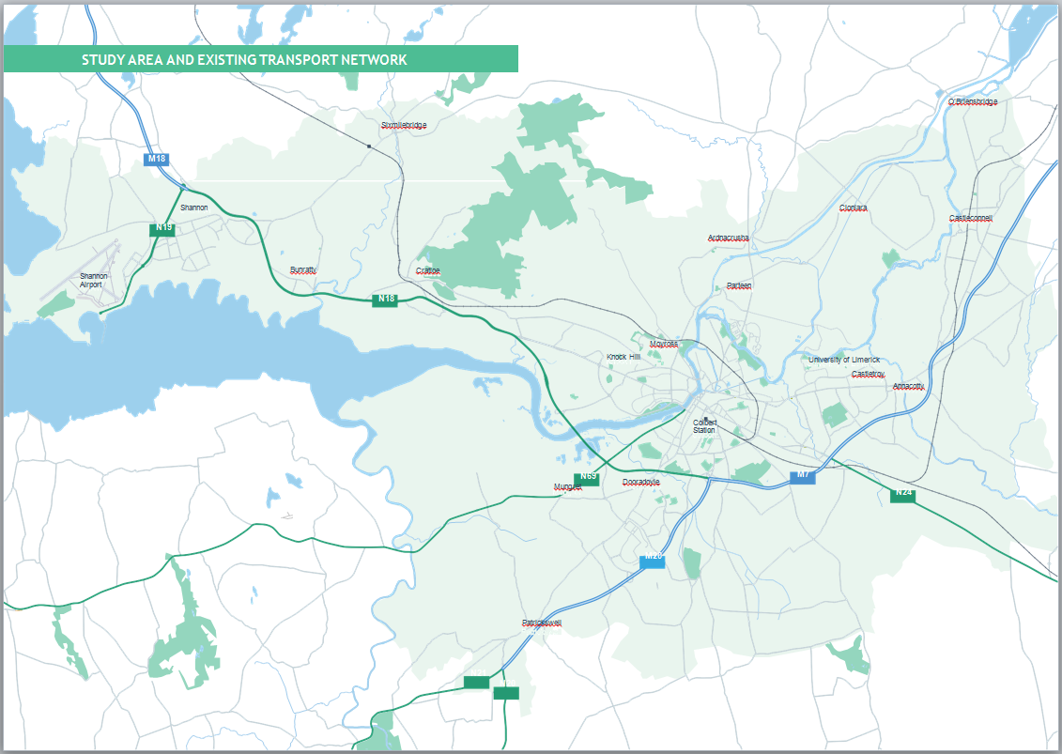

Study Area and Transport Context

The private car is the dominant mode of travel, but there is a strong walking culture already present within the city. Cycling and public transport have a low mode share.
Limerick Metropolitan District Movement Framework Study, 2015

The Limerick Shannon Metropolitan Area (LSMA) covers 387km2, and has a population of over 132,400 (CSO, 2016). This is made up of approximately 96,800 residents within the Limerick
City and Suburbs boundary as defined by the CSO.

Limerick City is the largest urban centre in Ireland’s Mid-West Region and the country’s third largest city. Shannon is a significant employment centre with assets such as Shannon International Airport and Shannon Free-Zone. Both Limerick City and Shannon are interdependent upon each other, with their complementary functions contributing to a combined strength which is a key economic driver for the Mid-West Region.

The residential population within the LSMA is concentrated mainly within Limerick City Centre and suburbs while less than 25% is distributed throughout Shannon and the rural areas

The areas with the highest population density are Limerick City Centre, Raheen, Dooradoyle and Shannon town centre. There are significant employment clusters across the LSMA including Shannon Free Zone, Raheen, National Technology Park and the University of Limerick.

The City and its Metropolitan Area is served by a number of InterCity rail services, city, regional and Expressway bus/coach services, Shannon International Airport (located approximately 20km to the north-west of the City Centre), a well-developed network of National, Regional and Local roads, and walking and cycle networks of varying quality.

There are 415,000 trips originating within the LSMA on average each weekday (over 24 hours). The majority of travel demand is mostly internal for Limerick City and Shannon, with 89% and 68% respectively of morning peak trips made within the same area. Almost half of the trips originating from the LSMA are made towards Limerick City and about 10% towards Shannon.

Mode Share
The following is the existing mode share for the LSMA across the whole day for all trip purposes:
- Public transport: 8%;
- Walking: 29%;
- Cycling: 2%; and
- Car: 61%.

This mode share reflects a legacy of high car dependency and the current limitations of the public transport provision in the LSMA.

Key Challenges
A number of existing challenges were considered in the preparation of this Strategy. To provide a significantly improved sustainable transport network and facilitate a modal shift toward sustainable modes, land use and transport planning, policy and investment in the LSMA will need to:
Support vibrant and accessible village and town centres across the LSMA including Limerick City Centre and Shannon Town;
Better integrate land use, and transport planning and investment;
Support increased population, employment and educational densities in accessible centres and along public transport corridors;
Maximise the potential of the existing transport infrastructure including the InterCity rail network, Shannon Airport, the Port of Foynes and Ennis as a connecting hub;
Re-allocate road space to support more walking, cycling and public transport;
Improve public transport through increased priority and higher frequency services operating with greater speed and journey time reliability with complementary facilities such as Park and Ride;
Minimise severance created by the River Shannon, railway infrastructure and road network;
Reduce the impact of transport on the environment, health, wellbeing and safety of residents;
The need to achieve efficiency and resilience within the LSMA’s transport network across all modes; and
Maintain and enhance the strategic function of the National road network.

LSMATS 2040 Land Use

The target is for at least 40% of all new housing to be delivered within the existing built-up areas of cities, towns and villages on infill and/or brownfield sites.
National Planning Framework 2040

The NPF estimates that the population of Ireland will increase by approximately 1 million people by 2040 with a requirement of an additional 600,000 jobs and a minimum of 500,000 additional homes.

The NPF recognises the role that Limerick and the other regional cites of Cork, Galway and Waterford have to play in providing a counter-weight to Dublin and assigned a minimum population growth forecast of 50-60% to each regional city, with a further targets of at least 40% of all new housing to be delivered within the existing built-up areas of cities, towns and villages on infill and/or brownfield sites.

The LSMATS 2040 land use scenario was developed by the National Transport Authority in collaboration with Limerick City and County Council and Clare County Council, guided by the population projections provided by the RSES up to 2031 for Limerick City and Suburbs (129,448) and the rest of the LSMA (48,074).

To support the compact growth aspiration of the NPF, Limerick City Centre will become the focus for significant regeneration opportunities at brownfield locations that include the Opera Site, the Georgian Quarter, the former Cleeves Site and a state-owned landbank south of Colbert Station.
In terms of employment and education, LSMATS supports development along its identified high capacity public transport corridors, to serve University of Limerick, University Hospital Limerick, LIT, Dooradoyle, Mary Immaculate College, the National Technology Park, Shannon Free Zone and Shannon Airport.

The Strategy is confronting a legacy which saw significant levels of growth and migration of land uses to suburban and peri-urban fringe locations, typically at lower densities and unconnected to existing and planned public transport services. This pattern of development has contributed to high rates of car dependency which cannot continue.

To ensure the success of this Strategy, the planning policy frameworks and implementation measures of Limerick City and County Council and Clare County Council must look to target higher densities and mixed-use developments in areas where opportunities exist for sustainable transport provision and in a manner that better aligns the provision of transport with demand.
Guided by the principles of the NPF, the following strategy development priorities for the distribution of land-use have been identified for the LSMA:
To deliver consolidated development in a manner that can avail of existing transport infrastructure and services, and nearby amenities and facilities, in line with the principles of Transit Oriented Development (TOD). The objective of this approach is to deliver a critical mass of growth in population and employment which can support the transition
to and sequencing of investment to higher capacity public transport infrastructure and services;
To increase densities in future residential and employment developments. This measure can contribute to a more compact urban footprint that brings more people closer to their destinations and to public transport services;
Prioritise mixed-use development which reduces the need to travel. This includes ensuring areas are developed in tandem with the delivery of schools, shops and other community services to enable people to choose sustainable modes of transport such as walking and cycling;
All new development areas will be fully permeable for pedestrians and cyclists and opportunities to improve permeability for these modes in existing developed areas will be sought. The principle of filtered permeability, whereby through private car traffic is discouraged, will apply; and
The layout of new developments will prioritise walking and cycling and enable the efficient provision of public transport services.

Strategy Development

Key Growth Enabler for LSMA: Provision of a citywide public transport network, with enhanced accessibility from the City Centre to the National Technology Park, UL and Shannon International Airport.
Regional Spatial and Economic Strategy for the Southern Region

LSMATS was developed in an iterative manner through extensive technical analysis to provide a transport network that underpins the ambitious population and employment growth envisaged for the LSMA under the NPF to 2040 and beyond.

The approach applied in developing and assessing the proposed LSMATS 2040 transport measures was as follows:
- Review relevant policy and guidance;
- Establish the baseline transport conditions;
- Identify key challenges to be addressed, in consultation with key stakeholders;
- Develop network options based on guiding principles;
- Test the transport network options with future land use scenarios set by the NTA and local authorities;
- Identify preferred transport strategy; and
- Public consultation and subsequent finalisation of the Strategy.

The resulting LSMATS transport network can best serve the ambitious projected population and employment growth in the LSMA, allowing it to develop in a sustainable manner.

It represents an integrated transport network offering residents of, and visitors to, the LSMA end-to-end access to high-quality services and the ability to conveniently access more destinations than the existing network would allow.

The Strategy Outcomes include:

- A scalable transport network framework to better manage the increased demand for travelling resulting from significant population growth
- Prioritised public transport, walking and cycling in urban areas across the Limerick-Shannon Metropolitan Area
- Enhanced social inclusion through the provision of a more equitable transport system and wider public transport accessibility to areas of deprivation
- A safer transport network where investment is priority-focussed and evidence-based
- Improved public health and wellbeing by promoting more physical activity in, either as walking and cycling trips in their own right or as part of linked trips with public transport
- Reduced transport related emissions through a provision of a cleaner greener public transport fleet, a modal shift to walking and cycling, a reduction in private car use and a shift towards low emission vehicles.
- A robust economic case for transport investment in the LSMA.

Map 2 Proposed LSMA Cycle Network
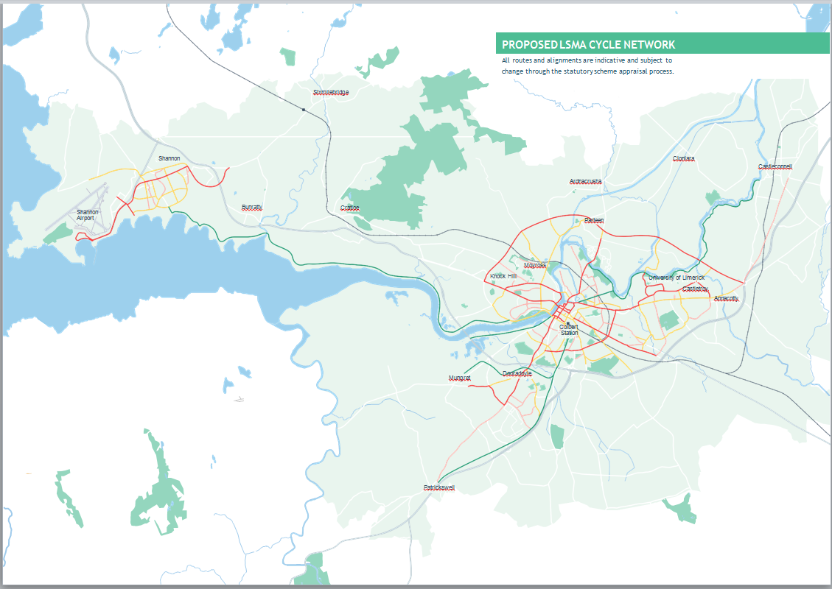

Walking
All journeys begin and end by walking irrespective of other modes used. Though often undervalued, walking links all modes of transport and is therefore critical to achieving the aims of the Strategy.

The overarching objective for LSMATS is to create a pedestrian environment that is be safe, accessible, interesting and attractive for pedestrians of all ages and abilities. At present, the quality of the pedestrian environment across the LSMA is inconsistent with a range of barriers including insufficient footpath widths, street clutter and a lack of crossing opportunities.

The Strategy proposes a significantly enhanced Walking Network, supported by a number of measures including wayfinding, permeability, Safe Routes to School and urban design and place- making. Walkability Audits are proposed in the short-term to assess the existing network and inform improvements.

Key outcomes for walking are as follows:
- An increase in mode share for all trips, particularly for short journeys;
- An increase in linked-trips with public transport, cycling and other forms of micro-mobility;
- A fully accessible, safe, and attractive pedestrian environment suitable for all ages and abilities;
- All new and retrofitted schemes will be designed in accordance with the overarching principles set out in DMURS; and
- A higher standard of urban design that prioritises safer and more efficient pedestrian movement over that of the private car.

Cycling
Cycling is a low cost, sustainable and growing mode of transport. Limerick City has a lot of untapped potential to become a haven for cyclists with its flat topography, compact design and the fact that a journey from the City Centre to the urban edge can be undertaken in less than 30-mins.

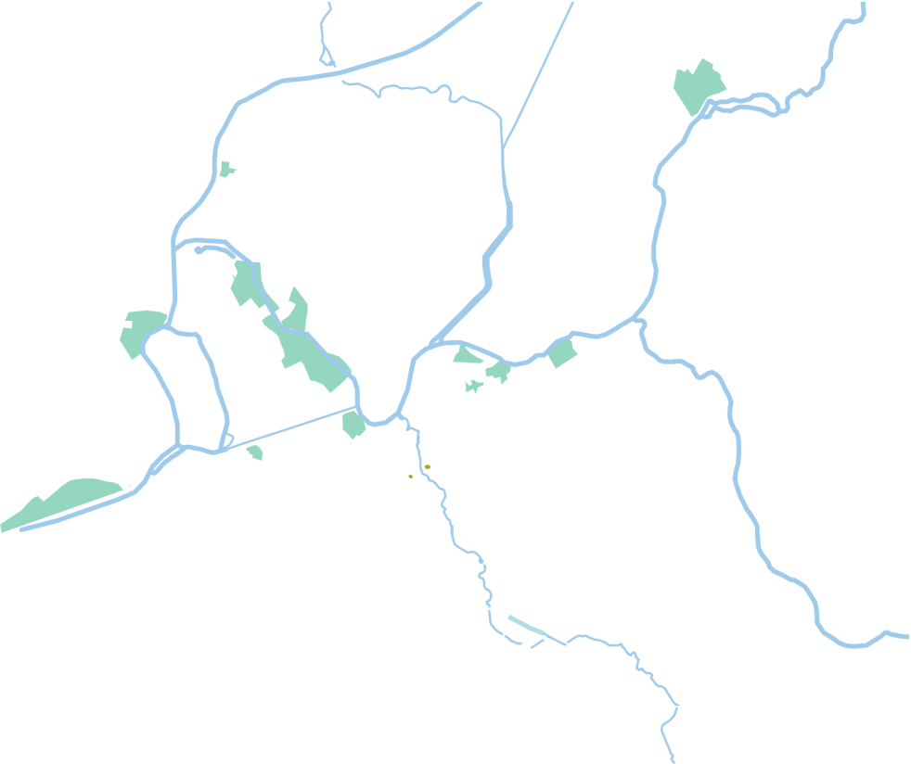
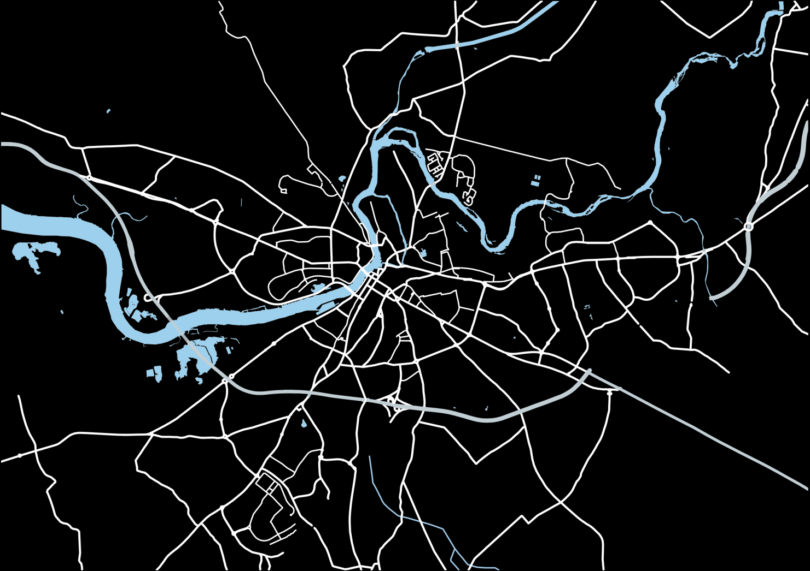
The NDP commits to the delivery of cycle networks for all of Ireland’s cities. Translating this at a regional level, the Limerick Metropolitan Cycle Network Study and the Shannon Town and Environs Local Area Plan form the basis of LSMA cycle network.

Additional proposals will align with BusConnects, LNDR and Park and Rides.

High-quality infrastructure and supporting measures are required to cultivate a cycling culture in the LSMA, and to give all individuals the choice to cycle, including:
- Identification of Primary, Secondary, Inter-Urban, Feeder and Greenway Routes, and Quiet Ways to develop a comprehensive cycle network across the LSMA;
- Facilities designed to National Cycle Manual standards;
- Full or light segregation from other modes to ensure safety and comfort for all road users;
- Local traffic calming, lower speed limits and junction treatments, particularly at complex junctions in an urban context; and
- Supporting measures including the public Bike Share Scheme, end-of-trip facilities and behavioural change initiatives.

PROPOSED LSMA BUS NETWORK

Map 3 Proposed LSMA Bus Network

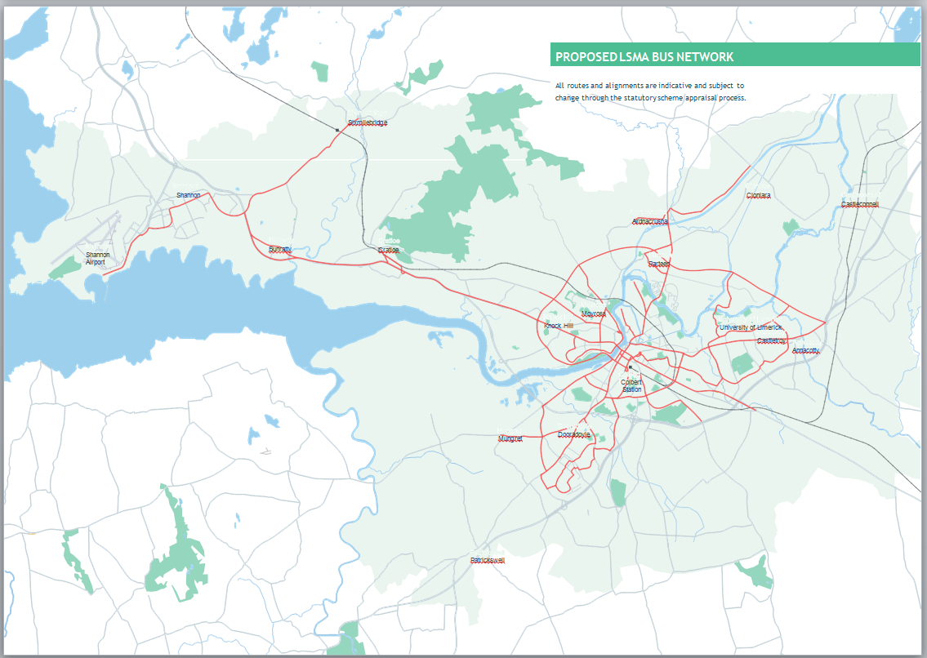

Map 4 Proposed Limerick City Bus Priority Measures
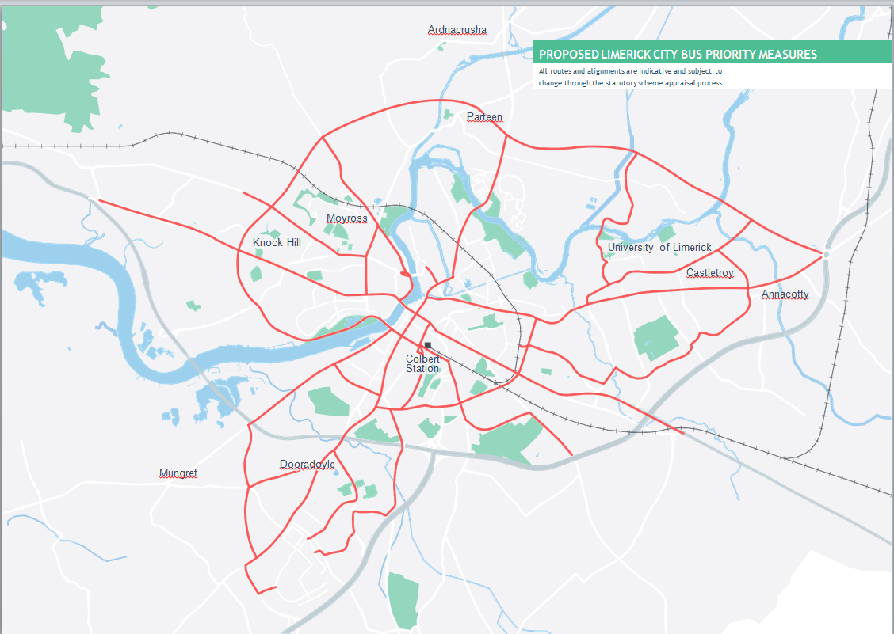

Bus Connects
The NPF identifies the provision of a citywide public transport network, with enhanced accessibility from the City Centre to the National Technology Park, UL and Shannon Airport, as a key enabler for Limerick. This aim is consistent with the Climate Action Plan, NDP and RSES which envisage a significantly enhanced bus service in Limerick by 2027. For the purposes of assessing the Strategy, a significantly enhanced indicative future bus network for 2040 has been developed and refined in an iterative manner taking into account corridor travel demand analysis work.

The final bus network that will be implemented in the short-medium term will require more detailed service planning and may differ from that assumed in the LSMATS due to, inter alia, detailed operational requirements and changing local traffic considerations. BusConnects Limerick has been devised based on the following 6 principles:
- Capacity
- Frequency
- Speed
- Directness
- Coverage, and
- Interchange

BusConnects Limerick will provide a reliable, high-frequency public transport service to improve connectivity of Limerick City and suburbs. The enhanced BusConnects represents a significant upgrade on the existing system and will comprise of a more comprehensive network, bus priority and new fleet. It will serve all key destinations and provide interchange with the rail network and proposed Park and Ride services.
Other objectives for the proposed LSMATS bus network include:
- Significantly improve connectivity to Shannon town, Airport and Freezone, and other urban centres within the LSMA;
- Provide of bus priority through the reallocation of road space from the private car, Advance Bus
- Signalisation, bus gates and acquisition of land to accommodate bus lanes where required;
- Provide Bus Priority within Limerick City Centre and Sarsfield Bridge through reallocation of space from general traffic lanes; and
- Maintain and enhance regional bus networks and Local Link services.
- A more strategic approach to coach and tourist bus parking management.

Rail
LSMATS proposes to maximise opportunities offered by the existing rail network to enhance regional connectivity. Maximising the potential of the rail corridor will support better integration of land use planning and public transport.

The LSMA’s existing rail network provides access to Limerick City Centre at Colbert Station from Dublin, Ennis and Nenagh. Limerick Junction is an important regional asset interconnecting the Dublin, Cork, Limerick, Galway and Waterford rail corridors.

In order to enhance this regional and national connectivity, a key strategic objective of the NPF and identified by the NDP, RSES and Iarnród Éireann, the examination of a dual-track between Limerick Colbert and Limerick Junction stations is proposed.
This would improve journey times and enable an increase in the frequency of services and connections.

Further LSMATS rail proposals include:
Investigate the potential for a new station to support the proposed Park and Ride at Ballysimon;
Complete the redevelopment of Colbert rail and bus station to provide a more attractive, secure and comfortable experience for passengers, in line with the project developed by Irish Rail and the NTA; and
Examine the feasibility of a bus-only link behind Colbert Station on Roxboro Road and enhanced improved pedestrian, cycle and bus connectivity to the City Centre.
Investigate the potential for rail freight in support of the proposed Regional Freight Strategy, including the reinstatement of the line between Limerick and the Port of Foynes; and
Examine the feasibility of the provision of new greenways either within disused rail lines or immediately adjacent to existing or proposed rail corridors.
Support the master planning process recently undertaken by the Land Development Agency and Limerick City and County Council to develop over 100 acres of State-owned land around Colbert Station as a Transit Orientated Development (TOD).

Map 5 Proposed Road Network
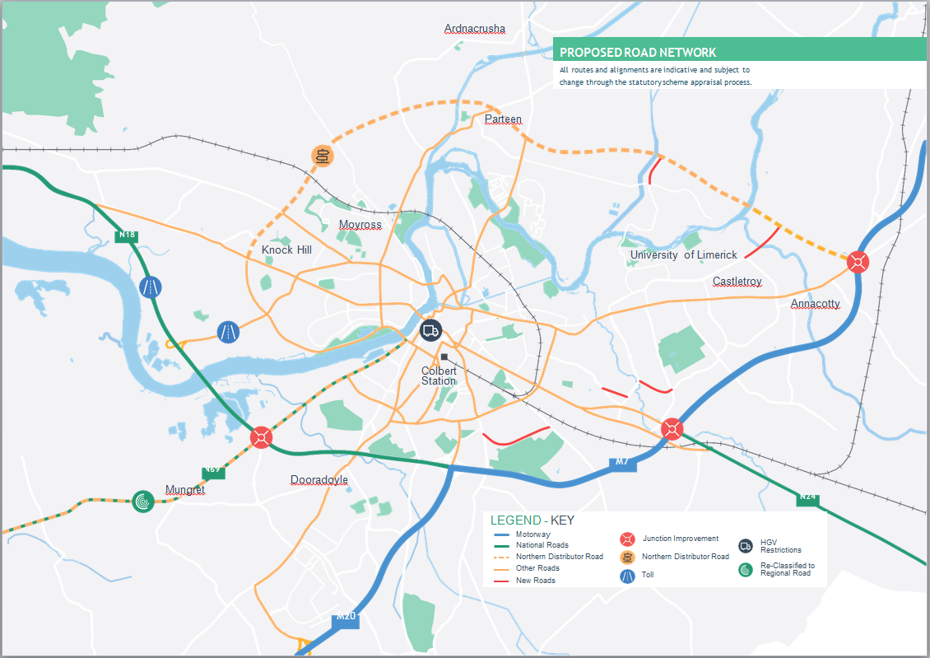

Map 6 Proposed Park and Ride Network
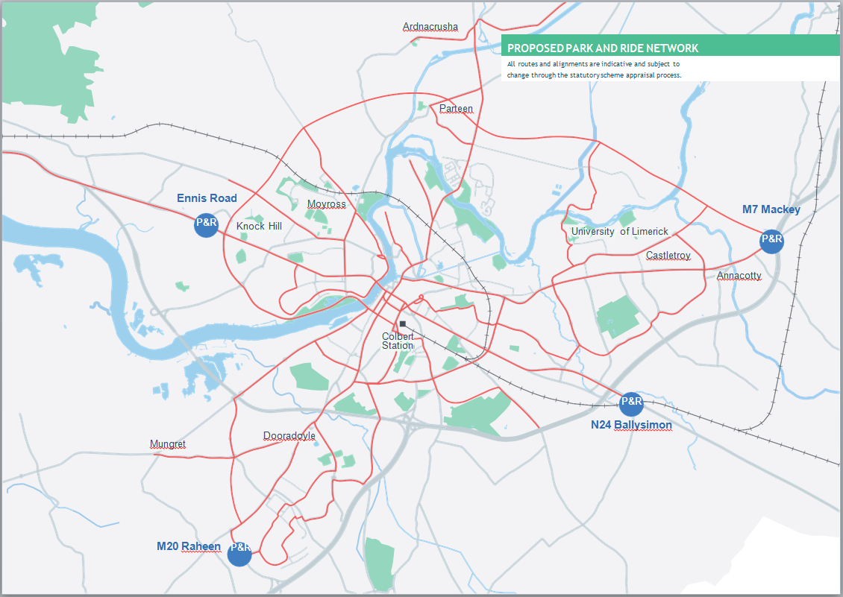

Roads and Streets
The road network refers to not only the carriageway itself but other highway infrastructure including bridges, the Shannon Tunnel, footpaths, cycleways, signage, markings and traffic signals. The LSMA has an existing well-developed network of National, Regional and Local roads and streets. In line with the NPF’s objective to achieve Compact Growth, the Strategy seeks to deliver on strategic development priorities for the distribution of a more compact settlement pattern based on ensuring effective integration between transport and land-use. This will provide a long-term sustainable economic, environmental and social case for reliable public transport, permeable, high-quality walking and cycling routes and an inclusive, people-centred public realm It is the intention of the NTA, TII and the local authorities to:
Maintain, manage and operate the existing road infrastructure in a more efficient manner;
Manage the road network to discourage through traffic in built-up areas; and
Prioritise the place making functions of the urban street network in line with the hierarchy outlined in DMURS.

Some objectives relating to roads and streets include the following;
- M7/N18 Limerick City By-pass
- M20 Cork- Limerick
- M21/N69 Foynes to Limerick Road (including Adare Bypass)
- A multi-modal Limerick Northern Distributor Road
- Junction improvements to provide bus and active travel priority
- P+R and parking management.

Implementation of these projects in all cases, will be subject to separate appraisal and environmental assessment.

Parking
There is a long-established link between the availability, provision and price of parking and relative attractiveness of the private car relative to sustainable transport options. Judicious management of parking should be used as an effective demand management tool to discourage private car journeys particularly for shorter trips across the LSMA. For longer journeys, the emphasis will be on discouraging through trips in urban areas through the provision of Park and Ride facilities and reliable interchange with walking, cycling and public transport provision. Strategic Park and Ride (PnR) entails the provision of high-capacity car parking facilities at designated public transport interchanges on the approach roads to Limerick City (and potentially Shannon). Park and Rides are a key component of LSMATS and are a means of increasing the catchment of the transport network to those that might not otherwise have access via walking, cycling or public transport. Indicative locations for Park and Rides are proposed at:
- M7: Newport Roundabout;
- M20/N21: Raheen;
- N18: Ennis Road; and
- N24: Ballysimon (rail and bus).

Mobility hubs will be encouraged in regeneration areas or central areas where low-car, high-density housing is planned, such as the LDA Colbert Station lands to contribute to sustainable transport mode share targets and reduce the reliance on the private car particularly for short-trips.

Effective parking management is required to control the availability and price of parking. Parking enforcement is also vital to ensure that footpaths, bus lanes and cycle lanes are not blocked by parked cars as this can be a barrier to movement for pedestrians and cyclists, especially those with disabilities. It is recommended that both Local Authorities seek to:

- Implement maximum parking standards.
- Implement a comprehensive on-street parking management structure including implementation of controlled (resident) parking controls.
- Restrict long-stay parking to PnR and purpose
- built off-street facilities.

Freight, Delivery and Servicing
To meet NPF growth projections, construction
of new homes, offices and schools will result in increased movement of freight. There will also be a greater level of delivery and servicing activity as well as waste management due to economic activity and recent trends in online shopping.
While presenting challenges in terms of safety, congestion, air and noise pollution, the clustering of activities allied to an improvement in the strategic transport infrastructure offers the possibility of innovative approaches to mitigate impact of freight activity.

Key objectives for the management of freight, deliveries and servicing include:
- Restrict HGV movements through Limerick city and neighbourhoods by identifying specific lorry routes and/or time restrictions;
- Examine the feasibility of consolidation centres and break-bulk facilities outside of the National road network to facilitate smaller vehicles delivering to Limerick City Centre;
- Reduce the amount of ‘last mile trips’ being made by motorised vehicles;
- Support the development of a Regional Freight Strategy; and
- Investigate the feasibility of rail freight from the Port of Foynes to Limerick and further afield.

t Ese

Supporting Measures
Supporting measures play an important role in complementing transport infrastructure and services to achieve the optimal outcomes of LSMATS.

The full benefits of the significant investment that will be delivered under LSMATS cannot be achieved solely through the provision of infrastructure and must be combined with the implementation of measures that support the best use of that infrastructure.

LSMATS’ supporting measures will be essential to the creation of physical, social and cultural environments where walking, cycling and public transport are attractive, practical and logical alternatives to the private car.

These initiatives will improve end-to-end trip facilities and integration between all modes and improve public awareness and perception around sustainable travel options.
LSMATS proposes a broad range of ‘hard’ and ‘soft’ measures to achieve this, including:
- Appointing Walking and Cycling Officers;
- Local Transport Plans;
- Smart Ticketing;
- Public Transport Fares;
- Car Clubs;
- Workplace and School Travel Planning;
- Event Management;
- Urban Design and Place-making;
- Mobility as a Service systems; and
- Dynamic Parking Systems/ Virtual Loading Bay Systems.

Implementation
LSMATS is intended to be scalable, flexible and future-proofed enough to meet changes in population and employment growth.

It is a live document, subject to periodic review every 6 years. It is acknowledged that each of the major elements proposed in the Strategy is subject to an individual appraisal based on its own merits regarding feasibility, design, planning, approval and funding.

To achieve the optimum results from LSMATS, Limerick City and County Council and Clare County Council will work in collaboration with the National Transport Authority, Transport Infrastructure Ireland, the Southern Regional Assembly and other key stakeholders to:
- Deliver on the necessary land-use consolidation to achieve compact growth and critical mass;
- Secure capital investment under the NDP and other forms of investment;
- Implement LSMATS’ transport network, supporting measures and demand management measures; and
- Monitor and review progress.

Costs and Funding
The delivery of LSMATS will be subject to the availability of funding. It is acknowledged that each of the major elements of LSMATS will be appraised individually on its own merits, in terms of feasibility, design, planning, approval and funding. Business cases will be required for each of the major infrastructure proposals included in the Strategy, in line with the requirements of the Public Spending Code and the Common Appraisal Framework.

Phased Implementation
A phased implementation plan has been devised to incrementally realise the transport infrastructure, services and investment over time to align with the projected growth of the LSMA. The Strategy’s timeline is cognisant of the NDP and aligned with that of the RSES.

The plan has disaggregated the strategy implementation in to three timeframes:
- Short-Term: 1-6 years (up to 2026);
- Medium-Term: 7-11 years (up to 2031); and
- Long-Term: 13-20 years (to 2040).

Strategy outcomes
The implementation of the Strategy’s proposals and principles will result in positive outcomes for the Limerick-Shannon Metropolitan Area, providing long-term economic, social and environmental benefits to the region.

It will enable the LSMA to grow in a sustainable manner in line with growth targets set by the NPF and RSES, supported by the delivery of an
integrated, reliable and efficient transport network.

It should be noted that the modal targets presented here for walking, cycling and public transport use are the result of a strategic modelling process and not envisaged as ceilings or targets.
Further revisions upwards to the sustainable mode shares are expected through the review process as infrastructure is improved and demand management measures are adopted by both Local Authorities.

To achieve the optimum results from LSMATS, Limerick City and County Council and Clare County Council will now work in collaboration with the National Transport Authority, Transport Infrastructure Ireland, the Southern Regional
Assembly and other key stakeholders to deliver on the necessary land-use consolidation to achieve compact growth and critical mass; secure capital investment under the NDP and other forms of investment; implement LSMATS’ transport network, supporting measures and demand management measures; and monitor and review progress.

Table 1 Implementation Plan
TIMEFRAME |  | SHORT TERM  (UP TO 2026) | MEDIUM TERM  (UP TO 2031) | LONG TERM  (UP TO 2040)
WALKING | Upgrades and Improvements to Pedestrian Infrastructure
CYCLING | Primary Network
 | Secondary Network
 | Feeder Network
 | Inter-Urban
 | Greenway
BUS | BusConnects Implementation
 | Wider Bus Network Improvements
RAIL | Dual-track between Limerick Colbert and Limerick Junction
 | Existing Station Upgrades and Improvements
 | Electrification of Rail
 | Investigate Potential New Stations
 | Implement Upgrade at Ballycar
PARKING | Delivery of Park and Ride facilities
 | Implementation of Parking Management Measures
ROADS AND STREETS | Development of a City Centre Traffic Management Strategy
 | Junction Improvements
 | Limerick Northern Distributor Road (LNDR)
 | M21/N69 Foynes to Limerick Road (including Adare Bypass)
 | Delivery of N19
 | Design and Planning of N/M20
 | Progress and Delivery of N/M20
 | Progress and Delivery of LSMA National and Regional Road Scheme
FREIGHT | Preparation of a Regional Freight Strategy
 | Preparation of a Local Freight Strategy
OTHER SUPPORTING MEASURES | Demand Management Measures
 | Integration Measures
 | Intelligent Transport Systems (ITS)

LIST OF ACRONYMS

AA | Appropriate Assessment | LSMATS | Limerick Shannon Metropolitan Area Transport Strategy
AV | Autonomous Vehicles | MaaS | Mobility as a Service
BSS | Bicycle Share Scheme | MASP | Metropolitan Area Strategic Plan
CLC | Construction Logistics Centre | NDP | National Development Plan
CSO | Central Statistics Office | NPF | National Planning Framework
DMURS | Design Manual for Urban Roads and Streets | NPO | National Policy Objective
DTTaS | Department for Transport Tourism and Sport | NSO | National Strategic Objective
EU | European Union | NTA | National Transport Authority
EV | Electric Vehicle | NTP | National Technology Park
EVCP | Electric Vehicle Charging Point | TOD | Transit Orientated Development
HGV | Heavy Goods Vehicle | RSES | Regional Spatial and Economic Strategy
ITS | Intelligent Transport System | RTPI | Real Time Passenger Information
LIT | Limerick Institute of Technology | SEA | Strategic Environmental Assessment
LNDR | Limerick Northern Distributor Road | TII | Transport Infrastructure Ireland
LSMA | Limerick Shannon Metropolitan Area | UL | University of Limerick

