Allocation Adjustment Form

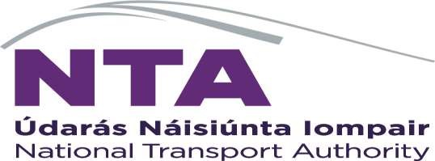

Allocation Adjustment Form
To be used for a change in a current year funding allocation in respect of an ongoing previously approved project. Form to be completed by NTA Programme Manager/ Senior Programme Manager

Add rows as required

Sponsoring Agency | Project Name | PRS Project Code | Existing Allocation | Adjustment Value | New Allocation | Reason

Signed: Date:

NTA Section Head (approver for all allocation adjustment requests)

Signed: Date:

NTA Director of Transport Planning and Investment (final approver where the allocation adjustment requested exceeds €500,000 for any one project)

NTA Budgetary Approval

Signed: Date:

Capital Financial Analyst where the total cost of the project is < €500,000
Senior Capital Finance Manager where the total cost of the is > €500,000
(The Capital Programme Office Representative approval is solely in respect of confirming funding availability, for extracting information for current year and multi-year spend forecasts and for confirming that the required information for PRS set-up is included and accurate.

