Canal Cordon Report 2019

Report on trends in mode share of vehicles and people crossing the Canal Cordon

2006 to 2019

May 2019

Contents
1 Introduction 4
1.1 Background to data collection 4
1.2 Definition of the Canal Cordon 4
1.3 Data Sources 6
2 Traffic Surveys – Vehicles, Cyclist, Pedestrians 7
2.1 Overview 7
2.2 Numbers of vehicles, cyclists and pedestrians crossing the canal cordon by mode 9
2.2.1 Buses 9
2.2.2 Cars 10
2.2.3 Taxis 11
2.2.4 Pedestrians 12
2.2.5 Cyclists 13
2.2.6 Goods Vehicles 14
2.2.7 Motor Bikes 15
3 Traffic and Transport Surveys - Overall Movements 16
3.1 Overview 16
3.2 Percentage mode share of people crossing the canal cordon 18
3.3 Trips Crossing the Canal Cordon by Sustainable Modes 20
4 Commentary on Canal Cordon Trends 24
4.1 Overall Trends 24
4.2 Public Transport Usage 24
4.3 Mode Trends 24

Introduction

Background to data collection
Since 1980, Dublin City Council (DCC) has been conducting traffic counts at 33 locations around the cordon formed by the Royal and Grand Canals. The counts are conducted during the month of November each year. Since 1997 the counts have been conducted over the period between 07:00 and 10:00.
Between 1997 and 2009, the Dublin Transportation Office (DTO) collected data from a number of sources on people crossing the Canal Cordon into Dublin’s City Centre in the AM peak period between 07:00 and 10:00. The National Transport Authority (NTA) subsumed the DTO in 2009, and has continued to collate this data on an annual basis.
Combining the two sets of data enables the tracking of trends in the modes of travel that people are using to travel into the City Centre for the period 2006-2019.

Definition of the Canal Cordon
Map 1 illustrates the Canal Cordon and the 33 locations on the Cordon where data is annually collected on the movement of people in the AM peak period between 7:00 and 10:00. As the name suggests, the cordon has been chosen to ensure (as far as possible) that any person entering the City Centre from outside must pass through one of the 33 locations where the surveys were undertaken. It should be noted that the data as presented in this report refers to movements of people in one direction only (i.e. inbound into the city centre) across the various cordon points.
All 33 cordon points are on routes for general traffic into the City Centre, while 22 of the cordon points (shown in red in Figure 1.1) are on bus routes into the City. People using DART and suburban rail services to enter the City Centre cross the cordon close to cordon points 2, 16 and 31 in Figure 1.1, while those travelling on the two LUAS lines cross the cordon at points 7 and 13.

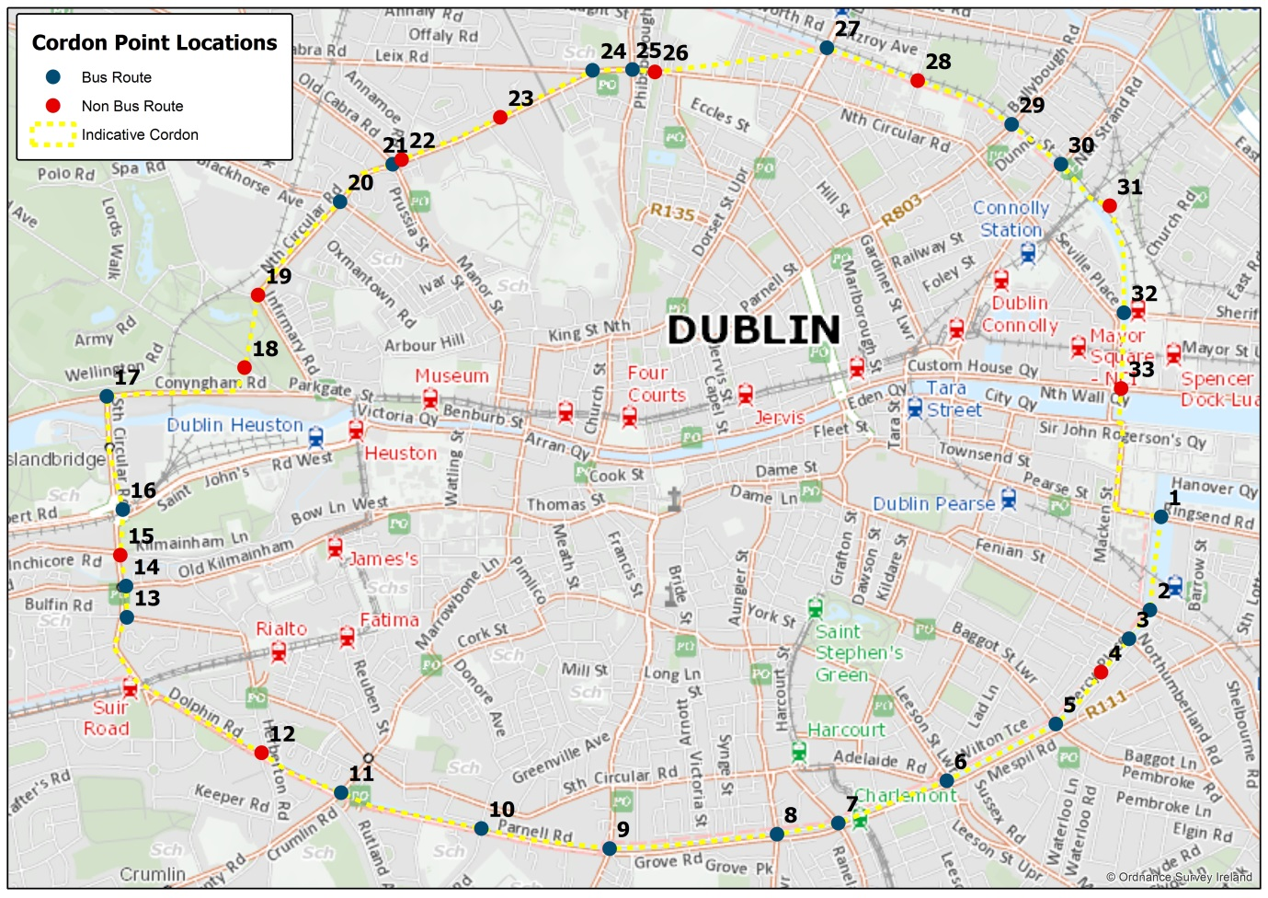
Map 1 Canal Cordon Showing all 33 count locations

Data Sources
Data on the movement of people across the Canal Cordon has been assembled from a number of sources as outlined below:
- Dublin City Council has undertaken surveys at the Canal Cordon in November annually since 1980. Surveys are undertaken over two days at each location and an average across the two days is reported. The survey counts pedestrians, cyclists, cars, taxis, buses, goods vehicles and motorbikes crossing the cordon points in the inbound direction in the three hour, AM peak period 07:00-10:00.

- To complement the Dublin City Council Canal Cordon annual surveys, Dublin Bus have undertaken their own surveys annually on a single day at each location in November. This is not necessarily the same day as the DCC cordon counts. Since 1997 this survey has counted the number of passengers on all buses (including privately operated bus services) crossing inbound over the canal cordon points. This survey is undertaken at the 22 cordon points that are on bus routes into the City (shown in red in Figure1.1).

- Since 2012, Iarnród Éireann has undertaken a census of passengers boarding and alighting on all services passing through all stations in the national rail network on a single day. In 2019 the national rail census was carried out on 21st November. Prior to 2012 and since 1997, Iarnród Éireann had undertaken a similar passenger census for services operating within the Greater Dublin Area (GDA). Analysis of this data enables a calculation of the numbers of rail passengers crossing the three Canal Cordon points (inbound) between 07:00 and 10:00 on the census day.

- Transport Infrastructure Ireland (TII) undertakes an annual census of passengers boarding and alighting at all LUAS tram stops. This census is undertaken on a single day in November. It has been undertaken every year since both LUAS lines became operational in 2004. This data enables calculation of the number of LUAS passengers crossing the two Canal Cordon points (inbound) between 07:00 and 10:00 on census day.
By combining these four data sources, the NTA and DCC have been able to compile a comprehensive picture of the modes of travel used by people travelling across the Canal Cordon into the City in a typical AM peak period. There may be gaps in the data compiled in certain years, and some changes in the survey methodology for the DCC cordon counts have been introduced in recent years.
The introduction of LUAS also had a significant impact on the data trends. For these reasons, the analysis of trends in chapter 2 of this report is restricted to the years 2006 – 2019. For these 13 years, there is a consistent and continuous set of data that enables a direct comparison of mode share trends.

Traffic Surveys – Vehicles, Cyclist, Pedestrians

Overview
This Chapter of the report records the data collected from the traffic counts only, which records the numbers of vehicles of different types and the numbers of cyclists and pedestrians. It does not include the public transport surveys which supplements the traffic counts with the additional passenger numbers on the various modes of public transport. That information is included in Chapter 3 of this report.
Table 1 below presents the total numbers of vehicles, pedestrians and cyclists crossing the Canal Cordon inbound between 07:00am and10:00am from 2006 to 2019. Figure 1 illustrates this data in graphical format.
Mode | 2006 | 2007 | 2008 | 2009 | 2010 | 2011 | 2012 | 2013 | 2014 | 2015 | 2016 | 2017 | 2018 | 2019
Bus | 1,680 | 1,740 | 1,814 | 1,704 | 1,688 | 1,539 | 1,503 | 1,539 | 1,504 | 1,528 | 1,652 | 1,637 | 1,837 | 1,852
Car | 58,664 | 58,686 | 58,897 | 58,232 | 58,047 | 55,745 | 55,343 | 54,458 | 53,033 | 53,064 | 51,908 | 50,158 | 48,820 | 46,388
Taxi | 3,825 | 4,583 | 5,079 | 4,980 | 4,809 | 4,862 | 5,277 | 5,458 | 4,955 | 4,699 | 4779 | 4,098 | 4,399 | 4,292
Walk | 17,114 | 18,594 | 18,360 | 14,618 | 15,092 | 14,551 | 17,070 | 17,495 | 19,711 | 18,727 | 21,473 | 24,936 | 23,858 | 24,691
Cycle | 4,839 | 5,676 | 6,143 | 6,326 | 5,952 | 6,870 | 7,943 | 9,061 | 10,349 | 10,893 | 12,089 | 12,447 | 12,227 | 13,131
Goods | 2,291 | 1,445 | 1,223 | 1,087 | 993 | 1,176 | 1,099 | 1,045 | 1,087 | 1,096 | 1,093 | 1,024 | 1,153 | 983
M.Bike | 2,395 | 2,429 | 2,375 | 2,060 | 1,656 | 1,485 | 1,425 | 1,423 | 1,372 | 1,390 | 1,464 | 1,532 | 1,477 | 1,485
Table 1 – Vehicle, cyclists and pedestrians crossing the Canal Cordon by mode of travel 2006-2019

Figure 1 – Vehicle, cyclists and pedestrians crossing the Canal Cordon by mode of travel 2006-2019
The next sections provide an analysis of this data by mode of travel, identifying the trends in the number of vehicles, pedestrians and cyclists crossing the canal cordon during the AM peak period from 07:00-10:00.
In Chapter 3, this analysis is supplemented with additional public transport patronage data to provide a full picture of the travel trends in person terms across the canal cordon.

Numbers of vehicles, cyclists and pedestrians crossing the canal cordon by mode

Buses
Between 2018 and 2019, there has been a slight increase in the number of buses crossing the cordon from 1,837 to 1,852. However within this total, Dublin Bus vehicle numbers decreased slightly by 4% whereas buses operated by Bus Éireann and private operators continued their increasing trend this year by 12%.
In the period 2006-2019 the total number of buses crossing the cordon has increased by 10%.
Number of Buses Crossing Cordon in AM Peak Period, 2006-2019

Cars
Continuing the trend of recent years, there was a decrease in the number of cars crossing the cordon from 48,820 to 46,388 between 2018 and 2019. This represents a decrease of just below 5%.
In the period 2006-2019 the peak year for cars crossing the canal cordon was in 2008 with almost 59,000 vehicles. The 2019 figure represents a decrease of 21%, or 12,509 cars, since this peak.
Number of Cars Crossing Cordon in AM Peak Period, 2006-2019

Taxis
Taxis made up 6.12% of all cars crossing the canal cordon in 2006. This proportion increased to 8.27% in 2018 and 8.47% in 2019. Although the proportional percentage increased between 2018 and 2019, 2019 saw a slight drop in the number of taxis crossing the cordon in the AM peak period from the previous year, down by 2% or 107 vehicles.

Number of Taxis Crossing Cordon in AM Peak Period, 2006-2019

Pedestrians
The number of pedestrians crossing the canal cordon has increased from 23,858 in 2018 to 24,691 in 2019, an increase of over 3% or 833 people. In the period 2006 to 2019, there has been a 44% increase in the number of pedestrians crossing the cordon during the AM peak period.

Number of Pedestrians Crossing Cordon in AM Peak Period, 2006-2019

Cyclists
There has been an increase in cyclists crossing the canal between 2018 and 2019 with numbers increasing by 7%. There has been a steady year on year growth in the number of cyclists crossing the cordon since 2010 with the exception of a slight dip in 2018. In 2019 the upward trend continues with 13,131 cyclists crossed the cordon in the AM peak period. This represents a significant growth of 171% when compared with 2006.

Number of Cyclists Crossing Cordon in AM Peak Period, 2006-2019

Goods Vehicles
With the exception of 2018, the number of goods vehicles crossing the Canal Cordon in the AM Peak had remained relatively static over recent years. This year has shown a decrease of 15% between 2018 and 2019. The goods vehicle count in 2019 are similar to figures of just below 1,000 last seen in 2010. Overall, the volume of goods vehicles crossing the cordon has remained broadly unchanged since 2009. Over the longer period from 2006 to 2019 however, the number of goods vehicles crossing the cordon has decreased by almost half at 57%. The majority of that decrease occurred in the period 2006-2007, and coincided with the opening of the Dublin Port Tunnel in 2006 and the implementation of the HGV Management Strategy in 2007.
Number of Good Vehicles Crossing Cordon in AM Peak Period, 2006-2019

Motor Bikes
There has been a very slight increase of 0.5% in the number of motor bikes crossing the canal cordon between 2018 and 2019. In the period 2006-2019 the volume of motor cyclists crossing the cordon in the AM peak has fallen by roughly 38% which equates to 910 vehicles. However the declining trend seems to have stabilised since 2011.
Number of Motor Bikes Crossing Cordon in AM Peak Period, 2006-2019

Traffic and Transport Surveys - Overall Movements

Overview
While Chapter 2 reports the number of vehicles, cyclists and pedestrians crossing the canal cordon, this chapter supplements that information with the data obtained from the public transport surveys, to give the overall number of people travelling across the cordon.
Using that supplementary data, Table 2 gives the total numbers of people crossing the canal cordon inbound in the AM peak period between 07:00-10:00 for 2019 and for each year since 2006, broken down by mode of travel. The data is displayed in graphical format in Figure 2.
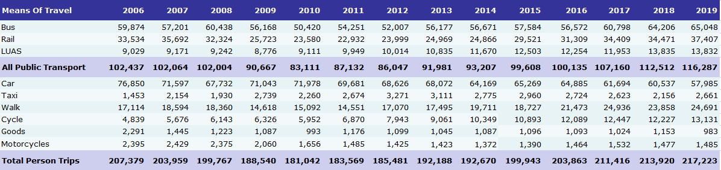

Table 2 – Numbers of people crossing the Canal Cordon by mode of travel 2006-2019

Figure 2– Numbers of people crossing the Canal Cordon by mode of travel 2006-2019

Percentage mode share of people crossing the canal cordon
Table 3 gives the percentage mode share for all modes of travel used by people crossing the canal cordon inbound between 07:00 and 10:00 for the years 2006 to 2019. The trend is graphed in Figure 3.
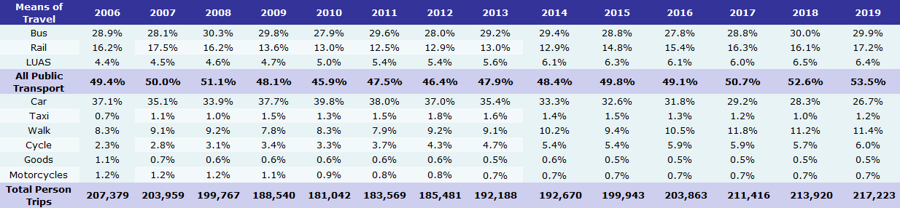

Table 3 – Mode share of people crossing the Canal Cordon by mode of travel 2006-2019

Figure 3 – Mode share of people crossing the Canal Cordon by mode of travel 2006-2019

Trips Crossing the Canal Cordon by Sustainable Modes
The tables below show the number and mode share of trips crossing the canal cordon in the AM peak period by sustainable modes during the period 2006 to 2019. Sustainable modes consist of public transport, active modes (walking and cycling) and taxi.
Table 4 – Numbers of people crossing the Canal Cordon by sustainable modes of travel 2006-2019

Table 5– Mode share of people crossing the Canal Cordon by sustainable modes 2006-2019

During the 2019 AM peak period (7am to 10am), 72% of all inbound trips crossing the canal cordon were made by a sustainable mode (walking, cycling public transport or taxi). The sustainable mode share has grown year on year since 2010. In the last 13 years the share for sustainable modes has grown by 11 percentage points.
In 2019 156,770 trips crossed the cordon by sustainable modes in the three hour AM peak period. This is the highest level of mode share and person trips by sustainable modes since the cordon count began. This represents 30,927 more person trips by sustainable mode than were made in 2006.

The graphs below show the trend in trips by sustainable modes for the 13 year period 2006 – 2019.
2019
2006

Figure 4 – Mode share of people crossing the Canal Cordon by sustainable modes 2006 & 2019

Figure 5 – Numbers of people crossing the Canal Cordon by sustainable modes of travel 2006-2019

Figure 6 – Mode share of people crossing the Canal Cordon by sustainable modes 2006-2019

Figure 7 – Relative increase/decrease in use of sustainable and other modes 2006-2019
INDEX: 2006 = 100

Commentary on Canal Cordon Trends

Overall Trends
As shown in Table 3 and Figure3, the total number of people crossing the canal cordon in the AM peak period (07:00-10:00) increased slightly by 1.5% between 2018 and 2019. This is an increase of 3,303 person trips, bringing the total number of people crossing the canal (inbound) in the AM peak period to 217,223. There is a continual annual increase in the number of people crossing the canal in the AM peak from 2010 and it is 4.7% higher than it was in 2006.

Public Transport Usage
Between 2018 and 2019, there was an increase of 3.4% in the number of public transport users crossing the cordon between 07:00 and 10:00. In 2019 116,287 people used public transport to get into the City Centre on census day.
There was little change between 2018 & 2019 in the use of LUAS with figures of 13,835 & 13,832 respectively. In 2019 rail trips increased by 2,936 and so too did bus patronage, showing an increase of 842 trips. Continuing a trend of growth since 2014, rail showed an increase of 8.5% relative to 2018, while bus saw an increase of 1.3% in the same period. Overall, since 2006, the number of public transport passengers has increased by 14%.

Mode Trends
A summary of the key changes in travel across the canal cordon set out above is described below:
In percentage terms mode share for bus travel across the canal cordon in 2019 is now 29.9%. This is a very slight decrease of 0.1% on 2018 figures. In absolute terms bus patronage increased in 2019 by person trips, and now carries just over 65,000 people into the City Centre in the AM peak period. This represents 56% of all public transport trips into the City Centre in the peak period.
The mode share for rail across the canal cordon in 2019 was 17.2%. This figure is just over 1% higher than last years’ but is approaching the highest peak rail mode share of 17.5% recorded in 2007. Intercity, Suburban Rail and DART had lost a significant share of travel into the City Centre between 2007 and 2014. However this trend reversed in 2015 and has continued to steadily increase year on year. Rail mode share has increased by almost 5% since its low point of 12.5% in 2011.
Car mode share (excluding taxis) declined in 2019, continuing the year on year decline since 2010. Overall since 2006, car usage has declined by approximately 25%. Car use declined by 4% between 2018 and 2019. On census day 2019 over 18,500 less cars entered the City during the AM peak period than on census day 2006.
Walking has increased by over 3% between 2018 and 2019. Walking levels were at their highest since the cordon count began in 2017 (11.8%) and while there was a small decline in 2018 (11.2%) it is showing an upward trend in 2019 with a walk mode share of 11.5%. There are now almost 38,000 “active trips” (walking and cycling) crossing the canal cordon during the AM peak period, more than is carried by the entire heavy rail network for the same period.
With the exception of a slight drop in 2018, cycling has presented a steadily increasing trend between 2006 and 2019. It is currently represented by a mode share of 6.1%, showing a slight increase (0.4%) from its 2018 figure. Whilst overall cycle numbers are up 171% on 2006 levels, the cycle mode share has more than doubled in the same period.
Over 2,600 people entered the City by taxi in 2019 - this represents a 23% increase on 2018 levels. This is a marked increase when compared to the observed decline of taxi use between 2012 and 2018. The peak taxi use occurred in 2012 when over 3,270 passengers crossed the canal in the AM peak period.
The number of motor bikes entering the City has reduced very slightly since 2018 (by 0.5%). There had been a slow and steady downward trend of motorcycle use between 2006 and 2013 with a relatively flattening from 2013 to the present day. Motor cycle mode share has remained static at 0.7% in 2019.
There has been a marked decline of 15% or 170 vehicles in the number of goods vehicles entering the City during the AM peak period between 2018 and 2019. Goods vehicle volumes in 2019 have decreased continuing a downward trend, with just over 980 vehicles crossing the canal cordon in the AM peak period, a decrease of 57% since 2006.
Since 2010, there has been a trend of increasing mode share for sustainable transport modes, with a consistent level of increase each year. In 2019 the overall mode share for sustainable transport modes – walking, cycling and public transport was 72% maintaining its highest levels since the canal cordon counts began in 2006. Goods vehicles and journeys by car and motorbike now account for only 28% of the trips crossing the canal cordon.

Surveyors board all Dublin Bus services at the cordon point and conduct a count of passengers. For non-Dublin Bus services (such as Bus Éireann and privately operated services) experienced surveyors estimate the volume of passengers on board as the bus crosses the cordon point.
When the Census was GDA only, passengers who began their trip outside of the GDA would still be counted once they completed their trip within the GDA. For example a passenger travelling from Cork to Dublin would be counted crossing the Cordon at point 16 i.e. departing Parkwest and Cherry Orchard station.
Previously Railway Procurement Agency (RPA)

