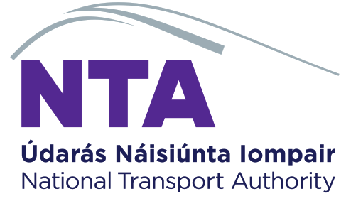

Statement of Compliance for Renewal of a Public Bus Passenger Service Licence

We/ I confirm that in respect of public bus passenger service licence number: __________________
- All of the conditions of the licence have been complied with,
- The public bus passenger service to be renewed is identical to that currently licenced,
- Before the COVID-19 restrictions were imposed, the service was operating as per the licensed timetable,
- All vehicles used to provide the public bus passenger service are insured to operate for hire or reward, and
- All vehicles used to provide the public bus passenger service are roadworthy.

Signed: . . . __________________________________________

Name in block capitals: . __________________________________________

Company Name in block capitals: __________________________________________
(where applicable)

Position in Company in block capitals: __________________________________________
(where applicable)

