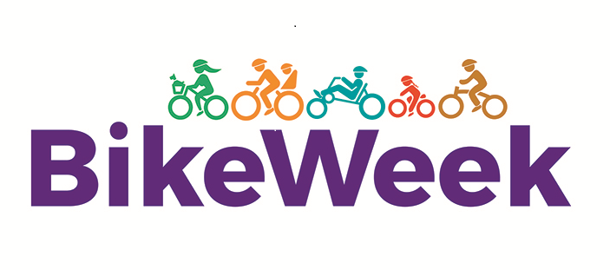
Bike Week Events 12th – 18th September

Local Authority/
Local Sports Partnership Name
Website link for further details*
Contact email for further details*
* these details will be published on bikeweek.ie so participants may contact you for further information on the events below.

Date | Event Name/Details | Time | Who are the target participants for this event? | Location(s)
Sunday
12/9
Monday
13/9
Tuesday
14/9
Wednesday 15/9
Thursday
16/9
Friday
17/9
Saturday
18/9

If you would like to include cycle routes or greenways in your area which will be published on the Bike Week website, please provide details below:

Route/Greenway Name | Length in Km | Terrain | Skill Level  (All, Beginner,  Intermediate,  Advanced) | Web link

