This is an example text that can be used to email all staff and students and to provide information on student and staff pages of your website –and anywhere else that might be relevant for your workplace or campus!

Subject line: Announcing the Ready, Set, Cycle campaign!
Email text:
Ready, Set, Cycle: March 6th – May 19th
We are delighted to announce that we are taking part in the Ready, Set, Cycle programme. This programme is aimed at getting you ready and set to cycle! There will also be the chance to win some great prizes along the way.
Whether you are interested in cycling for the first time, or want to get back on the bike, this programme will provide you with the tools to do just that.
Here is a look at the 10 week programme and what you can sign up for each week:
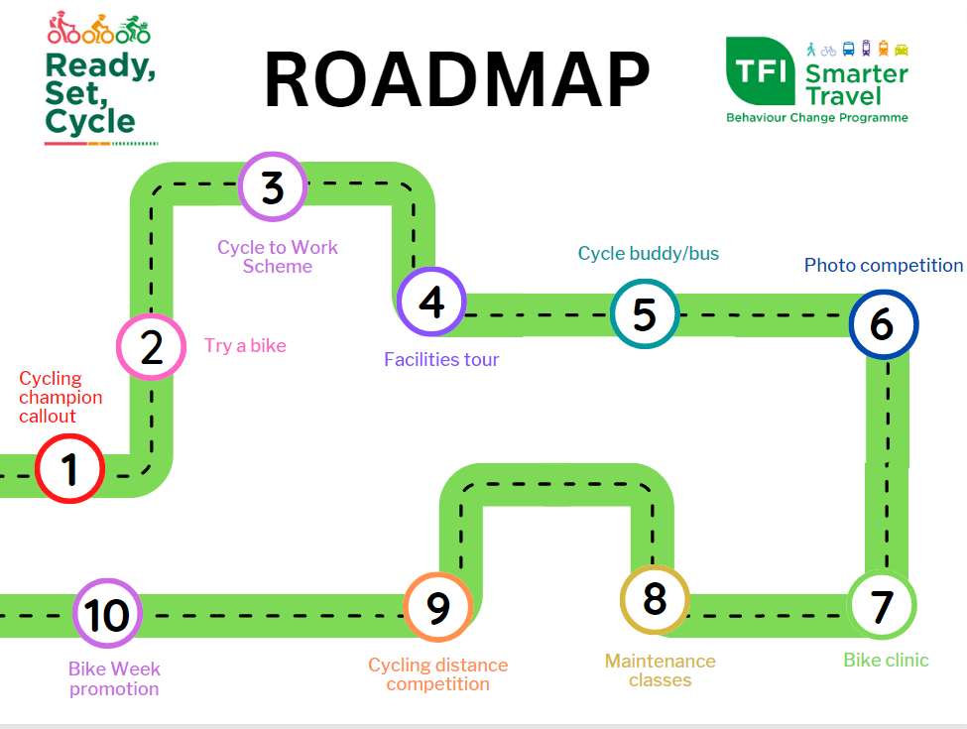

Cycling Champions: Are you an avid cyclist within (organisation name) and want to support participants along the way? Become a cycling champion and be in with the chance to win some great prizes! You can register your interest to become a cycling champion here:
https://eu.surveymonkey.com/r/RSC_Cycling_Champion
Keep an eye out for links to register for each week’s event and for more information on how you can get involved!

