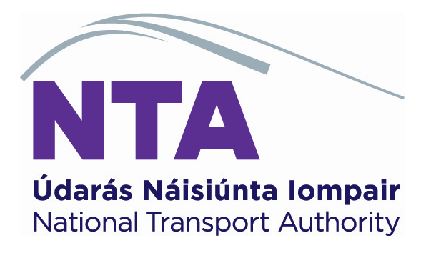

As per Title II (Transport of Passengers by Road) of the Trade And Cooperation Agreement between the European Union and the United Kingdom

AUTHORISATION APPLICATION – NEW/VARIATION/RENEWAL

Please ensure that the following information is included in your application prior to sending it to the NTA. Incomplete applications will be returned

Checklist:

- A completed application form, signed and dated
- The appropriate fee (see below)
- Copy of Valid Community Licence
- Valid Tax Clearance Verification Details
- Timetable
- Drivers rota
- Fare structure – Euro € and GBP £
- Copy of PSV Licence(s) for each vehicle(s) providing the service
- Copy of Certificate of Roadworthiness (CVRT) for each vehicle(s)
providing the service
- Copy of Insurance Certificate(s) for each vehicle(s) providing the
service
- *A complete map of the proposed route*
- *Maps clearly showing each individual stop*
Note:
All of the above items (1-12) are required for a new application or a renewal application.
Items marked with * are not required if your application is for a variation with no change in route and passenger pick-up/set-down locations.

FEES:
New Application for a new Authorisation | €
Authorisation Application Fee | 100
Issue Fees (due only if International Authorisation Granted) | €
On grant of an International Authorisation | 280
Application for and grant of variation to an existing International Authorisation | €
Application for and grant of variation to an existing International Authorisation | 50
Application to renew Existing Authorisation | €
Renewal Application Fee | 100
Renewal Issue Fees (due only if International Authorisation is Renewed) | €
On renewal of an International Authorisation | 280
Authorisation Certified True Copy | €
Each Authorisation Certified True Copy | 10

APPLICATION:

TO START A REGULAR SERVICE
TO START A SPECIAL REGULAR SERVICE
TO RENEW/VARY AUTHORISATION FOR A SERVICE
TO ALTER THE CONDITIONS OF AN AUTHORISED SERVICE³

carried out by coach and bus between the European Union and the European Atomic Energy Community, of the one part, and the United Kingdom of Great Britain and Northern Ireland, of the other part

To: National Transport Authority, Dún Scéine, Iveagh Court, Harcourt Lane, Dublin 2.

1. Name and first name or trade name and address, telephone, fax and/or email of the applicant and, where appropriate, of the managing carrier in the case of an association (pool):
.............................................................................................................................
.............................................................................................................................
.............................................................................................................................
.............................................................................................................................
.............................................................................................................................

2. Service(s) carried out¹
by an undertaking as a member of an association (pool) as a subcontractor

3. Names and addresses of the
carrier, associated carrier(s) or subcontractor(s)

3.1____________________________________________ Tel: ______________
3.2 ____________________________________________ Tel: ______________
3.3 ____________________________________________ Tel: ______________
3.4 ____________________________________________ Tel: ______________

(Second page of the application for authorisation or for renewal of authorisation)

4. In the case of a special regular service:

4.1. Category of passengers: ……………………………………………………………………………

5. Duration of authorisation requested or date on which the service ends:
………………………………………………………………………………………………………………………….

6. Principal route of service (underline passenger pick-up points):
………………………………………………………………………………………………………………………….
………………………………………………………………………………………………………………………….
………………………………………………………………………………………………………………………….
………………………………………………………………………………………………………………………….

7. Period of operation:
………………………………………………………………………………………………………………………….
………………………………………………………………………………………………………………………….

8. Frequency (daily, weekly, etc.): .............................................................................

9. Fares: …………………………………………………..…… Annex attached:

10. Enclose a driving schedule to permit verification of compliance with the Union legislation on driving and rest periods.

11. Number of authorisations or of copies of authorisations requested.
………………………………………………………………………………………………………………………….

12. Any additional information:
………………………………………………………………………………………………………………………….
………………………………………………………………………………………………………………………….
………………………………………………………………………………………………………………………….

13. .............................................................. ........................................................
(Place & date) (Signature of applicant)

(Third page of the application for authorisation or for renewal of authorisation)

Important Notice

1. The following is attached to the application, as appropriate:
(a) the timetable;
(b) fare scales;
(c) a certified true copy of the Community licence for the international carriage of passengers by road for hire or reward provided for in Title II (Transport of Passengers by Road) of the Trade And Cooperation Agreement between the European Union and the United Kingdom;
(d) information concerning the type and volume of the service that the applicant plans to provide in the case of a new service, or that has been provided in the case of renewal of an authorisation;
(e) a map on an appropriate scale on which are marked the route and the stopping points at which passengers are to be taken up or set down;
(f) a driving schedule to permit verification of compliance with the Union legislation on driving and rest periods.

2. Applicants shall provide any additional information in support of their application which they consider relevant or which is requested by the issuing authority.

3. In accordance with Title II (Transport of Passengers by Road) of the Trade And Cooperation Agreement between the European Union and the United Kingdom the following services are subject to authorisation:
- Regular services, services which provide for the carriage of passengers at specified intervals along specified routes, passengers being picked up and set down at predetermined stopping points. Regular services shall be open to all, subject, where appropriate, to compulsory reservation. The regular nature of the service shall not be affected by any adjustment to the service operating conditions.
- Special regular services not covered by a contract between the organiser and the carrier. Services, by whomsoever organised, which provide for the carriage of specified categories of passengers to the exclusion of other passengers shall be deemed to be regular services. Such services are called ‘special regular services’ and include:
- the carriage of workers between home and work;
- the carriage of school pupils and students to and from the educational institution.

The fact that a special service may be varied according to the needs of users shall not affect its classification as a special regular service.

4. The application shall be made to the competent authority of the Member State from which the service departs, namely one of the service termini.

5. The maximum period of validity of the authorisation is five years.

Tick or complete as appropriate.
Special regular services not covered by a contract between the organiser and the carrier.
In the context of Title II (Transport of Passengers by Road) of the Trade And Cooperation Agreement between the European Union and the United Kingdom.
Indicate in each case whether a member of an association or a subcontractor is concerned.
Attach list if applicable.
The attention of the applicant is drawn to the fact that, since the authorisation has to be kept on board the vehicle, the number of authorisations which the applicant must have should correspond to the number of vehicles needed for carrying out the service requested at the same time.

