A Programmatic Approach for the Delivery of Public Transport Policy in Ireland.
Juan Martinez-Covarrubias^{a, c*}, Yeonjung Song ^{b, d}, Mark Connolly^{d}, Catherine Murray^{d}
ª National Transport Authority, Ireland
^{b} Department of Transport, Ireland
^{c} American University, Washington DC, United of States
^{d} Kobe University, Kobe, Japan
^{e} AECOM, Ireland

lncs@springer.com
Abstract. Moving from plan to action seems a trivial affair. However, when vast resources are mobilised to deliver the transformation to sustainable mobility this is not so trivial. The Government of the Republic of Ireland is currently investing around €165 billion for infrastructure development over the next 10 years, with more than 20 percent allocated to the transport sector. Key policies provide the ambition and direction for such mobilisation: the National Sustainable Mobility policy (NSMP) and the National Investment Framework for Transport in Ireland (NIFTI). In addition the Infrastructure Guidelines (IG) provides the rules of approvals in the public sector to ensure value for money. From all this, a number of programmes and projects to deliver such policies emerged, such as BusConnects, Metrolink, DART+, and Active Travel programme to name a few. This paper delves into the literature of project management and institutional economics, and presents the case study of the National Transport Authority in Ireland to assess determinants affecting the degree of effectiveness in its delivery. Using an adapted PESTEL analysis, we conducted interviews to selected experts to determine the likelihood of such determinants. Lessons learned offer insights to policy makers and managers of public transport programmes elsewhere.
Keywords: Transport Policy, Programmatic Approach, Transformation, Sustainable Mobility, Institutional Economics.
- Introduction
At the end of 2015, Ireland signed the Paris Agreement signaling its commitment towards the climate agenda. Subsequently, a recalibration of its policies took place. In 2021 the Government of Ireland launched its revised National Development Plan becoming its greenest and most ambitious plan to date. The investment amounts €165 billion for infrastructure development over the next 10 years, with more than 20 percent allocated to the transport sector. This investment - at 5 percent of its national income- is well above the recent EU average of 3 percent. With these resources it is important to delve into the determinants of the speed of transformation to sustainable mobility.
This paper explores the likelihood of determinants affecting the transformation to sustainable mobility with emphasis on institutions and a programmatic approach to investment. An adapted Political, Economic, Social, Technological, Environmental, and Legal (PESTEL) analysis is used to systematically gather expert opinions with a survey.
Section two delves into the literatures of project management and institutional economics. Section three presents the case of the Irish transport policy and its institutional setting. Section four reports the results of the survey and discusses policy implications. Conclusions are presented in the end.
- Literature Review
  - Project Management
There is a rich literature in project management. However, exploration in detail of the technical aspects of managing public capital projects and programmes in Ireland has been more limited. While broad overviews of capital expenditure and potential outcomes are important, evaluation of the effectiveness of governance and technical management capability are critical to ensuring value for money on the public purse.
There is also growing interest on appraisal and investment management guidance for Irish public capital projects to address environmental impacts and increase the delivery rate of public investments. The Infrastructure Guidelines (IG), formerly known as Public Spending Code (PSC) introduced in 2013, as a decision making system based on project management principles, provides a set of rules and procedures to ensure that the right solution is chosen. A 2023 OECD report [1] examining Irish appraisal guidance in the updated version of the PSC in 2019 noted the opportunity to strengthen project appraisal guidance and improve the rate of delivery of public capital investments, through the use of investment programmes. In addition, Connolly and Newman [2] examined the potential additional appraisal and management guidance that would need to be put in place to ensure effective use of public finances under a programmatic approach. One of the recommendations is including the provision of a basic definition of a programme and proportionate levels of appraisal. However, a number of challenges regarding the use of programmes was also noted, including the potential approval process across a development lifecycle with multiple challenge and approval points.

  - New Institutional Economics
The New Institutional Economics helps to understand how the “rules of the game” affect the transformation required to sustainable mobility. Following Peterson St Laurent et al. [3] a spectrum can be considered to depict the Public Transport (PT) resistance-resilience transformation spectrum from active resistance to accelerated transformation. Many barriers slowdown this transformation. The New Institutional Economic school of thought is useful to articulate these challenges, see Figure 1.
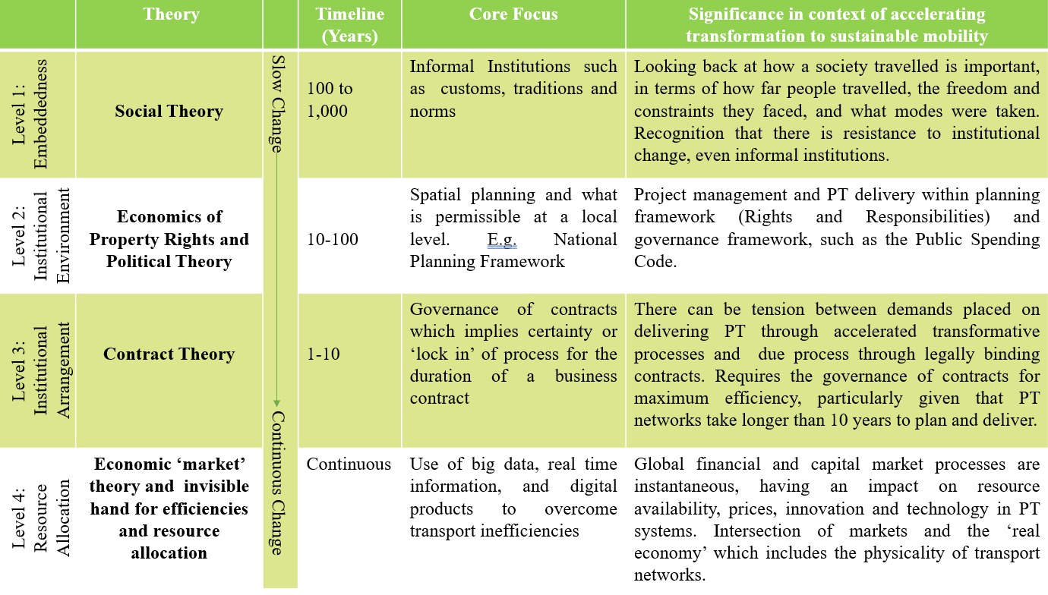
Fig. 1. Differing timeframes in Economics of Institutions. Source: Adapted from Williamson [4]
Williamson identifies four levels, where change happens at different paces. Level 1 is the slowest, termed ‘embeddedness’ where traditional practices, cultural norms, language and behaviour is shaped by a set of unique historic factors. The second level, the ‘institutional environment’ relates to the set of formal rules and legislation in operation at any particular time. The third level relates to the institutional arrangement or the shorter-term contracts that firms and entities enter. The fourth level is the fastest paced level of resource allocation, or what happens within ‘the market’. Adam Smith’s invisible hand and Schumpeter’s creative destruction processes are increasingly relevant for the provisioning of PT. The pace of technological change and digitalisation is transforming so many aspects of how the economy and society operates. PT providers are technology takers at this level, and need to keep apace of innovation that impact services.
There are processes operating at all of the four levels with differing durations. Programmes offer the opportunity to overcome the tyranny of time, and the shorter timescales associated with contract theory. Programmes offer longevity, but not the instantaneous of transactions in markets, which is where accelerated transformation could conceivably happen.
- The case of the Irish Transport policy delivery
  - The National Transport Authority Capital Programme
The National Transport Authority (NTA) in Ireland is the public body responsible for developing and implementing public transport strategies around the country. With an annual budget of nearly €1 billion, some of the NTA flagship programmes are BusConnects which is an overhaul of the Public Bus Systems in the major cities; the expansion of the electric rail system known as Dublin Area Rapid Transit (DART+); Metrolink, which is the first metro line in the country; the Active Travel Programme with an ambitious plan to build walking and cycling infrastructure throughout the country, and Connecting Ireland Programme focusing on rural areas.

  - The national policy and institutional framework
Whereas the National Sustainable Mobility Policy (NSMP) and the National Investment Framework for Transport in Ireland (NIFTI) are the key policies that provide the ambition for the transformation to sustainable mobility, the IG facilitates the appraisal, monitoring, management and delivery of public investment to ensure effectiveness and value for money. The IG has seen improvements from lessons learned in major projects, such as the PWC report [5] on the National Children’s Hospital which highlighted deficiencies in the 2013 edition of the PSC including upfront appraisal of costs and the challenge function within the approval process. Nowadays, it takes about one year for a typical project to go throughout the IG process to reach final approval. This is coming down from 1.5 years duration that the IG process used to take prior to recent reforms. Despite these improvements, some limitations remain. For instance, the lack of guidance on programmatic approach to optimize processing times.
Another Important element to bear in mind is the structure of the planning system in the country. Although the national government has control over National Plans and Strategies, such as the National Planning Framework and Metropolitan Area Transport Strategies, it has little control over the efficiency of instances where plans can be overthrown. For instance, An Bord Pleanála as the independent, statutory, quasi-judicial body that decides on appeals from planning decisions made by local authorities have been embroiled in recent scandals undermining its credibility. This creates delays in their resolutions with knock on effects to the delivery of infrastructure, including public transport. In addition, there is a surge of judicial reviews against An Bord Pleanála’s resolutions adding extra time in the overall approval process [6]. These deficiencies in the planning system are compounded to the increasing occurrence of NIMBYism (Not-In-My-Back-Yard), which is the behaviour of someone who does not want something to be built or done near where they live.
All this institutional setting operates under the context of two major crises. First a housing crisis where the commuting patterns are distorted and with ramifications on transport demand, congestions, and implications on the design of public transport infrastructure, and network transport effects. And second, a construction sector decimated in the aftermath of the 2008 economic crisis unable to meet the infrastructure demand.
Finally, it is important to consider the private sector participation in the public transport provision. There is a variety of Public Transport operators either State-owned, State-Tendered, or Privately-owned. It is the State-owned Transport Operators who dominate in the area of mass transportation.
- Results and Policy implications.
An adapted PESTEL analysis enabled a survey to gather the opinion of experts on the likelihood of determinants affecting the transformation to sustainable mobility in Ireland. PESTEL factors were identified and categorized in terms of the aspects of change in Economics of institutions. Given the narrow scope of this research, a dozen of experts were targeted given their first-hand knowledge on the topic. The collection of responses was anonymized to increase the response rate and to give freedom of opinion. The results are shown in Table 1.
Table 1. Determinants’ likelihood affecting transformation to sustainable mobility.
Aspect for change | Factor | Very Unlikely | Unlikely | Neither likely nor unlikely | Likely | Very likely | No Answer
Level 1: Embeddedness | NIMBYism (Social) |  |  |  | 30% | 70%
 | Housing Crisis (Social) |  |  |  | 30% | 70%
Level 2: Institutional Environment | Anti-climate political party (Political) | 30% | 20% | 10% | 40%
 | Long PSC approval times (Technological) |  | 10% | 20% | 30% | 30% | 10%
 | Planning system (Legal) |  | 10% | 10% | 20% | 60%
Level 3: Institutional arrangement | Budget reduction (Political) | 10% | 30% |  | 40% | 10% | 10%
 | More PPPs (Economic) |  | 20% | 50% |  | 10% | 20%
 | Construction sector low capacity (Economic) | 10% |  |  | 40% | 40% | 10%
Level 4: Resource Allocation | Greater Private sector participation (Economic) | 30% | 10% | 20% | 10% | 20% | 10%
 | Public Transport Operators stay technology takers and not innovators (Technological) | 60% | 10% | 20% |  |  | 10%
 | Current rate of progress - Not meeting Climate Targets (Environmental) |  |  |  | 10% | 90%

The collective judgement identifies NIMBYism and the current Housing Crisis as significant threats to the transformation to sustainable mobility. Other two determinants worth to observe are the planning system and the technological capabilities of the PT operators. In the view of most respondents An Bord Pleanála’s underperformance and the increase of judicial reviews pose a significant risk to the transformation to sustainable mobility. The implication of PT operators being technology takers without innovative capacity is that it undermines the ambition of Ireland to become a global leader in public transport provision and sustainable mobility. For the rest of determinants under investigation the results are inconclusive as no consensus was detected.
In terms of the programmatic approach, the majority of respondents (60%) stated that a programme level would facilitate a swiftly IG approval process rather than at a project level. However, there are nuances to this consideration. The 'right' level needs to be considered for the various projects in question and a decision made as to where their value is in aggregating them into a programme. As a respondent stated: “Some projects may be able to proceed perfectly well at a project level. However, focusing on project level misses the big picture (transport strategies need to be combinations of numerous projects and incentives. Some of these may not have a good BCR [Benefit Cost Ratio] at a project level, however it is the programme/ strategy level that is important). If individual projects are rejected for poor economic performance then this puts the entire strategy at risk.” Another respondent was more audacious and hinted to the need of a transport programme for climate change in order to achieve transformation at national level rather than with incremental projects. The collective opinion is that at the current rate of progress, it is unlikely that climate targets will be met. Therefore, more and better needs to be done.
- Conclusions
This paper contributes to the literature of transport economics by using a PESTEL analysis adapted to the differing timeframes in the economics of institutions to assess the likelihood of determinants affecting the speed of transformation to sustainable mobility.
The results point to a high degree of experts’ agreement on the likelihood of clear threats to the transformation to sustainable mobility in Ireland: NIMBYism, Housing Crisis, the planning legal system underperformance, and the poor technological capabilities of PT operators. There recently published Infrastructure Guidelines seem an improvement of the programmatic approach in the right direction. Overall, the literature on the technical management and appraisal aspects of Irish public capital investments and projects remains limited. Noting this, there are widespread opportunities to explore potential improvements.
Future research avenues emerge. Without diminishing the validity of the results presented in this paper, there is an opportunity to apply the survey to a wider range of stakeholders, such as politicians, private sector, PT operators, and civil society. There is also the possibility to delve into cultural norms and how long these take to change. Cultural norms around driving, speed limits, driving in rural areas, cycling, status of car ownership, perceptions of use of public transport. There are a lot of cultural norms that need to be unpicked for the transformational change.

References
- OECD Strengthening Environmental Considerations in Public Investment in Ireland: Assessment and recommendations. https://www.oecd-ilibrary.org/docserver/83b97aca-en.pdf?expires=1695834081&id=id&accname=guest&checksum=05D101D7E695456D559870538060126C last accessed 2023/10/06.
- Connolly, M. and Newman, F. The Public Spending Code: Planning, Appraising and Managing Capital Investment Programmes – Irish Government Economic and Evaluation Service (IGEES) 2022 https://assets.gov.ie/242770/19cd0477-6efd-478f-b678-ba6dd133cbdf.pdf last accessed 2023/10/06.
- Peterson St-Laurent, G., Oakes, L. E., Cross, M., & Hagerman, S. (2021). R–R–T (resistance–resilience–transformation) typology reveals differential conservation approaches across ecosystems and time. Communications biology, 4(1), 39.
- Williamson, O. E. (1998). The institutions of governance. The American economic review, 88(2), 75-79.
- New Children’s Hospital Independent Review of Escalation in Costs – PWC, 2019 https://merrionstreet.ie/merrionstreet/en/news-room/releases/20190409_nch_report.pdf last accessed 2023/10/06.
- Irish Times https://www.irishtimes.com/opinion/editorials/2023/07/07/the-irish-times-view-on-reform-of-an-bord-pleanala-a-vital-task/ last accessed 2023/10/06.

* Corresponding author. Tel.: +353 (01) 881 5680 E-mail address: juan.martinez@nationaltransport.ie
At the time of the survey application in October 2023, the Public Spending Code was the current referent. The Infrastructure Guidelines were published in December 2023.

