LAUNCH EMAIL

This is an example text that can be used to email all staff and students and to provide information on student and staff pages of your website –and anywhere else that might be relevant for your workplace or campus!
Subject line: Announcing the Ready, Set, Cycle campaign!
Email text:
Ready, Set, Cycle: April 8th to May 17th
We are delighted to announce that we are taking part in the Ready, Set, Cycle programme. This programme is aimed at getting you ready and set to cycle! There will also be the chance to win some great prizes along the way.
Whether you are interested in cycling for the first time, or want to get back on the bike, this programme will provide you with the tools to do just that.
Here is a look at the 6 week programme and what you can sign up for each week:
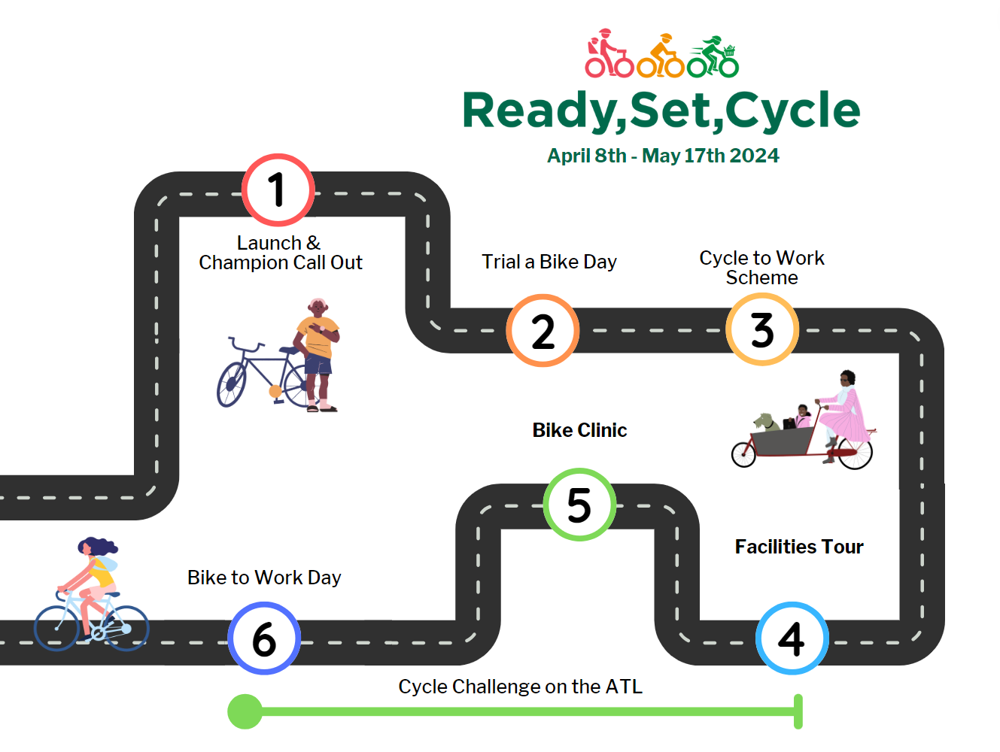

Cycling Champions: Are you an avid cyclist within (organisation name) and want to support participants along the way? Become a cycling champion and be in with the chance to win some great prizes!
Ready Set Cycle Quiz: To kick off the programme, we invite participants to take our Ready, Set, Cycle quiz which is a fun way to learn more about cycling, the programme, and win some prizes. The quiz will close on Friday April 12th
(Shane will send you the link prior to launch date)
Kind regards,
[Name]

