The Walking and Cycling Index Report, a look at the dashboard feature
Sarah McDonagh¹[0000-1111-2222-3333]
¹ National Transport Authority
Abstract. The NTA, in partnership with UK charity Sustrans has published two iterations of the Walking and Cycling Index (WACI) (previously titled ‘Bike Life’) to date, with a third iteration due to be published in early 2024. The WACI is a comprehensive report which assesses and promotes walking, wheeling and cycling across Ireland. The first two iterations of the report were based on data from the Dublin Metropolitan Area, however the 2024 publication will include data from four other Irish Metropolitan areas for the first time; Galway, Cork, Limerick and Waterford.
While the report itself is a useful tool to highlight the growth in walking, wheeling and cycling across Ireland, there is a huge amount of data collected which can be further utilised to direct active travel investments and improvements into the areas they are most needed.
In 2023 Sustrans released all data collected for the WACI report in an online dashboard tool. The dashboard is available as two separate tools, which presents the data under two titles ‘what people think’ and ‘what people do’. The data collected for the Irish WACI report can be viewed online on the dashboards, and can be disaggregated by location, year, gender, ethnicity, sexual orientation, age, socio-economic group and disability. This paper will take a closer look at these dashboards and delve into the data that may not have been previously presented within the WACI report for Ireland.

Keywords: Transport, Data, Dashboard.
- Introduction
The importance of developing active transport, such as walking, wheeling and cycling, has gained significant attention worldwide due to its potential to enhance public health, reduce carbon emissions, and create more liveable communities. In Ireland, similar concerns about congestion, environmental degradation, and sedentary lifestyles have driven investment to prioritize active travel. However, what is sometimes lacking, is the evidence basis with regard to public behaviour and opinion when considering where public funding should best be invested to improve active travel infrastructure and increase its uptake.
While the Walking and Cycling Index report is available in the Dublin Metropolitan Area (DMA), which presents a wide number of statistics and data regarding walking, wheeling and cycling in the DMA, the WACI collects such a vast amount of data that it was never possible to include it all within the main report. Therefore, in 2023 Sustrans released all data collected for the WACI report in an online dashboard tool. The dashboard is available as two separate tools, which presents the data under two titles ‘what people think’ and ‘what people do’. The data collected for the Irish WACI report can be viewed online on the dashboards, and can be disaggregated by location, year, gender, ethnicity, sexual orientation, age, socio-economic group and disability.
The data available via the dashboards can now be used for evidence based decision making regarding active travel development in Ireland. This paper will look at the different data statistics available on the dashboards and the data will be presented below to give an in-depth picture of what people in Ireland think of Walking, Cycling, the related infrastructure and their local areas.
This data can be utilised in policy making and to guide the allocation for resources for targeted improvements within active travel. This paper demonstrates the use of the Sustrans WACI dashboards in an Irish context, and the different datasets available.

- Methodology
This methodology will refer to the process used for the data collection for the 2021 iteration of the WACI. The data contained in the reports comes from datasets which were collected by the National Transport Authority, Sustrans, and the Local Authorities in Ireland, along with a Behaviour and Attitude Survey which is commissioned by Sustrans and funded by the NTA.
The majority of the data used in the 2021 report was collated in 2021 and most of the data applies to 2021. Where up-to-date data was not available, older datasets were used where applicable.
Once the data has been collected it is analysed by Sustrans, who the produce the reports and the dashboards. There is an in-depth methodology [1] document available on the National Transport Authority website.
The following sections will discuss the resulting data dashboards which have been prepared by Sustrans and are available openly on their website.

- Data Review
  - ‘What People Think’
The WACI dashboard ‘what people think’ analyses a number of questions which were asked during the face-to-face Behaviour and Attitude survey. These questions and their answers will be presented below to give an in-depth picture of what people in Ireland think of Walking, Cycling, related infrastructure and their local areas. The following paragraphs will present a sample of the data available via the dashboards.
In Figure 1 we present data from the dashboards which looks at the support that residents have for more segregated cycling facilities, more low-traffic neighbourhoods, and 20 minute neighbourhoods. In this analysis socio-economic groups have been compared to see how the answers differ between socio-economic groups. Socio-economic group is a classification based on occupation maintained by the Association of Irish Market Research Organisations. Groups A and B are professional and managerial. Group C1 is supervisory/clerical and students. Group C2 is skilled manual. Groups D and E are semi-skilled and unskilled manual occupations, homemakers and people not in employment.
It is interesting to note that in all socio-economic groups the support for 20-minute neighbourhoods is all roughly similar across the different groups. However there is a noted difference in the support for more segregated cycling facilities, with the AB social class showing 10% more support than the DE class. Note: C1 and C2 graph not shown due to space constraints.

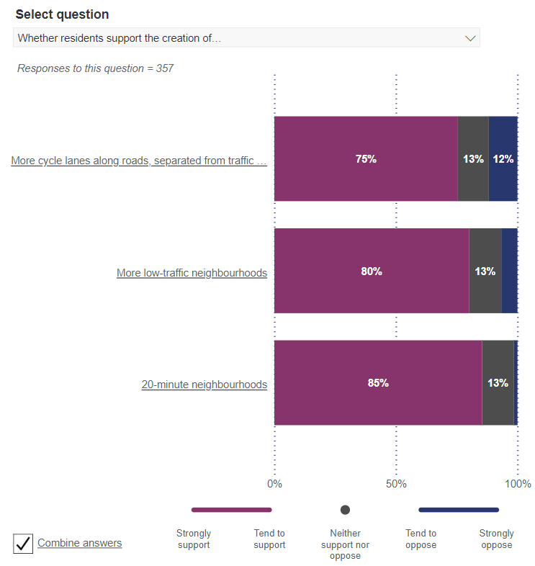  AB | 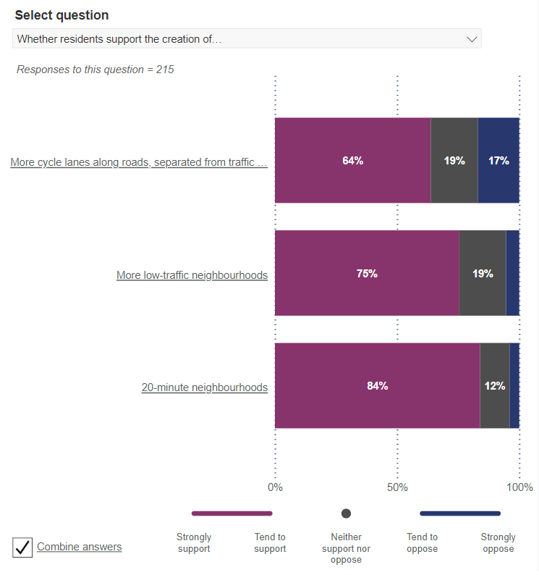  DE
Fig. 1. Whether residents support the creation of....
In Figure 2 the data looks at ‘how much it would help residents to cycle more if there were..’ For this question we have compared ethnicities to examine any differences. Overall, those who stated that they were from minority ethnic groups were more likely to consider each improvement listed below as more useful than those who said they were white. Among the biggest differences were “ better links with public transport e.g. cycle parking at stations” 70% vs 55%, “more cycle training and organized social rides” 65% vs 57% , “access to a bicycle” 66% vs 51% and “access to a cargo bike to carry children or shopping” 43% vs 27%.
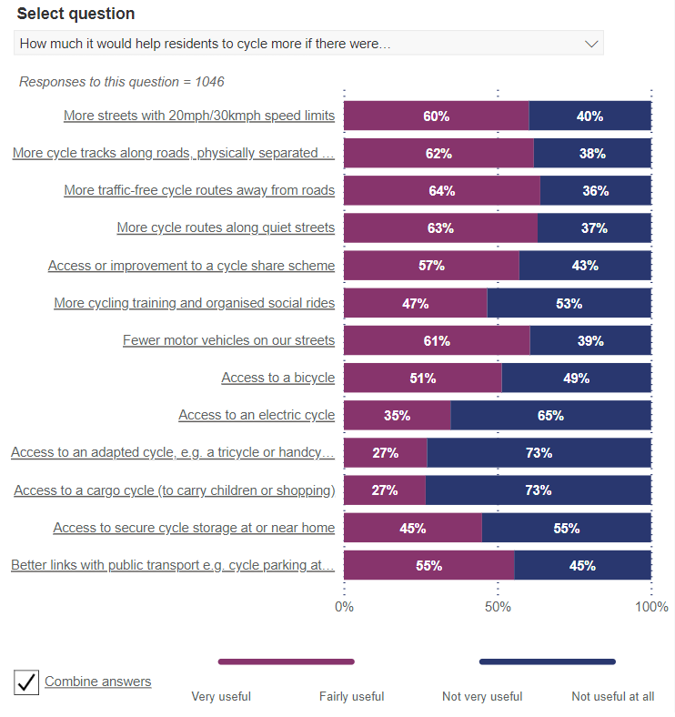  White people | 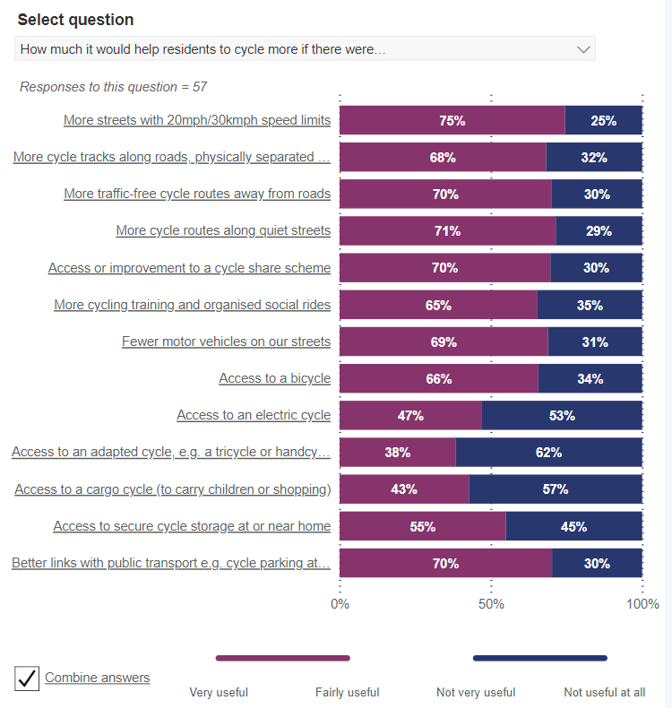  Minority ethnic groups
Figure 2: How much it would help residents to cycle more if there were..
In Figure 3 we consider the question ‘whether residents think their local area is good or bad…’ and we considered the responses from women compared to men. Men had a more positive opinion of how good their local area is for cycling, and how safe they thought their local area was for cycling, with 71% of men thinking their local area is good for cycling safety vs 59% of women. Interestingly, there wasn’t a large difference between how good or bad men and women thought their local area was for walking. Overall we can see that women do not think that their local area is as good of a place to cycle as men do. This may indicate that more funding or resources should be allocated to identifying the issues women face when cycling and rectifying these via training or infrastructure.
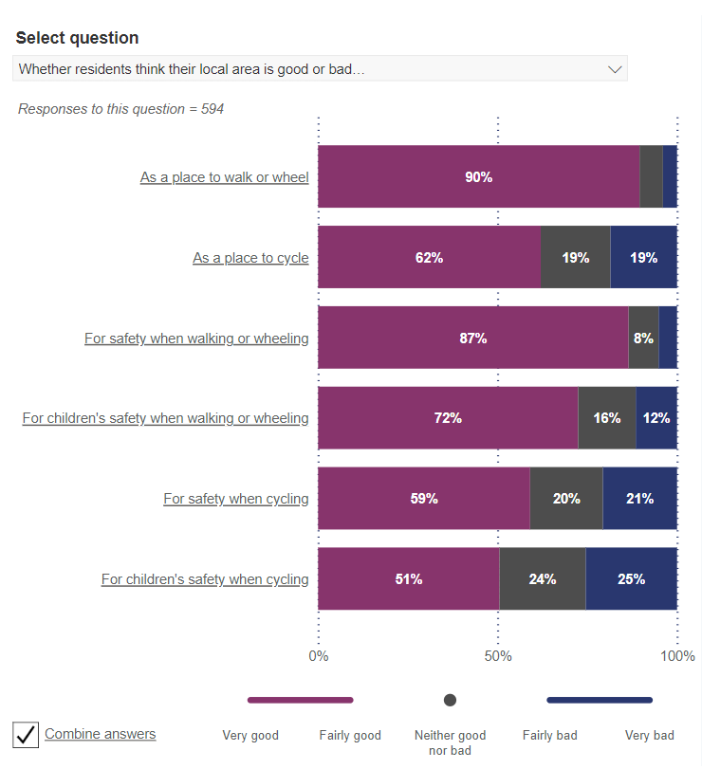  Female | 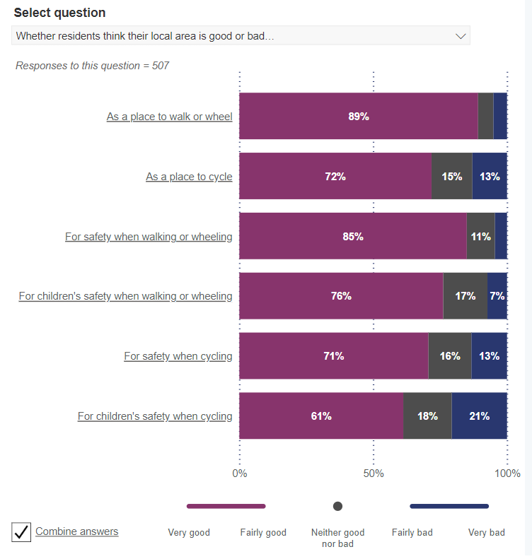  Male
Figure 3: Whether residents think their local area is good or bad..

‘What People Do’
In this section we will look at the dashboards that consider people’s behaviour. In the ‘what people do’ dashboard, there are a number of questions which can be analysed to consider residents behaviour around cycling, walking and wheeling.
Figure 4 looks at how often residents use different transport modes and compares the data from residents under the age of 25 versus those over the age of 25. Those within the 16-25 age bracket are much more likely to use active modes of travel like walking, running or cycling, along with public transport to get around. Those over the age of 25 are more likely to drive 5+ days a week, which may indicate where behaviour change interventions need to be targeted in order to reduce the tendency to drive over active travel use.
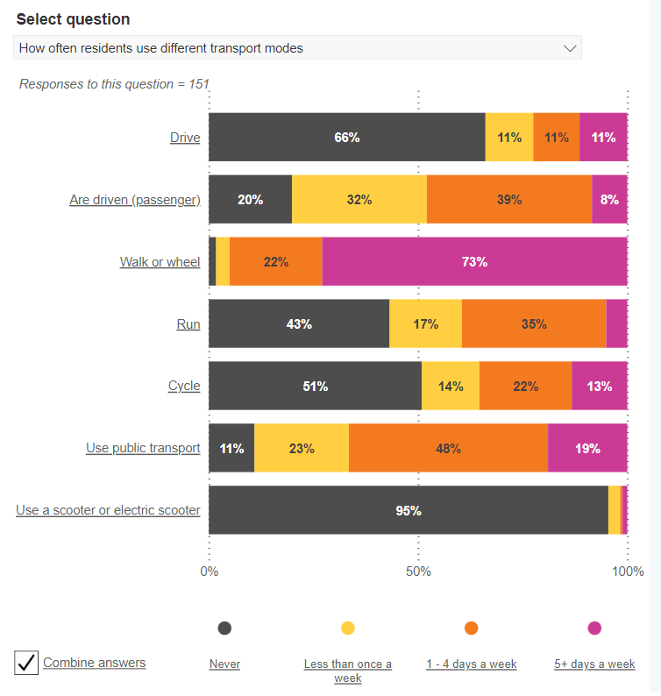  Under 25 | 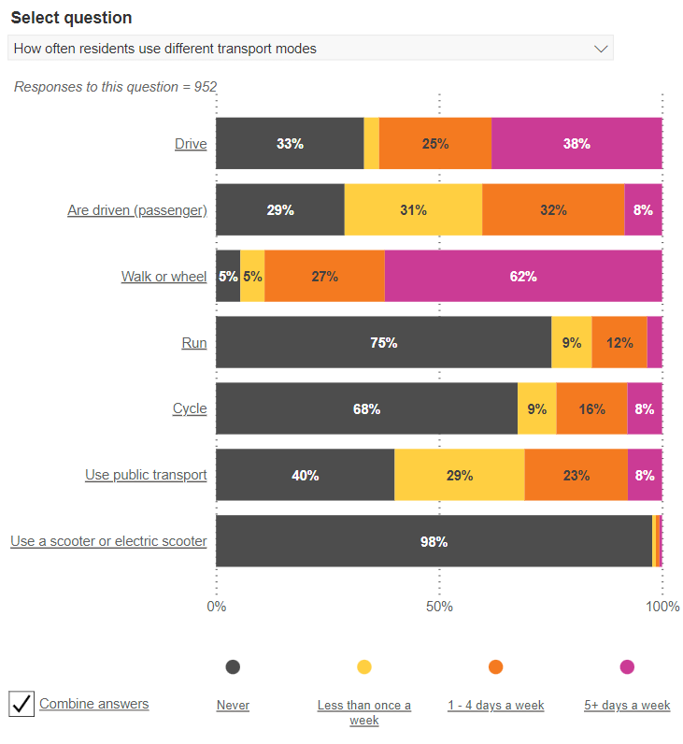  Over 25
Figure 4: How often residents use different transport modes
Dashboard Comparison
The dashboards also allow comparisons to be made between regions, for example between the Dublin Metropolitan Area, Belfast and 16 other UK Cities. In Figure 7 below we consider the question ‘how often adult residents cycle to or from work’ and can compare the three aforementioned areas. The Dublin Metropolitan Area has the lowest number of people who never cycle to or from work, and also has the highest number of people who cycle to or from wok at least 5 days a week. It is useful to be able to compare the different cities and regions using the dashboards, as this comparison is not available in the reports. From the 2024 iteration of the WACI onwards, it will be possible to compare data between five Irish cities that are reported upon within the WACI; Dublin Metropolitan Area, Cork Metropolitan Area, Limerick Metropolitan Area, Waterford Metropolitan Area and Galway Metropolitan Area.

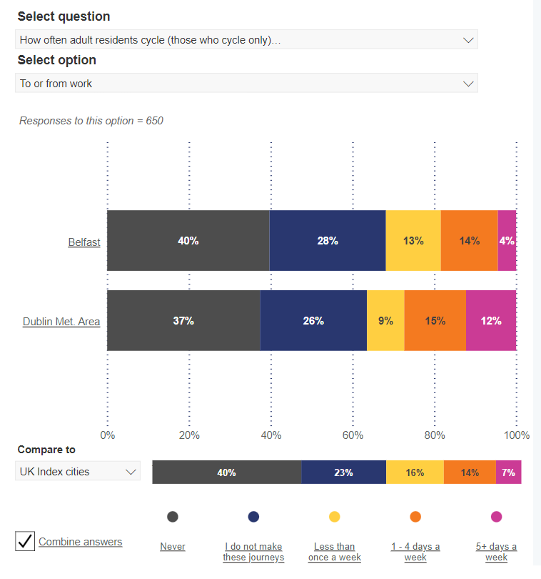
Figure 5: Dashboard country comparison

Conclusion
The dashboards are a very useful tool to delve further into the data. The functionality of the publicly available tool which allows data to be filtered by a number of different demographic features allows public authorities and advocate groups to further consider the data sets in ways that are not possible in the reports. The detailed insight into the data that is available at the filtered level may allow for more focused investment plans into active travel infrastructure in the future.

References
- Walking and Cycling Index 2021 Methodology https://www.nationaltransport.ie/wp-content/uploads/2022/05/SUSR2043-Walking-and-Cycling-Index-2021-Data-sources-and-methodologies-v3.0.pdf

