Land Use Planning for a Better Bus:
Ireland’s Approach to Orientating Development
Towards Public Transport
Michelle Poyourow¹[0000-1111-2222-3333] and Eoin Farrell²[1111-2222-3333-4444]
¹ Jarrett Walker + Associates, 104 Baggot Street Lower, Dublin, Ireland
² National Transport Authority, Dublin, Ireland
michelle@jarrettwalker.com
Abstract. Planning for “transit oriented development” has long been discussed, mostly in relation to rail and metro lines. However, modern Ireland has developed around its road network, and public transport on roads primarily means buses.
Ireland’s national government is making major investments in bus operations, infrastructure, fleet and technology. For these investments to have maximum impact, the way that Ireland uses land and develops new urban areas must change.
To that end, the National Transport Authority of Ireland and Jarrett Walker + Associates have co-authored an illustrated guidance document for planners and developers, showing how land use decisions affect the ultimate cost, usefulness and patronage of bus services.
This guidance document is contributing to greater coordination among national plans, national investments, local authorities’ development decisions and private development. It provides advice that is relevant in any country and that is urgently needed to address the climate crisis.
Keywords: Land Use; Spatial Planning; Development Planning; Transit Oriented Development; Bus; Public Transport.
- Introduction
Since 2018 the national government of Ireland has been increasing its investment in bus services across the country. The purpose of this investment is to accommodate population growth and maintain quality of life for residents whilst reducing energy consumption by transport.
However, public transport’s future success will depend not only on the level of public transport investment, but also on the built environment. An amenable built environment multiplies public transport’s usefulness and value, while a hostile one can reduce it to near zero.
All decisions about how to lay out a new urban area or design a road are decisions about public transport. In fact, they are collectively as powerful as any routing or service decisions made by a public transport operator.
Land use planning has long been incorporated into planning for railway services. A railway station is widely-understood to be an investment whose return depends on the surrounding land uses and built environment. For this reason, railway planning is accompanied by an intense focus on development in the areas around stations. During the planning phase, these station-area plans contribute to the expected benefits of the line and help to justify its construction.
Given the scale of investment being made in Ireland's bus services, a similar focus on land use and the built environment is needed around bus services just as it has been provided around railway stations. However there is very little guidance available in English explaining to land use and urban planners how growth should be planned for successful bus services.[1]
To that end, the National Transport Authority of Ireland and Jarrett Walker + Associates have co-authored an illustrated guidance document for planners and developers. The document shows how land use decisions affect the ultimate cost, usefulness and patronage of bus services.
- What is Useful Public Transport?
From any location, within a given amount of time, there is a certain area someone can reach by public transport. The sum of the destinations in this area – the schools, jobs, shops, and so on – define someone’s access to opportunity, if they rely on public transport and their time is limited.
Although many factors affect people’s decisions about whether to use public transport, travel time remains crucial. Most people have jobs or attend school, which means they have limited time in their day and they need to use their time efficiently. If a trip can’t be made on public transport in an amount of time that feels reasonable to them, they are likely to use a car.
Access to opportunity – also called accessibility – is a good way to measure this benefit of public transport. Patronage has many causes and tends to go up and down for reasons completely external to public transport such as economic conditions, pandemics or the cost of parking a car. However, when we increase access, we increase the likelihood that any person, looking to make a trip, will find the public transport journey time reasonable. This is why higher access is correlated with higher patronage and higher public transport mode share.[2][3]
Public transport is useful if people can reach destinations they value in a reasonable amount of time. The core “product” of public transport is the movement of people to places they want to go, at the time when they want to go, reasonably fast. Access describes that “product.” Access is the best objective measure of what makes public transport useful to most people.
What type of public transport service supports high access?
  - Frequent
High frequency service improves access by reducing waiting time and thereby shortening overall journeys. High frequency is correlated with high patronage, at the level of the network, the route and the bus stop.[2][4][5][6][7][8]
High frequency on a line is a product of three factors: how many vehicles are assigned to the line, the length of the line, and the speed of the vehicles.
Frequency is often under-emphasised because it is invisible. You can't take a photo of the fact that the next bus is coming soon. However, frequency is what makes a theoretical line into something someone can use whenever they want, just as a motorist can use a road whenever they want to.
  - Connected
A well-connected network means that each line not only serves the people, places, and opportunities along it, but also the people, places, and opportunities near other lines in the network.
Connectivity between public transport lines can be achieved in two ways:
- By the coordinated timing of vehicle arrivals and departures, to ensure short interchanges. However this can only be done in one or two places per line, and is vulnerable to even minor disruptions.
- By the provision of high frequencies, which make interchanges fast and reliable at any time.
  - Fast and Reliable
Speed affects how far someone can travel, and therefore how many opportunities they can access, once they've boarded a public transport vehicle. Services that are very slow limit people's access to destinations and compete poorly against cars.
Reliability describes how consistently a service operates at its scheduled speed, and therefore how consistently it provides access to opportunities.
Speed and reliability can be degraded by numerous events and factors, including how many passengers board and alight; how many times per kilometre the vehicle stops to serve passengers; congestion and other obstructions in the road; and emergencies or maintenance problems.
Different actions are required to address these very different sources of delay. One of the most effective actions for buses is the provision of priority measures such as bus-only lanes and signal priority which give bus passengers a similar degree of protection from congestion that light rail passengers enjoy.
The fact that bus priority measures make passengers' journeys faster is obvious. Less obvious is the fact that they save public funds and make investments in bus service more effective.
Slow service is not just unattractive to passengers. It is also more expensive to operate. The number of buses and drivers needed to operate a route at a certain frequency depends on how long it takes the buses to drive the line out and back. Within any limited budget for service, a bus line that is slowing down will have a degrading frequency as well as a degrading speed.
The design and operation of roads, and the distances bus lines are expected to cover, therefore affect the level of frequency that can be provided.
- Land Use Planning that Supports High Access
Public transport does not deliver access by itself. High access arises from the interaction between the public transport service, the land use pattern and the built environment.
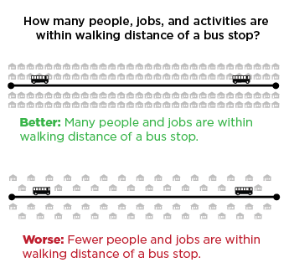
  - Density
High density means that there are more people, jobs, and activities in the fixed area around a public transport stop. This means that access to many destinations from that stop can benefit more people.

  - Walkability
There may be a certain number of people or jobs in the area around a bus stop, but not everyone in that area can actually walk to the bus stop. The connectedness of the street or path network determines people's walking distance to the stop. On a disconnected street network, the walk to the stop might be much longer than the "as the crow flies" distance. Walkability is undermined by:
- Disconnected street networks that require pedestrians to walk an indirect path.
- Fences or walls separating adjacent developments.
- Lack of consistent footpaths along roads.
- Lack of lighting on footpaths, at junctions and at other road crossings.
- Lack of a safe place to cross the street near a bus stop.
- Building orientation that puts front doors far from the street, and thus farther from a bus stop.
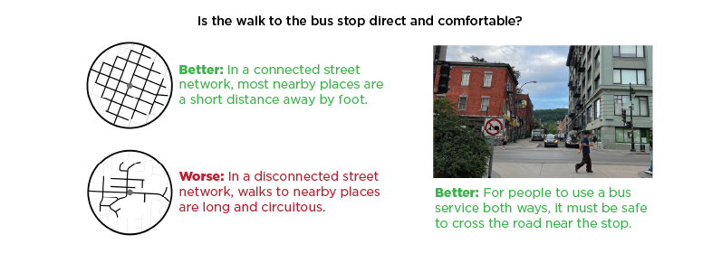
- Dual carriageways or train tracks without regularly-spaced pedestrian crossings.
More walking time to and from public transport stops reduces people’s access to opportunities within a reasonable journey time. Time isn't the only issue: if the walk is unsafe or uncomfortable, then many people won't walk it at all. This reduces patronage in the area, making it harder to justify high levels of service there.[9]
Poor walkability can also affect the directness and linearity of services, if bus routes must deviate into certain areas because people in those areas can't be asked to walk to a stop.
  - Continuity
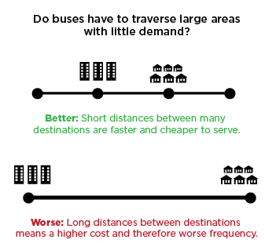
Continuity of development reduces travel time by all modes: walking, cycling, public transport and car.
However, the effect of distance on public transport is unique among the travel modes because public transport requires high operating cost, in addition to capital cost. Due to this operating cost factor, the longer the distance public transport vehicles must cover, the less frequency can be provided.
Within any limited operating budget for service, distance therefore trades-off against frequency. Longer journeys on the vehicle, and worse frequencies, both reduce access. Continuous urban development allows people to make shorter journeys and allows operators to provide better frequencies, which both improve access.
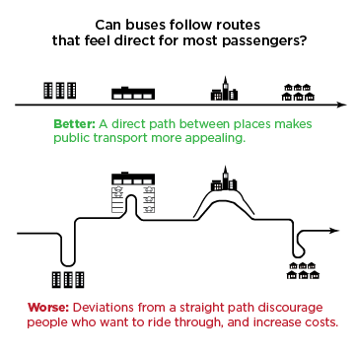
  - Linearity
In most developed areas built before private cars were widespread, destinations and residences are within a short walk of streets that provide direct travel to many other places. This was a natural pattern of development when nearly all travel was by foot, bicycle or shared transport. The result was fairly linear main roads and streets, except where topography required otherwise.
With the advent of the private car, developments can now be put in disconnected street networks and at the ends of cul-de-sacs. When an important destination for public transport is at the end of a cul-de-sac, a bus must deviate from a direct path to serve it, adding time for everyone traveling through.
Deviations don't just cost passengers more time – they also cost the operator. Deviations lengthen the line; the longer a line, the less frequency can be afforded within any limited operating budget, undermining access and patronage.
Of the five principles listed here, linearity is least likely to be mentioned in general discussions of planning, because it is uniquely an issue for public transport.
When using the individual modes (walking, bicycling or driving a car) each person can travel to the end of their cul-de-sac without inconveniencing anyone else or increasing public costs. But for public transport operators and passengers alike, deviations are disastrous.
New developments should "Be on the way!" so as to benefit from buses going past them, in a linear fashion, to other dense areas and destinations.
  - Mix of Uses
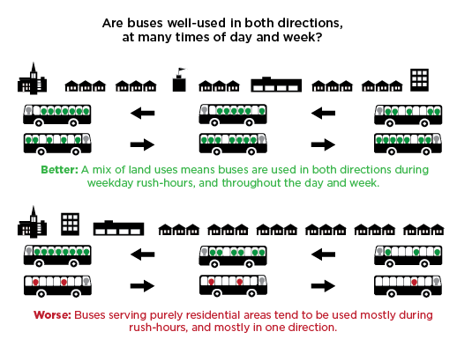
A mix of uses has a particular value for public transport. In a single-centred urban development, most travel is into the centre in the morning and outwards in the evening. This one-directionality is inefficient for public transport, because buses or trains can be full in one direction but must return empty in the other.
A mix of housing, retail and employment uses along corridors is much more efficient to serve with public transport because the operating cost of returning buses to the centre in the morning results in additional passenger journeys, rather than empty seats.
- Three Essential Actions
The guidance note recommends three essential actions that all land use planners should take to shape growth around successful bus networks.

Make bus operations efficient and direct. Public transport is expensive to provide, so it is important to use this resource efficiently. When public transport is inefficient, the limited budget for service must be divided across more routes and more kilometres, undermining frequency and shortening hours or days of service. The result of this dilution is that access to opportunity is worse, and fewer people use public transport. Planning urban and suburban areas to have continuous, linear patterns of dense, mixed-use and walkable development supports efficient bus operations and makes bus service more useful to more people.

Make it easy to walk to the bus. There are several ways to get to public transport, but walking should be the focus in planning. Walking is the foundation because it requires very little land and no operating cost; affords people the greatest freedom and spontaneity; is extremely sensitive to the details of planning decisions for land use and the built environment, and is therefore very easy to discourage.

Organise development around a frequent network. The highest-access public transport networks make use of numerous connected frequent lines. Dense development and important social destinations should be located near those lines. Rather than expecting public transport to chase development to wherever it is approved, development should be planned into shapes that public transport can service efficiently.

References
- There are many published guides for the design of public transport services and infrastructure. There are very few published guides on how land use and built environment should be arranged to make public transport successful. However, a very good English language example is “Buses in Urban Development” by the Chartered Institution of Highways & Transportation (CIHT) of the United Kingdom, published in 2018.
- Diab, E., DeWeese, J., Chaloux, N., et al: Adjusting the service? Understanding the factors affecting bus ridership over time at the route level in Montréal, Canada. Transportation. 48, 2765–2786 (2021). https://doi.org/10.1007/s11116-020-10147-3
- Cui, B., Boisjoly, G., Miranda-Moreno, L., et al: Accessibility matters: Exploring the determinants of public transport mode share across income groups in Canadian cities. Transportation Research Part D: Transport and Environment, 80, 102276 (2020). https://doi.org/10.1016/j.trd.2020.102276
- Berrebi, S., Joshi, S., Watkins, K.: On bus ridership and frequency. Transportation Research Part A: Policy and Practice. 148, 140-154 (2021).
- Dill, J., Schlossberg, M., Ma, L., et al: Predicting Transit Ridership at Stop Level: Role of Service and Urban Form. Transportation Research Board 92nd Annual Meeting Compendium of Papers, 13-4693 (2013).
- Gregory, T., Brown, J.: Explaining variation in transit ridership in U.S. Metropolitan Areas between 1990 and 2000: Multivariate analysis. Transportation Research Record 1986.1:172–181 (2006).
- Stewart, A., Attanucci, J., Wilson, N.: Ridership response to incremental Bus Rapid Transit upgrades in North America. Transportation Research Record: Journal of the Transportation Research Board 2538: 37–43 (2015).
- Balcombe, R., Mackett, R., Paulley, J., et al: The demand for public transport: A practical guide. Transportation Research Laboratory. Report 593 (2004).
- Ewing, R., Cervero, R.: Travel and the built environment: A synthesis. Transportation Research Record 1780. Paper No. 01-3515:87–114 (2001).

