Developing Connectivity Tools: Improving Urban Spaces with the assistance of Connectivity Analysis

Deborah John ¹[0000-1111-2222-3333] and Barry O’Neill ²[1111-2222-3333-4444]
¹ National Transport Authority, Dublin, Ireland
² Compass Informatics, Dublin, Ireland
deborah.john@nationaltransport.ie
boneill@compass.ie
Abstract. Since 2022, Ireland’s National Transport Authority (NTA) have been developing web-based tools that are capable of undertaking connectivity assessments of settlements throughout Ireland. These tools have the opportunity to greatly enhance land use and transport planning decision making processes, and it is the intention of the NTA to introduce them as a standardised approach to connectivity analysis for use by Local Authorities and Government Bodies.

The tools highlight opportunities and constraints for sustainable modes within existing transport networks, while also offering the potential to explore improved options. The application of these tools in the development of Local Transport Plans assists in the improved design of urban spaces by bringing active modes and permeability to the forefront of the planning process.

These toolkits are now widely used amongst Local Authorities during development of their Local Transport Plans and have also attracted significant interest from Government Departments as they look to establish better ways to promote sustainable development methodologies.
Keywords: Connectivity; Sustainable Transport; Web based Assessment; Public Realm; Local Transport Plans.
- Introduction
The NTA has for many years recognized the importance of measuring connectivity to both Public Transport (PT) services and local opportunities and services. Until recently this analysis has been carried out on a relatively ad-hoc basis. The NTA came to realize that to gain the maximum benefit from this type of analysis, a standardized method was required; one that could be used by a wide range of organizations, and that had at its core centrally managed base data.

Transport for London’s ‘Assessing transport connectivity in London’ [1] provided a sound basis for the methodology and the NTA have adapted two of the toolkits for the Irish market. The NTA wished to use these tools both for analysis within Metropolitan areas but also more widely, in smaller regional towns.

The first tool developed was the Public Transport Accessibility Level (PTAL) tool. This tool measures the distance to a local PT stop and scores that stop based on its walk distance combined with the level of service at the stop. Combining the results of this tool with additional land use data can highlight areas that are either in need of additional Public Transport services or would benefit from alternative land use zoning.

The second tool to be developed was ATOS (Access to Opportunities and Services). The ATOS tool measures an area’s connectivity to services such as Employment, Education, Health Services, Retail and Open Spaces. It calculates the journey time from grid squares to local services. Each grid is then scored relative to the average journey time for all grid squares within the study area. The NTA have, in the first instance, concentrated on walking and cycling connectivity. As with the PTAL tool, combining the results of the ATOS tool with other data such as housing locations can quickly identify areas that are outside an acceptable walk distance to local services.
- How the tools work
Both the PTAL and ATOS tools were initially developed as ArcGIS Python (ArcPy) script toolboxes and deployed within Esri’s ArcMap and ArcPro desktop GIS applications, with later versions being deployed as ArcGIS geoprocessing services in ArcGIS Server.
  - Public Transport Accessibility Level (PTAL)
A PTAL is a measure of the accessibility of a location to the public transport network, considering walk access time and service availability. For any selected location, PTAL suggests how well that location is connected to public transport services. It does not consider accessibility by car. PTAL values are simple by design, ranging from zero to six, with the highest value (6b) representing the best connectivity.

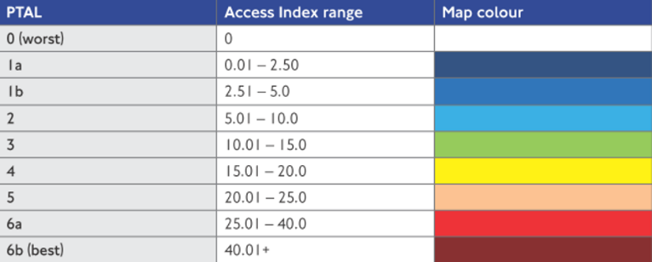
Figure 1 - PTAL score range.
In general a location will have a higher PTAL if it is a short walking distance to the nearest stops or Service Access Points (SAP); waiting times at the nearest stations or stops are short; more services pass at the nearest stations or stops; and here are major rail/bus stations nearby.

The NTA’s PTAL methodology focuses on analysis of 100m grid squares. Wait times, walk-times, access times, and service frequencies are calculated in each grid square. PTAL formulas are applied to generate Accessibility Indexes which are then summed to generate the final PTAL value for a grid square. The NTA’s ArcGIS PTAL toolbox is comprised of two tools: Tool 1 and Tool 2 which are responsible for the import, transformation, analysis, and visualization of GTFS data, and subsequent calculation of PTAL results.

PTAL Analysis Results
The following image shows the results of a PTAL analysis for the greater Dublin metropolitan area. Hotter (red) areas are those with better relative access to public transport.

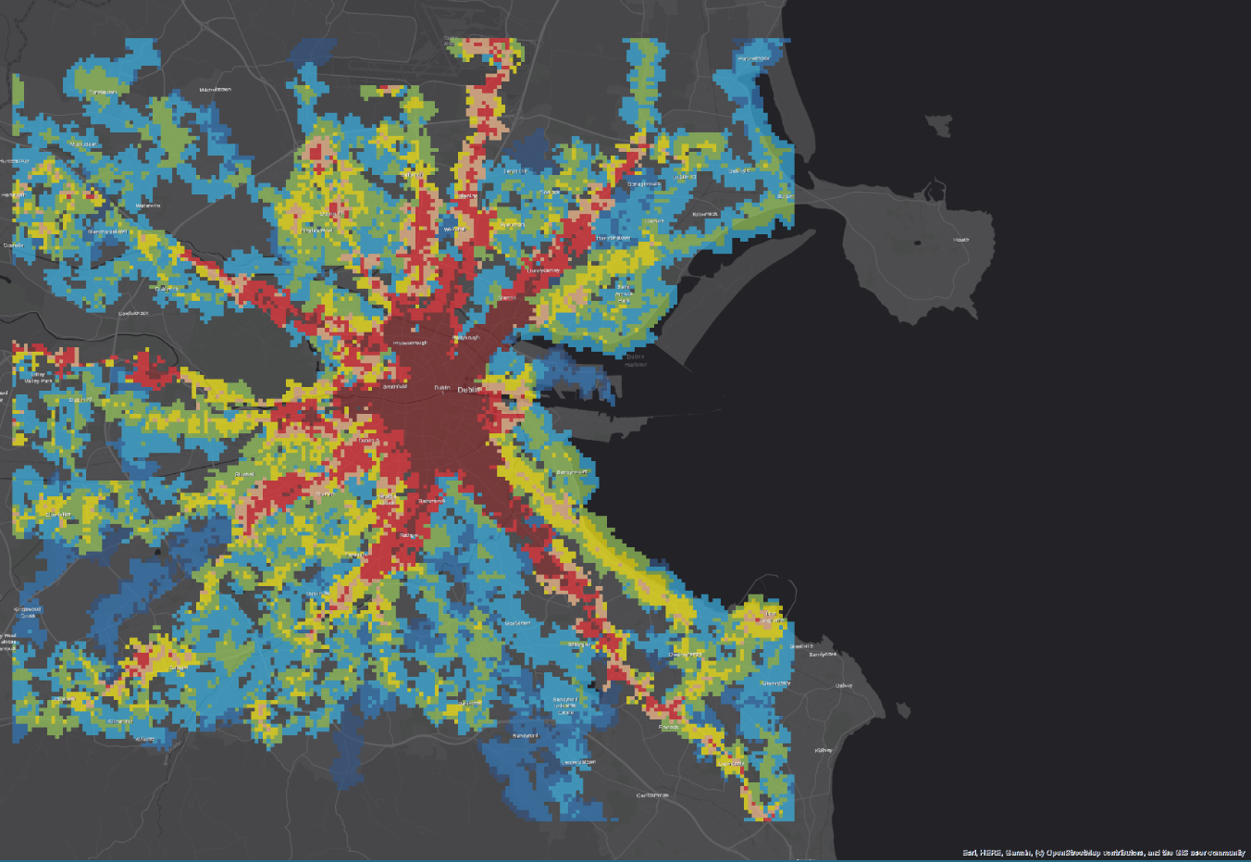
Figure 2 - Dublin PTAL analysis results.
  - Access to Opportunities and Services (ATOS)
Access to Opportunities and Services (ATOS) is a metric which serves as an indicator of a location’s connectivity to essential key services and opportunities. ATOS scores range between A and E, with A representing the highest level of connectivity.

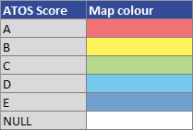
Figure 3 - ATOS score range.
The ATOS measure plays a crucial role in public transport planning by assisting in the identification of areas in need of connectivity improvements and guiding decisions on the optimal locations for introduction of essential services such as healthcare and education. This makes it an indispensable tool in the planning process.

In general an area will have a more favourable ATOS score if there are many of a given service type within close proximity, and the transport network in the vicinity is dense and well developed since this should reduce travel time to service locations.

The NTA’s ATOS methodology focuses on the analysis of 100m grid squares. The ATOS scoring methodology differs from PTAL in that the score for an individual grid square is dependent upon how travel times to the nearest relevant destinations (for the specific type of service) compare to the average travel times across all selected grid squares. In this manner an ATOS score provides a realistic representation of the relative connectivity of a grid square to a given service within the entire selected grid area.

There are two distinct analysis types available within the ATOS toolbox:
- The nearest {X} services within {Y} minutes travel time from origin point
This analysis assesses the relative connectivity to a given number of services {X} within a pre-defined travel time {Y}.
- Total number of jobs within {Y} minutes travel time from origin point.
This analysis assesses the relative employment available within {Y} minutes travel time from a location.

ATOS Analysis Results
The following image shows the results of an ATOS open spaces analysis for the greater Dublin metropolitan area. Hotter (red) areas are those with better relative access to open spaces.

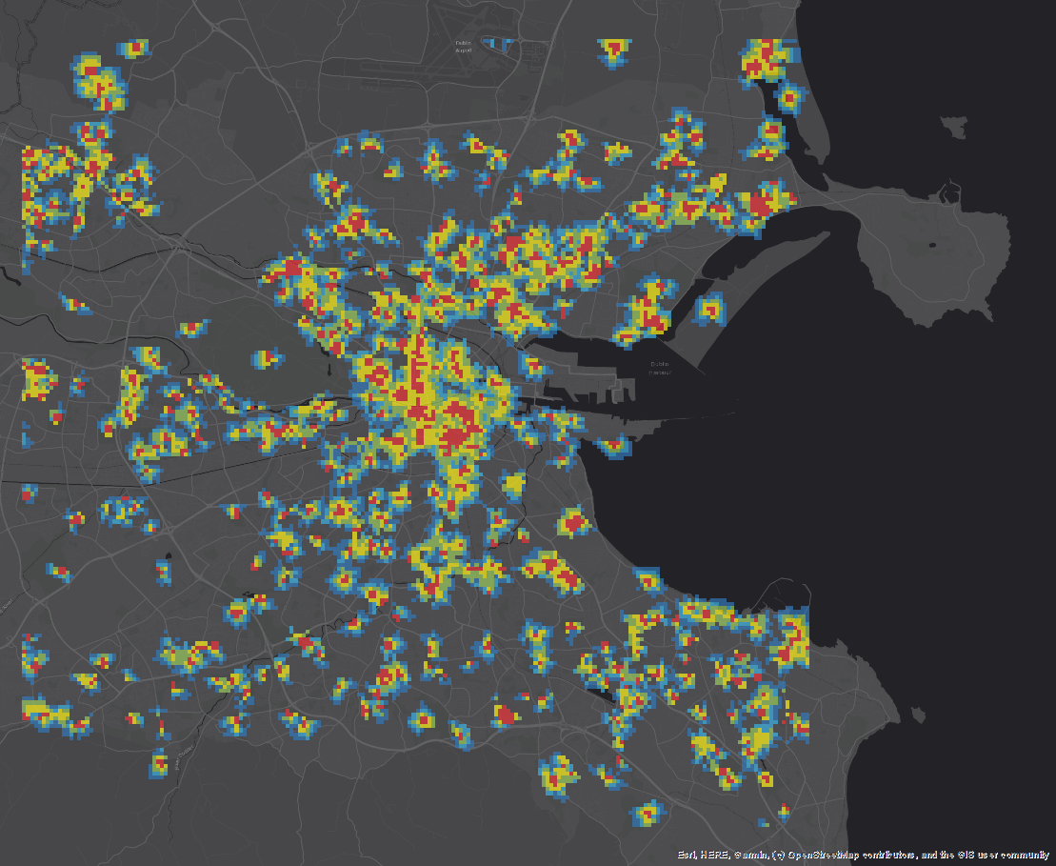
Figure 4 - Dublin ATOS Open Spaces analysis results.
- How we adapted them for Ireland
Both the ATOS and PTAL toolboxes are closely based upon the algorithms developed by Transport for London (TfL). However several adaptions to the TfL algorithms, along with additional innovations were added to the toolboxes to make them applicable to Irish Public Transport.

The PTAL toolbox enables automatic repair of repair of incorrect stop coordinates and route types; customized PTAL analyses limited to specific services, service dates, and service times; Service Proportional Weighting, a custom weighting used to highlight scoring differences when a service does not operate on all days within the “Mon-Fri” range; and customizable symbology.

The ATOS toolbox focuses on walking and cycling; allows the user to customize the number of service types and travel time cut-offs for analysis; applies negative weightings to illustrate that not all {X} services were reachable within the allowed travel time; allows both positive and negative weightings to be applied if the travel times are greater or less than a specified travel time; and enables customizable symbology.
- How we made them on-line tools
To maximize interactivity and accessibility, and to enable local authorities and authorized third parties to execute their own ATOS and PTAL analyses, the toolboxes were converted to on-line tools by publishing the ArcGIS Python script tools to ArcGIS Server as geoprocessing services. Safe Software’s FME Flow Server Apps are used to provide secure web-accessible user-interfaces for both the ATOS and PTAL analyses. The ATOS and PTAL toolboxes along with other components of the NTA’s connectivity toolkit are made available via a secure NTA Data Analysis web-portal.
- Applying the tools to Local Transport Plans
Both toolkits are now widely used in developing Local Transport Plans (LTPs).
  - Using PTAL in Local Transport Plans
At the local level it is possible to use PTAL for more in-depth analysis. A poor PTAL score or a sudden change from a high to a low score could indicate where there is opportunity to improve permeability in the local network or where the frequency level could be improved. It is a relatively easy task to edit the underlying network to include a new walk link through a previously sealed off cul-de-sac, the PTAL tool is run again to see what impact the new walk link has had. For existing residential areas, this improvement can be converted to the population that is now within walking distance of PT.
Introducing a new PT route or improving existing services is often the outcome of a Local Transport Plan. The impact of these can be assessed using the PTAL calculation. A before and after analysis can show if the new services or routes have improved the connectivity in the area. The NTA are currently investigating the simplest way to incorporate new / test services into the PTAL calculation.
  - Using ATOS in Local Transport Plans
Like PTAL, ATOS is a useful tool for measuring the permeability of a walk or cycle network. Poor ATOS scores can indicate where permeability measures may help to improve overall connectivity. A walk network can be easily edited to demonstrate the before and after scenario. The images below show that making an existing informal walk link across some park land would open access to a larger area.
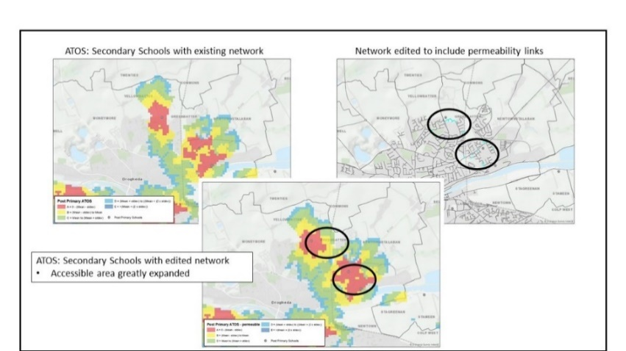
Figure 5 - Network changes improve an ATOS score.

Before and after scenarios can be carried out for the re-location of existing services, or to aid in the site selection for new services. The service location layer required by the ATOS calculation is a point feature class, so it is easy to edit. Calculations can be made using the existing network or if the site selection process requires it, the underlying network can be edited.
- Conclusion
In every use case it is the intention to bring the integration of Land Use and Transport to the fore when approaching areas for development. Using a simple score such as PTAL or ATOS can be quickly and easily adopted and understood.

References
- Transport for London: Assessing transport connectivity in London (2015).

