Using the logsum to explore transport equity in public transport planning in Ireland
Wen Zhang¹,2 , Brian Caulfield^{1,2}, Yeonjung Song^{3,4} and Barry Colleary ^{1,2}
¹ National Transport Authority, Ireland
² Trinity College Dublin, The University of Dublin, College Green, Dublin 2, Ireland
³ Department of Transport, Ireland
⁴ Kobe University, Kobe, Japan
wen.zhang@nationaltransport.ie
Abstract. Transport planning decisions can have large and diverse equity impacts and evaluating these can be challenging but this is an important element as equity is considered as a major policy goal in transport policy (Litman, 2022). Whilst there are various ways to measure the impacts of equity, use of logsum has not been widely discussed yet. The logsum is a disaggregate measure that can capture the impact of land-use, transport, individual characteristics and their interactions on accessibility. It is capable of capturing accessibility benefits from changes in the distribution of activities as it accounts for both changes in generalised transport costs and destination utility. Therefore, this paper explores the use of logsum method to evaluate the impacts of transport projects on accessibility. It also reviews the literature on measuring transport equity and using logsum as an assessment tool for transport infrastructure. The case study, using Regional Modelling System (RMS) developed by the National Transport Authority (NTA), will show where logsums are computed in several transport scenarios to assess the distributional impact across social groups and geographic locations.
Keywords: Logsum, Accessibility, Transport Equity, Distributional Impact, Regional Modelling System (RMS).
- Introduction
A core element in recent changes in transport policy and planning is the increasing move to replace the traditional mobility focus with an accessibility-based perspective (ITF, 2020). The logsum accessibility measure can provide a convenient solution to measure the direct accessibility benefits from land-use and/or transport policies when a travel-demand model is available that already produces logsums (Geurs et al., 2010).
This paper explores the use of logsum method to evaluate distributional impacts of transport projects on accessibility within the Regional Modelling System (RMS) developed by the National Transport Authority (NTA) across social groups and geographic locations. The paper also aims to demonstrate how the logsum measure can be applied within an existing modelling system, and to explore the implications of the results for transport equity analysis.
- Literature review
Accessibility refers to people’s ability to reach desired services and activities (Litman, 2022) It is a crucial component of transport equity, which ensures that transport systems are accessible, affordable and fair for all social groups. Accessibility is a wider concept than mobility though conventional planning tends to evaluate transport system quality primarily based on mobility, which focuses on the physical act of moving from place to place and the factors that enable or hinder that movement (Litman, 2022).
Research shows existing land use and transport system has a distributional impact on population groups, especially the low income earners and car-less households (Rock et al., 2016). There is a high level of car dependency and forced car ownership for people in living rural areas. It shows how accessibility differs between drivers and non-drivers, and therefore non-drivers’ relative disadvantage (Carroll et al., 2020; Litman, 2022).
Most of the measures for computing accessibility focus are either infrastructure-based or place-based, e.g., distance/time to the closet location or cumulative opportunity measures. However, they might overestimate or underestimate an individual’s functional accessibility because they do not consider the individual’s unique travel behaviour or the temporal variation of transport services (Kim, 2018; Geurs, 2018; Miller, 2019). Compared to other common approaches, the logsum measure has advantages of being sensitive to multiple modes of travel and to individual-level factors such as travel times and costs, automobile availability, and individual travel preferences (De Jong et al., 2005; Dixit and Sivakumar, 2020). It can also account for long term land use change, such as trip production effect and destination utility effect (Geurs et al., 2010). Bill et al. (2022) forecasted equity benefits by using a logsum accessibility calculated from a regional travel demand model. The result shows that the accessibility gains would be slightly higher for lower income communities and transit-dependent households.
The logsum measure has also been applied in many researches to measure the user benefits in transport appraisal. The rule-of-half is in widespread use for measuring user benefits in transport appraisal. It is commensurate with the assumption that the benefit of switching between alternatives is related only to the (generalised) cost changes associated with the alternatives, and therefore can ignore the underlying attractiveness of the alternatives, e.g., large generalised cost changes, introduction of new modes and new generation of trips (Geurs et al., 2010). The use of logsum measure is also able to include consistency between simulated behavioural changes in the travel model and quantification of benefits, which cannot be achieved using typical measures of benefits such as travel time savings. However, it also suffers issues related to the form and creation of alternatives in the mode choice model, and the difficulty in explaining the concept and changes to non-technical audiences (Villanueva et al., 2018).
- Methodology
In econometric choice theory often used in mode choice and destination choice models, the probability of choosing one alternative among several options is a percentage incorporating the various utility of each alternative. The logarithm of the denominator of this ratio is called the logsum, which can be used directly as an accessibility measure. Mathematically, this is represented as
$A_{i}=\log{(\sum_{j∈J}{exp⁡(V_{ij}))}}$ (1)
where:
$A_{i}$ is the accessibility in zone i; J is the set of all destination zones; $V_{ij}$ is the utility of selecting destination j
The logsums presented in this paper are derived from the NTA’s RMS - East Regional Model (ERM). These logsums are computed for at demand segment level and it shows the utility from a choice set of travel alternatives including both mode (car, public transport, park and ride, walk and cycle) and destination (1953 zones in the east regional model). The utility function for a mode and destination choice is specified as:
$V_{dm}=β_{GenTime}*\left(GT_{dm}\right)+β_{IZ}{IZ}_{d}+{ASC}_{m}+ln⁡(A_{d})$ (2)
where:
$β_{GenTime}$ is an all-mode generalised time parameter; ${GT}_{dm}$ is the generalised time to destination d by mode m ; $β_{IZ}$ is an intrazonal constant; ${ASC}_{m}$ is the mode specific constant ; ${IZ}_{d}$ is an intrazonal destination flag which takes a value of 0 or 1; $A_{d}$ is the attraction variable for destination d
The logsum for zone is computed as:
$\log{(\sum_{j∈J}{exp⁡(μ_{d}*\frac{1}{μ_{m}}(ln\sum_{m∈M}{exp⁡(μ_{m}*V_{dm})}))}}$ (3)
Where $μ_{d}$ and $μ_{m}$ are the spreading parameters as the mode and destination model here uses the architecture of a nested logit model.
This study compares accessibility changes between current (or equivalent) transport provision and future transport provision within the County Dublin area in Ireland. To see distributional impacts between different social groups, this study considers individual characteristics (e.g. blue-collar, white collar) and trip characteristics such as trip purpose and car availability.
A total of 33 demand segments are modelled in RMS model (NTA, 2016). In this paper, only the logsums for the following demand segments are calculated:
- Blue Collar with Car Availabililty (Commute)
- Blue Collar Car without car Availabilility (Commute)
- White Collar with Car Availabilility (Commute)
- White Collar without Car Availability (Commute)
- Other Employed with Car Availablility (Other purposes of the trip, e.g. medical visit, leisure or social trips etc.)
- Other Employed without Car Not Availability (Other purposes of the trip)
- Other Not Employed with Car Availability (Other purposes of the trip)
- Other Not Employed without Car Availability (Other purposes of the trip)

The case study uses the following three scenarios for logsum computation and results comparison:
- 2016 Scenario: RMS 2016 ERM calibrated base year scenario.
- 2035 Scenario A: a hypothetical project scenario that includes transport schemes within the National Development Plan that are likely to open before 2035 such as bus network improvement and light rail project. Most of the schemes included in this scenario are public transport schemes and active travel schemes.
- 2035 Scenario B: In addition to the transport schemes included in the A scenario above, light rail extension project is also included in this scenario.
- Result Discussion
Accessibility computed using the logsum measure is compared spatially between 2016 scenario and 2035 scenario B for all the demand segments.
The comparison is undertaken at the ERM modelling zone level for the County Dublin area. It is important to note that 1) the logsum measure considers both land-use changes and generalised cost savings, which includes travel time cost, wait time, transfer time, parking charge, productions/attractions change etc, and 2) the logsums are not comparable across demand segments as they were estimated separately (NTA, 2016).
The accessibility change trend is different across demand segments when comparing 2016 and 2035 B scenarios. Commute demand segments with car availability are likely to experience disbenefits in the future year in general as the congestion experienced on the road traffic is incorporated in the logsum measure. On the contrary, commute demand segments without car availability show increases in accessibility in most of the areas. There is no significant change for ‘Other’ demand segments on the county level regardless of their geographic location and car availability status.
Figure 1 shows the output for the demand segment (4) white collar without car availability, which shows noticeable changes between two scenarios. The accessibility is found to be highest in the city centre area (inside of the black line) for both 2016 and 2035 Scenario B scenarios. 2016 scenario shows poorer accessibility for areas such as Portmarnock, Baldoyle and Howth areas (inside of the purple line) though they are in the vicinity of the DART line, which . With more public transport schemes introduced across the County Dublin in 2035, there is significant increase in accessibility within the areas surrounding the city centre and Swords (indicated by dark blue box) areas.
Accessibility change on a particular scheme (e.g. the light rail extension project) is also evaluated by comparing the results between 2035 scenario A and B, to see the accessibility change brought by a specific transport infrastructure scheme only. Figure 2 shows that areas close to light rail show significant increase of accessibility for demand segment (4) white collar car not available. Though there are some areas experiencing disbenefit (red areas), the negative impact is minimal. This observation is seen in both ‘Commute’ and ‘Other’ for the groups without car availability. While the public transport project could bring out disbenefits (red areas) in some areas, the results show that the group which would rely on the public transport could gain accessibility benefits from this scheme.
The analysis of this case study shows that: 1. The logsum measure shows a person’s underlying perception of accessibility and this varies between social groups and geographic locations. 2. Improvement on public transport system might not provide the same level of accessbility benefits for everyone, and these benefits could be localised.

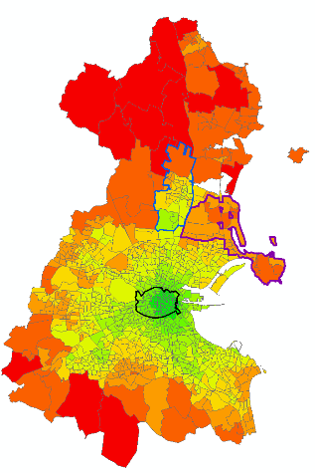  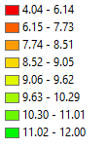 | 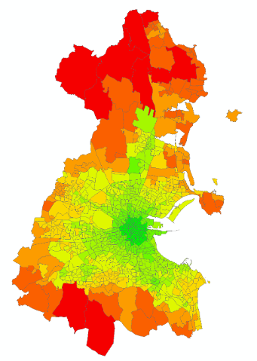
2016 Scenario (a) | 2035 Scenario B (b)
Fig. 1. Accessibility computed from 2016 and 2035 B scenario for demand segment (4) white collar without car availability
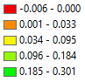
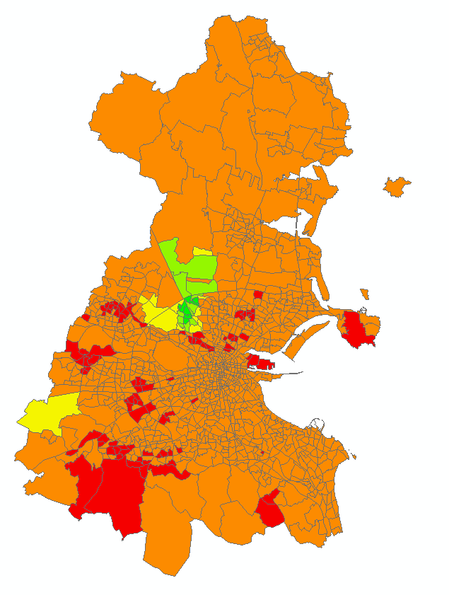

Fig. 2. Accessibility change before and after the opening of the light rail project for demand segment (4) white collar without car availability (the light rail alignment in black color is indicative only)
- Conclusion
This paper explores the application of computing the logsum measure using NTA’s RMS for transport equity analysis. The results show distributional impacts that accessibility varies across different social groups and geographic locations.
There are limitations associated with the assumptions within this analysis. In terms of the model specifications, most of the variables considered in the utility function are still related to the concept of mobility, which might not be applicable to those trips who don’t have time constraint. The current values of accessibility (utility) are ordinal and can only be compared between the same demand segments. It would be useful that the benefits are quantified and presented in a universal unit (e.g. minute or euros) to be compared across demand segments. The magnitude of the accessibility benefits can also be calculated which take the level of trip makings of each demand segment into account.

References
- Ben-Akiva, M.E. and Lerman, S.R., 1985. Discrete choice analysis: theory and application to travel demand (Vol. 9). MIT press.
- Bills, T.S., Twumasi-Boakye, R., Broaddus, A. and Fishelson, J., 2022. Towards transit equity in Detroit: An assessment of microtransit and its impact on employment accessibility. Transportation Research Part D: Transport and Environment, 109, p.103341.
- Carroll, P., Benevenuto, R. and Caulfield, B., 2021. Identifying hotspots of transport disadvantage and car dependency in rural Ireland. Transport policy, 101, pp.46-56.
- De Jong, G.E.R.A.R.D., Pieters, M., Daly, A., Graafland, I., Kroes, E. and Koopmans, C., 2005. Using the logsum as an evaluation measure: Literature and case study. Calif.: RAND Corporation, Santa Monica. Disponível em: http://www. rand. org/pubs/working_papers/WR275. html.
- ITF, 2020. Accessibility and Transport Appraisal: Summary and Conclusions, ITF Roundtable Reports, No. 182, OECD Publishing, Paris
- Dixit, M. and Sivakumar, A., 2020. Capturing the impact of individual characteristics on transport accessibility and equity analysis. Transportation research part D: transport and environment, 87, p.102473.
- Geurs, K., Zondag, B., De Jong, G. and de Bok, M., 2010. Accessibility appraisal of land-use/transport policy strategies: More than just adding up travel-time savings. Transportation Research Part D: Transport and Environment, 15(7), pp.382-393.
- Geurs, K.T., 2018. Transport planning with accessibility indices in the Netherlands. International Transport Forum Discussion Paper.
- Kim, J., 2018. What about People in Accessibility. A Comparative Analysis between Place-Based Accessibility and Person-Based Accessibility. APA Student Paper Competition: Master’s Thesis, University of Illinois, Urbana-Champaign, IL, USA, 1.
- Litman, T.A., 2021. Evaluating Accessibility for Transport Planning-Measuring People’s Ability to Reach Desired Services and Activities-22 April 2021.
- Litman, T.M., 2022. Evaluating Transportation Equity: Guidance for Incorporating Distributional Impacts in Transport Planning. Institute of Transportation Engineers. ITE Journal, 92(4), pp.43-49.
- Miller, E.J., 2020. Measuring accessibility: Methods and issues. International Transport Forum Discussion Paper.
- NTA, 2016. Model Development Report, East Regional Model, Model Version 3. https://www.nationaltransport.ie/wp-content/uploads/2022/09/ERM-Model-Development-Report.pdf
- Rock, S., Ahern, A. and Caulfield, B., 2016. The economic boom, bust and transport inequity in suburban Dublin, Ireland. Research in Transportation Economics, 57, pp.32-43.
- Villanueva, K., Zorn, L., Ory, D. and Vautin, D., 2018. The pros and cons of using the change in destination choice logsums as a practical measure of user benefits. Transportation Research Record, 2672(46), pp.64-72.
- Winkler, C., 2016. Evaluating transport user benefits: Adjustment of logsum difference for constrained travel demand models. Transportation Research Record, 2564(1), pp.118-126.

the National Development Plan sets out the Government’s over-arching investment strategy and budget for the period 2021-2030. Please see details at: https://www.gov.ie/en/publication/774e2-national-development-plan-2021-2030/
Dublin Area Rapid Transit, https://www.irishrail.ie/en-ie/about-us/iarnrod-eireann-services/dart-commuter

