LAUNCH EMAIL

This is an example text that can be used to email all staff and students and to provide information on student and staff pages of your website –and anywhere else that might be relevant for your workplace or campus!
Subject line: Announcing the Ready, Set, Cycle campaign!
Email text:
Ready, Set, Cycle: April 8th to May 17th
We are delighted to announce that we are taking part in the Ready, Set, Cycle programme. This programme is aimed at getting you ready and set to cycle! There will also be the chance to win some great prizes along the way.
Whether you are interested in cycling for the first time, or want to get back on the bike, this programme will provide you with the tools to do just that.
Here is a look at the 6 week programme and what you can sign up for each week:
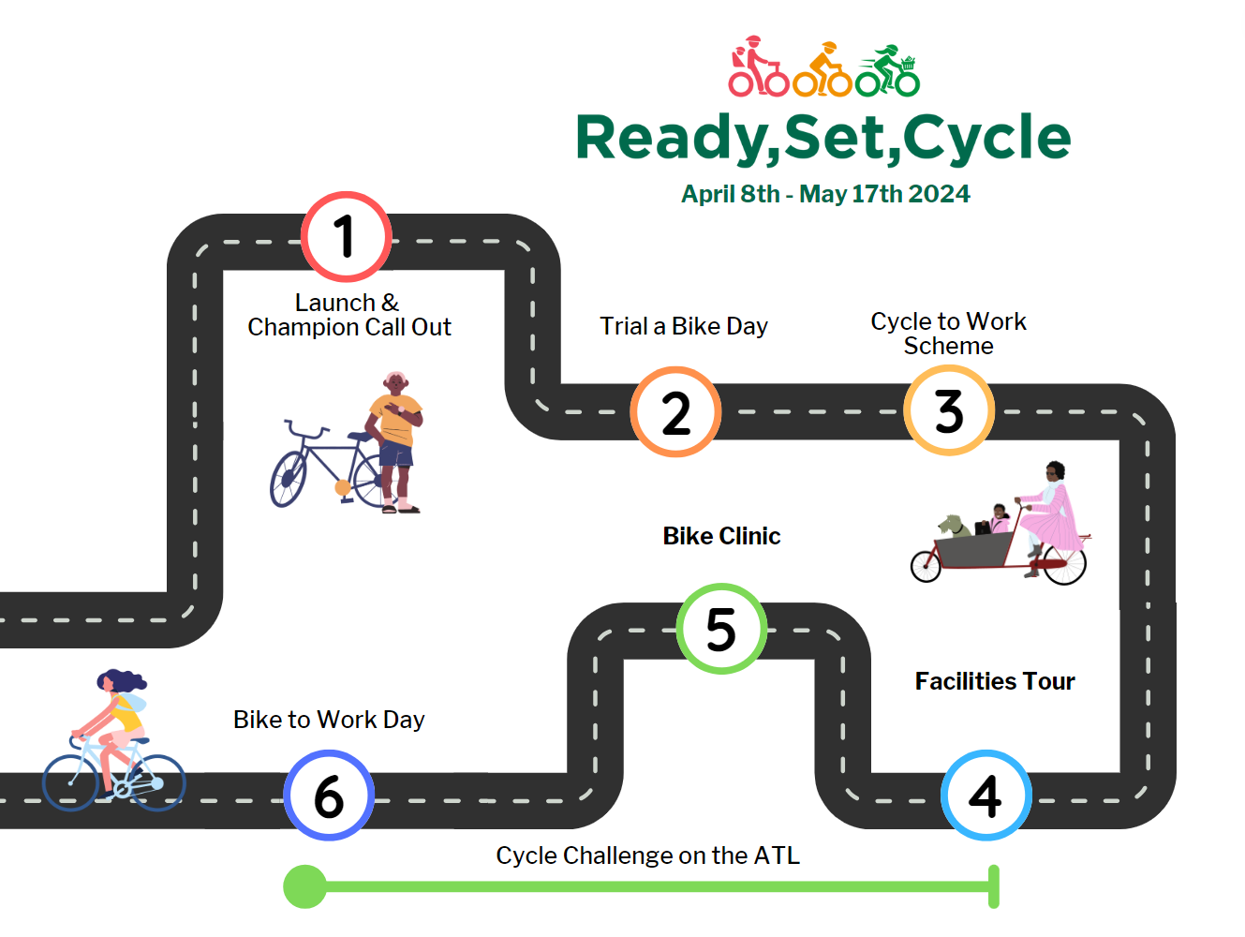

Cycling Champions: Are you an avid cyclist within (organisation name) and want to support participants along the way? Become a cycling champion and be in with the chance to win some great prizes!
To sign up and become a cycling champion, visit the competition page and enter your testimonial all about why you love to cycle:
Cycling Champion Competition Entry Form

Ready Set Cycle Quiz: To kick off the programme, we invite participants to take our Ready, Set, Cycle quiz which is a fun way to learn more about cycling, the programme, and win some prizes. The quiz will close on Friday April 12th
(Shane will send you the link prior to launch date)
Kind regards,
[Name]

SAMPLE EMAIL – TRY A BIKE DAY

Subject line: Ready, Set, Cycle – Try a bike day

If having an in-house try a bike day
Email text:
Calling all new cyclists!
We are delighted to be running a “Try a Bike day” on [Add date here]
This event is designed to encourage more people to consider cycling as a form of active transport.
During the try a bike day, you will have the opportunity to test a range of bicycles and learn more about the benefits of cycling. [If applicable] There will also be an expert on hand to answer any questions you might have!
Kind regards,
[Name]
If having a virtual try a bike day
Calling all new and returning cyclists
As part of the Ready, Set, Cycle programme we are promoting cycling as a form of active transport on the commute and beyond.
Attached are some helpful guides on the different types of bikes available to help you choose which suits you best.
You can also check out: (insert local bike shop(s)) that are registered with the cycle to work scheme.
Kind regards,

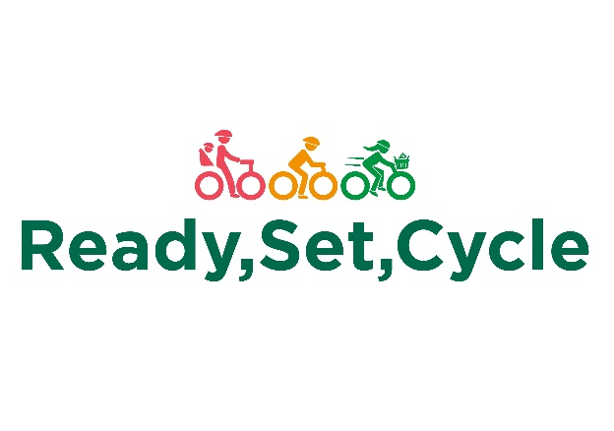
SAMPLE EMAIL – CYCLE TO WORK SCHEME

Dear [Staff Member],
As part of the Ready, Set, Cycle programme, we are excited to promote and encourage you to sign up for the Cycle to Work scheme! This scheme allows you to save money on a brand new bike and cycling equipment while also improving your health and wellbeing.
By signing up for the scheme, you can get up to 52% off the cost of a new bike and equipment, making it an affordable way to get active and reduce your carbon footprint. You can choose from a wide range of bikes, including road bikes, hybrids, and e-bikes, and you can spread the cost over a year through salary sacrifice.
To sign up, [Insert internal resource on how to sign up here]. You can then choose your bike and equipment and submit your application to us for approval. Once approved, you can start enjoying the benefits of cycling to work!
We strongly encourage all our staff members to take advantage of this fantastic scheme, whether you're a seasoned cyclist or a complete beginner. Cycling is a great way to improve your physical and mental health, reduce your stress levels, and save money on commuting costs.
If you have any questions about the Cycle to Work Scheme, please do not hesitate to contact us [insert contact details]. We are here to support you and help you get the most out of this exciting opportunity.

Best regards,

[Your Name]

