Appendix 11 - The Method to be used for Disposal of Assets and Access to Assets of Third Parties
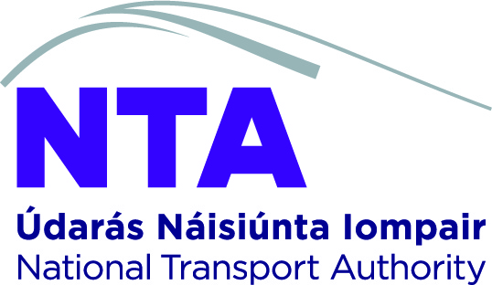

National Transport Authority

The Method to be used for Disposal of Assets and Access to Assets of Third Parties
(Version 1.0)

May 2025

This document is classified as confidential and is for internal use by the National Transport Authority (the “Authority”) only.

Each policy shall require approval by the National Transport Authority prior to implementation.
Any modifications to existing polices shall be carefully documented. This shall include the completion of the revision history table.

Reader Guidance: If a policy is modified the table below must be inserted at the end of the modified policy to reflect any changes. All fields in the table must be completed.

Revision History

Version | Date | Description | Prepared | Reviewed
1.0 | 16/05/2025 | For Board Approval | Gerard Cuddihy | Board Approved

Next review date: May 2027

Approvals
Position |  | Name | Date
Corporate Risk Manager | Review for submission to Board | Gerard McBrien | 08/05/2025
Head of Governance and CRO | Approved for submission to Board | Gerard Cuddihy | 08/05/2025
Director of Finance & Corporate Services | Approved for submission to Board | Philip L’Estrange | 08/05/2025
Chief Executive Officer | Approved for submission to Board | Hugh Creegan | 08/05/2025
Board | Approval | Board | 16/05/2025

- The method used shall be both transparent and likely to achieve a fair, market-related price. The anticipated value may be determined either by a reserve price recorded in advance in the Authority’s records or by a formal sign-off by the Board on the advice of the CEO or, if delegated by the Board, sign-off by the CEO or a Member of the Audit and Risk Committee, that, in their view, the anticipated value is likely to be less or greater than €150,000. In determining market value, regard shall be had to accounting standards best practice in Ireland.

- If an auction or competitive tendering process takes place and the highest bid is not accepted, then specific approval by the Board is required before the disposal of the asset or granting of access to property or infrastructure for commercial arrangements with third parties can be completed. The Board must ensure that the provisions of the EU Commission Communication on State Aid elements in sales of land and buildings by public authorities are complied with. For reasons of transparency, such approval, together with the reason why a lower bid was permitted to be accepted, shall be noted in the minutes of the Board meeting concerned. Given commercial considerations, this record may be made in a confidential section of the minutes.

- If an auction or competitive tendering process does not take place, and the proposed price is €150,000 or more, then specific approval by the Board is required before the transaction can be concluded.

- No disposal of an asset or grant of access to property or infrastructure for commercial arrangements with third parties shall be completed until the officer authorising the disposal has certified formally that (i) the Board’s approval is not necessary, with the reasons therefor, or (ii) the Board’s approval, where necessary, has been obtained.

- Disposal of assets to Authority Members, staff members or their families or connected persons shall, as with all disposals, be at a fair, market-related price. Where the Authority is considering a proposal for any such disposal, the Authority Member connected to the potential purchase shall absent him or herself from the Board’s deliberations on the issue. A record of all such disposals to such persons (to include details of the asset disposed of, price paid and name of the buyer) shall be noted in a register kept for this purpose (minor disposals below a threshold of €5,000, as approved by the Board may be omitted from the register). This register shall be available for inspection, if requested, by the Board or by any individual Board Member. Any disposal above the approved threshold may not be made without having been formally endorsed by the Board, who may impose specific restrictions with regard to any such disposal.

- Details of all disposals of assets to third parties (save for connected third parties which is dealt with above) below the threshold value of €150,000 without auction or competitive tendering process shall be formally reported, with the paid price and the name of the buyer, to the Board on an annual basis.

- Details of, and explanations for, disposals of assets to third parties above the threshold of €150,000 which have not been subject to auction or competitive tendering process, shall be included in the Chairperson's annual report to the Minister for Transport. The Chairperson, in the annual report to the Minister for Transport, is required to affirm that the disposal procedures, as outlined above, have been complied with.

- The Chairperson, on behalf of the Board, shall seek the approval of the Minister for Transport and the Minister for Public Expenditure, NDP Delivery and Reform in advance of any material disposal of land, buildings or other material assets.

