NTA logo with text and a logo



Infrastructure Equality

December 2023

Active Travel Advice Note:

Infrastructure Equality Guidance

Accessible Version

Document Control Sheet

Document Type: Advice Note

Document Title: Infrastructure Equality Guidance

Document Number: ATAN-2023-02

Pages: 18

Appendices: 3

Revision: One

Date Published: 01 December 2023

Author: SMD

Reviewed by: JS

Approved by: HC

Contents

1 Introduction 3

1.1 Relevant equality issues to active travel: 4

1.2 Scope of Guidance 5

2 Infrastructure Equality Guidance 6

2.1 Guiding principles for assessment 6

3 Design Issues Impacting Equality & Relevant Design Guidance 8

3.1 Issues and Recommendations / Mitigations 12

3.2 Infrastructure Equality Guidance Users - Gathering Feedback 12

4 Equality Auditing 13

4.1 Methodology for Design Stage Checklists 13

4.2 Methodology for using baseline/construction checklist 13

4.3 Site Visits 13

4.4 Report 14

5 Expected Outcomes 14

Appendix A – Screening Template 15

**Infrastructure Equality Guidance Screening Template** 15

Scheme Name 15

Scheme Description 15

Appendix B – Baseline & Construction Checklist 18

6 Checklist for Baseline and Construction Stage Projects 18

Appendix C – Design Stage Checklist 26

**7** **Checklist for Design Stage Projects** 26

# Introduction

The National Transport Authority (NTA) recognises the importance of funding infrastructure that meets the needs of all members of society. The NTA are committed to equality within transport and to the elimination of all forms of discrimination as defined under the Equal Status Acts (<https://www.irishstatutebook.ie/eli/2000/act/8/enacted/en/html>). The Equal Status Acts 2000-2018 (‘the Acts’) prohibit discrimination in the provision of goods and services, accommodation and education. The Acts cover the nine grounds of gender, marital status, family status, age, disability (Disability can be defined by pain, memory issues, concentration issues, mental health status, intellectual disability, and disability related to breathing, hearing, seeing or speech), sexual orientation, race, religion, and membership of the Traveller community. It is an objective of the NTA to ensure that infrastructure provided by the Authority is suitable for all needs and addresses this Act. This document seeks to provide guidance regarding equality within active travel infrastructure to assist with conforming to a transport infrastructure equality objective.

Table A: Nine Grounds covered in the Equal Status Act

| **Equality Factor** | **Description of Factor / Class** |
| --- | --- |
| Gender | Men, women, binary, non-binary, transgender, transitioning and other gender identities, married and single people; parenting, caring, flexible working and equal pay concerns. |
| Civil/Marital Status | Discriminatory concerns based on less favourable treatment due to civil status of being single, married, separated or divorced, widowed, in a civil partnership or being a former civil partner in a civil partnership that has ended by death or has been dissolved. |
| Family Status | Including being pregnant or having responsibility as a parent or lone parent for a person under the age of 18 years or responsibility as a parent or resident primary care-taker of a person of 18 years or over with a disability requiring care or support. |
| Age | Children (zero to sixteen), young people (seventeen to twenty-five), working age people (fifteen to sixty-four) and elderly people  (sixty-five and over). |
| Disability | People with physical, mental, sensory, visible or hidden medical condition or impairment. |
| Sexual Orientation | Impacts based on sexual orientation of heterosexual or lesbian, gay, bisexual, transgender, intersex, asexual and queer people, and persons with other sexual orientations and gender identities. |
| Ethnicity (Race) | People from various ethnic groups, including colour, nationality, ethnic background and national origin. |
| Religion | People who have a religious belief; people who are atheist or agnostic; people who have a philosophical belief which affects their view of the world or the way they live. |
| Membership of Traveller community | Member of the Traveller community’ and identifying as people with a shared history, culture and traditions including, historically, a nomadic way of life. |

This Infrastructure Equality Guidance aims to provide guidance for schemes funded by the NTA to ensure that development of active travel infrastructure does not adversely impact any of the nine protected characteristics listed in Table One Nine Grounds covered in the Equal Status Act. This guidance intends that all stakeholders to work together collectively to ensure the equitable development active travel infrastructure.

## Relevant equality issues to active travel:

While it is recognised that all nine protected characteristics hold equal weight, following a screening exercise by the NTA, it has been determined that the characteristics most likely to be affected by the development of active travel infrastructure are: Gender, Family Status, Disability, Race and Age.

This is not a definitive list and NTA recognise that in certain circumstances, other characteristics may be affected and additional caution may be required to ensure an equitable outcome on all active travel schemes.

In the absence of any doubt as to whether a characteristic is affected, the screening document in Appendix A can be used for further assessment. The screening questions will be used to determine whether any of the protected characteristics are likely to experience differential and/or disproportionate effects as a result of the proposed scheme. Any characteristics that are perceived to be impacted by the proposed scheme should be further investigated.

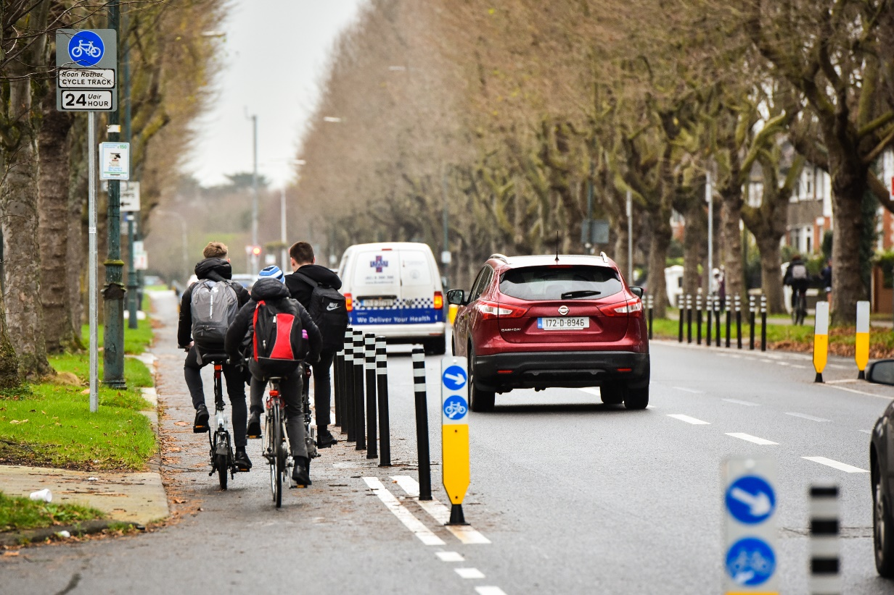

Figure 1: School children cycling

## Scope of Guidance

This document sets out guidelines to follow in order to achieve equitable infrastructure development. These guidelines are intended for use on all active travel schemes funded by the NTA which result in new construction or permanent changes to a street layout.

These guidelines are not intended as a check of compliance with design standards, nor are they concerned with structural safety.

It is important to note that it is not possible for every single street or road to meet all users’ requirements, however this guidance requires that the needs of all users are considered, and where appropriate, that these needs are met. Recommendations arising from the use of this guidance should make allowance for the fact that strategic decisions on route choice and junction type reflect a balance of factors, including safety.

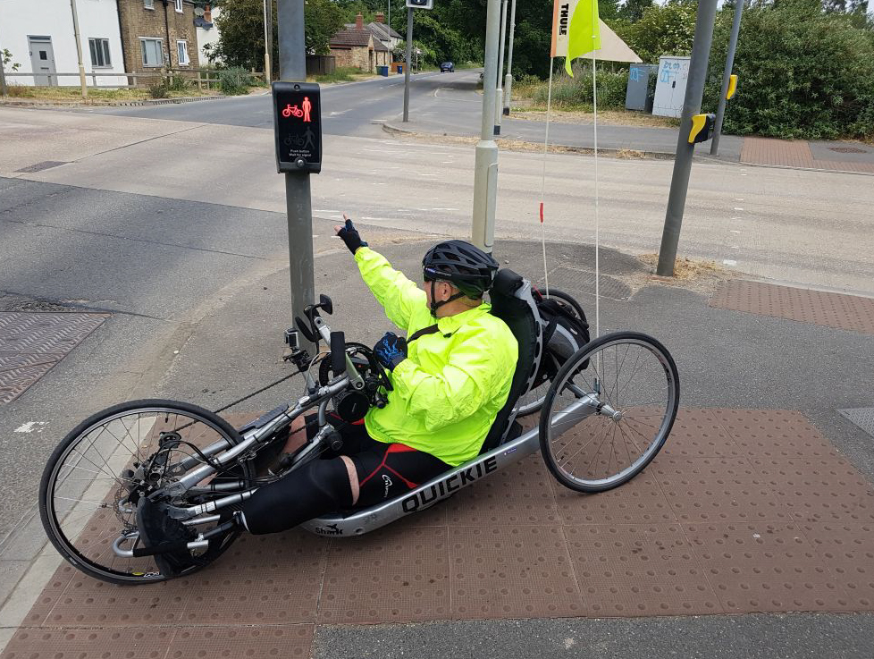

Figure 2: Push Button Design - Source Cambridge Cycling Campaign

# Infrastructure Equality Guidance

This guidance presents a number of issues to be aware of when designing or upgrading an active travel scheme. This section will be presented under the protected characteristics that have been identified as being considerably likely to be impacted by the development of active travel infrastructure; gender, family status, disability, race and age.

There are a number of items to be cognisant of during the development and design of a scheme which are outlined in Table B: Equality Issues in Infrastructure Design, available in Section 3. The relevant guidance documents should be referred to for design specifications.

## Guiding principles for assessment

**Gender**: There may be issues in accessing / using active travel infrastructure for more women than men. This may be related to perception of personal and/or road safety. It may also be related to participation in active travel and representation by women within active travel.

**Sexual orientation:** Unfortunately, people who are part of the LGBTQ+ community may experience harassment. People from this community may avoid walking or cycling if they feel threatened.

**Disability:** People with a disability may find it more difficult to navigate through the street network due to infrastructure issues such as lack of dropped kerbs and tactile paving. Therefore they are more likely to be impacted by poor street design.

**Age:** There is evidence that age can be related to health and mobility, and a decline in physical activity and health with age is common. Therefore older people may face barriers to active travel due to safety concerns, poor infrastructure, and fear. Young people (e.g. children) can also be disproportionally effected by poor street design as they become ‘designed out’ of their environment due to high speeds, lack of segregation and unforgiving environments.

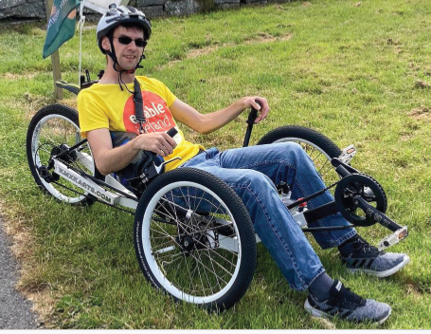

Figure 3: Wayne Wrafter, Recumbent Cyclist, Galway

**Family Status:** people with children may find it more difficult to travel along the street network due to deficiencies in the infrastructure e.g. lack of dropped kerbs making pushing a buggy difficult. In addition, women who are pregnant may require infrastructure like dropped kerbs to avoid trips.

**Ethnicity:** people from ethnic minority groups may be more likely to experience hate crime and harassment. Therefore, if appropriate, ethnicity could be considered when examining whether the proposed infrastructure is designed with equity in mind.

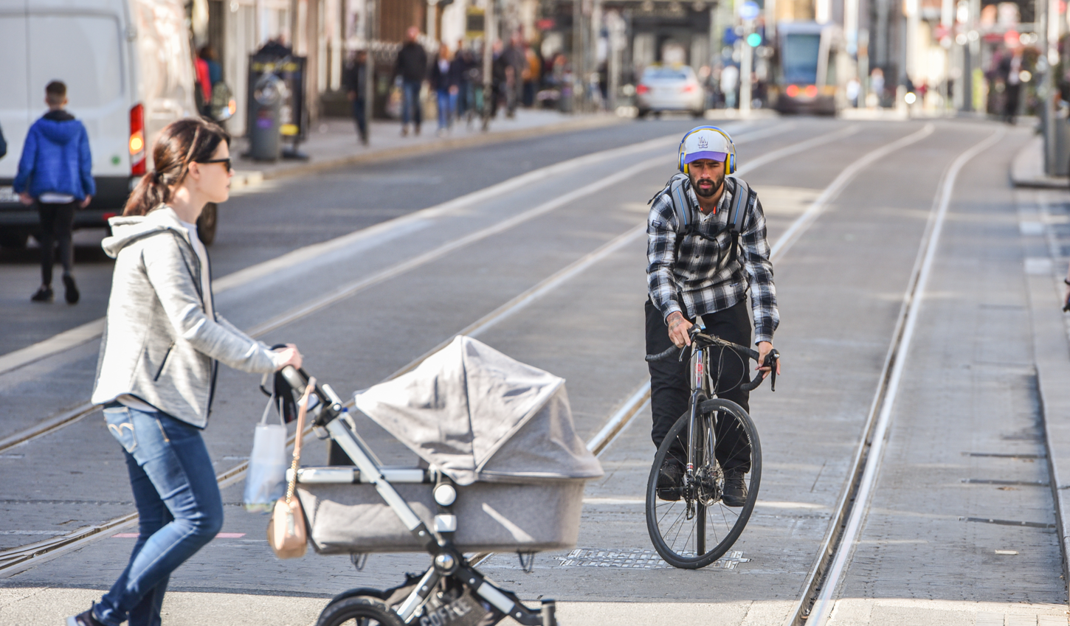

Figure 4: Woman pushing a buggy

# Design Issues Impacting Equality & Relevant Design Guidance

This section is intended to outline the common infrastructure issues experienced by people within the protected characteristics of Gender, Disability, Age and Family Status.

This table is intended to identify the common issues that are experienced, and to outline the relevant guidance that should be referred to in order to mitigate or avoid the re-occurrence of these issues. Designers should run through these questions and ensure no issues will occur due to a design oversight. Please note, in all instances, the designer should refer to IS EN: 17210: Accessibility and Usability of the Built Environment and S.R. CEN TR 17621:2021 - Functional and Technical Requirements. For a more detailed assessment refer to checklists in Appendix B and C.

Table B: Equality Issues in Infrastructure Design

|  |
| --- |
| **Issue & Relevant Guidance** |
| Issue - Lack of dropped kerbs and tactile paving:  Appropriate Guidance: [UK Guidance on the Use of Tactile Paving Surfaces](https://assets.publishing.service.gov.uk/government/uploads/system/uploads/attachment_data/file/1046126/guidance-on-the-use-of-tactile-paving-surfaces.pdf) |
| Footpath widths which are not wide enough for needs e.g. wheelchairs, child travelling alongside buggy: Appropriate Guidance: [Design Manual for Urban Roads and Streets](https://www.gov.ie/pdf/?file=https://assets.gov.ie/227051/cbe57ca9-b4c8-4aae-842f-79c805cfc639.pdf#page=null) |
| Footpath Issues: gaps in provision, condition, access, vertical separation from road or cycle lane, gradient, segregation from traffic, trip hazards, and obstructions:  Appropriate Guidance: [Design Manual for Urban Roads and Streets](https://www.gov.ie/pdf/?file=https://assets.gov.ie/227051/cbe57ca9-b4c8-4aae-842f-79c805cfc639.pdf#page=null)  [Universal Design Building for Everyone](https://universaldesign.ie/Built-Environment/Building-for-Everyone/1-External-Environment.pdf) |
| Poor footpath surface hindering wheelchair or buggy use or potentially causing trips/falls:  Appropriate Guidance: [Design Manual for Urban Roads and Streets](https://www.gov.ie/pdf/?file=https://assets.gov.ie/227051/cbe57ca9-b4c8-4aae-842f-79c805cfc639.pdf#page=null) |
| Footpath obstructions e.g. poorly maintained greenery, vehicles blocking footpath, street clutter e.g. signage: Appropriate Guidance: [Design Manual for Urban Roads and Streets](https://www.gov.ie/pdf/?file=https://assets.gov.ie/227051/cbe57ca9-b4c8-4aae-842f-79c805cfc639.pdf#page=null)  [Universal Design Building for Everyone](https://universaldesign.ie/Built-Environment/Building-for-Everyone/1-External-Environment.pdf) |
| Lack of appropriate pedestrian crossing for location, desire lines not catered for, incorrect crossing facility: Appropriate Guidance: [NTA Cycle Design Manual](https://www.nationaltransport.ie/publications/cycle-design-manual/)  [TII Standard Construction Details Series 5100](https://www.tiipublications.ie/downloads/SCD/Series-5100-SCDs-compiled-set.pdf) |
| Pedestrian Crossing quality: is there an audible push button unit, is it accessible, is the crossing time sufficient, are wait times too long, is the crossing direct, correct tactile paving in place?:  Appropriate Guidance: [Building for Everyone: A Universal Design Approach](https://universaldesign.ie/built-environment/building-for-everyone/)  [TII Standard Construction Details Series 5100](https://www.tiipublications.ie/downloads/SCD/Series-5100-SCDs-compiled-set.pdf) |
| Lack of segregated cycling facilities?:  Appropriate Guidance: [NTA Cycle Design Manual](https://www.nationaltransport.ie/publications/cycle-design-manual/) |
| **Issue & Relevant Guidance** |
| Lack of cyclist facilitation at junctions and side roads?:  Appropriate Guidance: [NTA Cycle Design Manual](https://www.nationaltransport.ie/publications/cycle-design-manual/) |
| Lack of cycle lanes wide enough to cycle with child alongside:  Appropriate Guidance: [NTA Cycle Design Manual](https://www.nationaltransport.ie/publications/cycle-design-manual/) |
| Lack of secure bicycle parking:  Appropriate Guidance: [NTA Cycle Design Manual](https://www.nationaltransport.ie/publications/cycle-design-manual/) |
| Lack of secure accessible bicycle parking for non-standard bicycles:  Appropriate Guidance: [NTA Cycle Design Manual](https://www.nationaltransport.ie/publications/cycle-design-manual/) |
| Shared space without sufficient directional guidance for blind or partially sighted pedestrians:  Appropriate Guidance: [NTA Cycle Design Manual](https://www.nationaltransport.ie/publications/cycle-design-manual/)  [Universal Design Shared Space Report](https://universaldesign.ie/Built-Environment/Shared-Space/Shared-Space-Full-Report.pdf) |
| No space to stop and rest for those that need it:  Appropriate Guidance: [Building for Everyone: A Universal Design Approach](https://universaldesign.ie/built-environment/building-for-everyone/) |
| Routes through isolated areas with limited or no passive surveillance or alternative exit points:  Appropriate Guidance: Route design choice - [NTA Cycle Design Manual](https://www.nationaltransport.ie/publications/cycle-design-manual/)  [Design Manual for Urban Roads and Streets](https://www.gov.ie/pdf/?file=https://assets.gov.ie/227051/cbe57ca9-b4c8-4aae-842f-79c805cfc639.pdf#page=null) |
| Inappropriate vehicle speeds:  Appropriate Guidance: [NTA Cycle Design Manual](https://www.nationaltransport.ie/publications/cycle-design-manual/)  [Design Manual for Urban Roads and Streets](https://www.gov.ie/pdf/?file=https://assets.gov.ie/227051/cbe57ca9-b4c8-4aae-842f-79c805cfc639.pdf#page=null) |
| Lack of, or ineffective traffic calming (required to meet design speeds):  Appropriate Guidance: [NTA Cycle Design Manual](https://www.nationaltransport.ie/publications/cycle-design-manual/)  [Design Manual for Urban Roads and Streets](https://www.gov.ie/pdf/?file=https://assets.gov.ie/227051/cbe57ca9-b4c8-4aae-842f-79c805cfc639.pdf#page=null) |
| Guard rails restricting movements or desire lines?:  Appropriate Guidance: [Design Manual for Urban Roads and Streets](https://www.gov.ie/pdf/?file=https://assets.gov.ie/227051/cbe57ca9-b4c8-4aae-842f-79c805cfc639.pdf#page=null) |
| **Issue & Relevant Guidance** |
| Access control measures blocking access to parks and public routes:  Appropriate Guidance: [NTA Access Control of Active Travel Facilities](https://www.nationaltransport.ie/wp-content/uploads/2022/08/Access-Control-Final_v3_09.08.2022.pdf) |
| Dead-ends present on routes:  Appropriate Guidance: [NTA Permeability Best Practice Guide](https://www.nationaltransport.ie/news/permeability-in-existing-urban-areas-best-practice-guide/) |
| No CCTV (where required):  Appropriate Guidance: [Code of Practice for Community Based CCTV Systems](https://assets.gov.ie/123700/bedd93b6-0ab3-404f-9622-3ef14f4b2d32.pdf) |
| Evidence of antisocial behaviour e.g. vandalism:  Appropriate Guidance: Route design choice - [NTA Cycle Design Manual](https://www.nationaltransport.ie/publications/cycle-design-manual/) |
| Reduced visibility from street clutter, overgrown trees, bushes, vegetation:  Appropriate Guidance: [Traffic Signs Manual](https://www.gov.ie/en/publication/f288e1-traffic-signs-manual/), [NTA Cycle Design Manual](https://www.nationaltransport.ie/publications/cycle-design-manual/),  [Design Manual for Urban Roads and Streets](https://www.gov.ie/pdf/?file=https://assets.gov.ie/227051/cbe57ca9-b4c8-4aae-842f-79c805cfc639.pdf#page=null) |
| Lack of appropriate lighting:  Appropriate Guidance: [NTA Cycle Design Manual](https://www.nationaltransport.ie/publications/cycle-design-manual/)  [Design Manual for Urban Roads and Streets](https://www.gov.ie/pdf/?file=https://assets.gov.ie/227051/cbe57ca9-b4c8-4aae-842f-79c805cfc639.pdf#page=null)  [TII Design of Road Lighting for the National Road Network](https://www.tiipublications.ie/library/DN-LHT-03038-03.pdf)  [PLG23; Lighting for Cycle Infrastructure; Institute of Lighting Professionals](https://theilp.org.uk/publication/plg23-lighting-for-cycling-infrastructure/)  [BS 5489-1:2020; Design of Road Lighting, Part 1 Lighting of roads and public amenity areas – Code of Practice.](https://www.thenbs.com/PublicationIndex/documents/details?Pub=BSI&DocID=265177)  I.S. EN 13201-2:2015; Road Lighting Performance requirements |
| Tunnel/laneway design without lighting, CCTV, passive surveillance where appropriate, or presence of blind corners:  Appropriate Guidance: [NTA Cycle Design Manual](https://www.nationaltransport.ie/publications/cycle-design-manual/) |
| Lack of ramped or appropriate gradient access:  Appropriate Guidance: [Building for Everyone: A Universal Design Approach](https://universaldesign.ie/built-environment/building-for-everyone/)  [NTA Cycle Design Manual](https://www.nationaltransport.ie/publications/cycle-design-manual/) |
| No lift provision (in the absence of suitable ramp):  Appropriate Guidance: [Building for Everyone: A Universal Design Approach](https://universaldesign.ie/built-environment/building-for-everyone/) |
| Handrails not provided on steps or ramp:  Appropriate Guidance: [Building for Everyone: A Universal Design Approach](https://universaldesign.ie/built-environment/building-for-everyone/) |

## Issues and Recommendations / Mitigations

It is recommended that a meeting between Designer and Sponsoring Agency is used as the primary means to discuss the relative importance of issues raised through the use of this guidance and proposed recommendations and mitigations.

The recommendations to address issues should not be overly prescriptive. Recommendations should be worded so that the Designer has some choice in the measures to be implemented. It is possible that the Designer can devise an amendment which overcomes the potential problem.

Recommendations should be as practical as possible and be appropriate in relation to the overall scheme cost and objectives. It must be recognised that the implementation of certain measures such as a change to design standards or national or local policy will be outside the scope of the designer.

Issues that remain unaddressed at the initial design stages should be reviewed at subsequent design stages. Recommendations may change throughout the design process.

A hierarchy of treatment is set out below which aims to minimise Infrastructure Equality issues. The order of preference for mitigation measures is as follows:

1. Remove the hazard or impact.
2. Relocate the hazard or impact.
3. Re-design the hazard or impact to reduce the risk to users.
4. Revise the layout or cross-section to lower the risk.
5. Reduce impact severity.
6. Relocate the route.

## Infrastructure Equality Guidance Users - Gathering Feedback

Along with the design team, the following groups could also be consulted on the design of a scheme to ensure feedback from relevant parties are considered:

* Disability User Groups
* Disabled Persons Organisation’s (DPO’s) as per the requirement to consult with DPO’s according to the UN Convention of the Rights of People with Disabilities
* Older Persons/Public Participation Networks
* Business Improvement Organisations
* Neighbourhood Associations
* Gardaí
* Community Engagement Officers
* Community Centres
* Neighbourhood businesses (shops, restaurants, etc.)
* Impacted Sport Clubs or Schools

# Equality Auditing

Accompanying this guidance document are two separate checklists which can be utilised to audit an active travel scheme either during the design stage or, post-construction. These checklists are available in Appendix B and C.

The ‘baseline/construction’ stage checklist can be used to audit the infrastructure on the ground (with a site visit), prior to starting a project, and/or to audit a scheme post-construction.

The other available checklist is the ‘Design Stage Checklist’ which can be used to audit the scheme and determine if there are any issues during preliminary or detailed design.

Following on from the completion of either checklist, a report should be completed, which outlines any issues that have been highlighted within the checklist. Mitigations and recommendations should be suggested to remove, or mitigate, any issues (where feasible) from the scheme.

## Methodology for Design Stage Checklists

The following describes a suggested method for using an Infrastructure Equality Checklist during the design stages of a project;

1. Drawings reviewed and Design Stage checklist used to assess the scheme.
2. The reviewers discuss their findings and discuss possible recommendations and mitigations.
3. The designer and Sponsoring Agency takes steps to address any recommendations/mitigations.
4. Once mitigation measures have been addressed insofar as possible, the design process for this stage can be closed out.

## Methodology for using baseline/construction checklist

Guidelines for the use of the checklist at the preliminary design stage/post-construction stage of a project.

1. Site visit should be carried out on foot or bike, whichever is more relevant.
2. Take notes of all the possible issues using the Baseline/Construction Checklist.
3. Take photographs of all the possible issues.
4. Observe road user behaviour for a period.
5. Prepare list of issues and recommendations
6. Take steps to address any mitigation measures recommended.

## Site Visits

A site visit can be carried out for baseline and construction stage checklists. The site may need to be split into sections, particularly where a road or street is defined by different characteristics at different points. The following should be considered along with the checklists:

* topography,
* local amenities,
* tie-ins of the scheme,
* time of day – consider whether checks should be done in daylight and/or at night-time,
* Season – consideration for risks present in Autumn/Winter compared to the summer time, (e.g. leaves on ground, less daylight, ice and snow),
* Time of year
* Photographs can be collected and stored for future reference.

It may be necessary to make more than one site visit during the day, particularly if traffic patterns or other factors are markedly different at different times of day.

## Report

After carrying out an audit using one of the templates, a report can be written up. The following items should be included within the report:

1. A brief description of the scheme being assessed;
2. Identified issues and recommendations for action.

The information in the report can be organised by grouping all the points under themes, such as:

* security issues
* social concerns
* accessibility issues
* sight-lines
* issues of isolation and entrapment sites
* lighting
* maintenance
* signage and maps
* nearby land use issues
* overall design features
* list of stakeholders consulted

# Expected Outcomes

The designer should use the guidance in this document to check that potential equality issues are captured and addressed or mitigated where possible.

Monitoring and evaluation processes should take place on the intervention/scheme for at least six months to one year post implementation.

#### Appendix A – Screening Template

**Infrastructure Equality Guidance Screening Template**

This screening document should be used alongside the Equality Guidance Document.

This screening template should be used to identify likely impacts on the nine protected characteristics:

1. Gender

2. Civil/Marital Status

3. Family Status

4. Age

5. Disability

6. Sexual Orientation

7. Race

8. Religion

9. Membership of the Traveller community

Table C below should be filled in as part of the screening template.

Table C: Scheme Details

| Scheme Name |  |
| --- | --- |
| Scheme Description |  |
| Aim of Scheme |  |
| Objective of Scheme |  |
| What existing sources of information will you use to help you identify the likely equality impact on different groups of people? (E.g. statistics, survey results, complaints analysis, consultation documents, customer feedback, existing briefings submissions or business reports, policies etc.) |  |
| Are there gaps in information that make it difficult or impossible to form an opinion on how your proposals might affect different groups of people? If so what are the gaps in the information and how and when do you plan to collect additional information? |  |
| Having analysed the initial and additional sources of information, is there any evidence that the proposed changes will have an adverse equality impact on any of these different groups of people and/or reduce equality of opportunity? |  |

Table D below should be used to screen the project based on the questions in Table D.

Table D: Screening Questions

| Protected Characteristic | Screening Question | Will this group be adversely impacted? | Details of Impact /Rationale for Answer |
| --- | --- | --- | --- |
| Gender | Will the scheme have a disproportionate impact on availability of or access to infrastructure used by women, men or other gender identity?  Will the construction and/or operation of the scheme have a disproportionate impact on access to employment for women, men and/or other gender identities? | Yes/No |  |
| Civil/Marital Status | Is the scheme predicted to have adverse impacts on those who are married, in a civil partnership or single? | Yes/No |  |
| Family Status | Will provision be made of a fully inclusive design for pregnant women and parents with young children? | Yes/No |  |
| Age | Is the scheme predicted to have adverse impacts on any one age category? Will elderly be affected in terms of access? Will children’s access to school or places of recreation be affected? Are the young or elderly disproportionately affected by the scheme? | Yes/No |  |
| Disability | Will provision be made for a fully inclusive and accessible design? | Yes/No |  |
| Sexual Orientation | Are particular sexual orientation groups likely to experience a differential impact as a result of scheme? | Yes/No |  |
| Race | Are particular racial or ethnic groups disproportionately represented in the communities impacted by the scheme? Will the construction of the Transport scheme impact particular racial or ethnic groups? | Yes/No |  |
| Religion | Is there any places of worship in the vicinity of the scheme that will be negatively impacted? Will any religious practices be negatively affected? | Yes/No |  |
| Membership of the Traveller community | Will the construction and/or operation of the scheme have a disproportionate impact on members of the Traveller Community? | Yes/No |  |
| Other Criteria | Is the area of the proposed development isolated? | Yes/No |  |
| Other Criteria | Is there any immitigable issues in the area that will affect accessibility e.g. very steep gradients? | Yes/No |  |

#### Appendix B – Baseline & Construction Checklist

# Checklist for Baseline and Construction Stage Projects

Instructions: sheet to be completed per street or area

| **Details** |  |
| --- | --- |
| **Type of Area:** | e.g. residential, commercial, school etc. |
| **Date:** |  |
| **Location:** |  |
| **Section:** |  |
| **Time/Day:** |  |

| **Issue** | **Guiding Questions** | **Yes** | **No** | **Comments** |
| --- | --- | --- | --- | --- |
| **Footpaths** | Is there a footpath? |  |  |  |
| **Footpaths** | Are there footpaths on both side of the road? |  |  |  |
| **Footpaths** | Are the footpaths continuous? |  |  |  |
| **Footpaths** | Are the footpaths in good condition/well maintained? (Cracks, unevenness, damaged, slippery) |  |  |  |
| **Footpaths** | Are footpaths at least 1.8m wide (or wider in busy areas) |  |  |  |
| **Footpaths** | If the footpath is not at least 1.8m wide does the route have passing places provided at intervals for wheelchair users? |  |  |  |
| **Footpaths** | Is footpath access ramped/are dropped kerbs available regularly? |  |  |  |
| **Footpaths** | Are the footpaths non-slip and well drained? |  |  |  |
| **Footpaths** | Are the footpaths vertically separate from the cycle lane? Describe vertical separator if present? |  |  |  |
| **Footpaths** | Are the footpaths separated from a cycle lane by a 60mm kerb, a white line or a delineator? |  |  | Note segregation type: |
| **Footpaths** | Is the gradient greater than 1:12? (E.g. too steep for a wheelchair?) |  |  | Note – measuring tool needed |
| **Footpaths** | Is the gradient steep? |  |  |  |
| **Footpaths** | Is the footpath separated from the traffic? How is it separated? |  |  |  |
| **Footpaths** | Does it feel safe to walk here? |  |  |  |
| **Footpaths** | Is there any trip hazards? |  |  |  |
| **Footpaths** | Is there sufficient space to push a buggy (with a suitable surface) |  |  |  |
| **Footpaths** | Is there evidence of informal paths or walkways that should be formalised? |  |  |  |
| **Footpaths** | Are there pedestrian crossings available? |  |  |  |
| **Footpaths** | Are they appropriate for the location (e.g. signalised or uncontrolled) |  |  |  |
| **Pedestrian/Cycle Crossings** | Are there pedestrian crossings available? |  |  |  |
| **Pedestrian/Cycle Crossings** | Are they appropriate for the location (e.g. signalised or uncontrolled) |  |  |  |
| **Pedestrian/Cycle Crossings** | Is there a push button? Is the push button accessible? |  |  |  |
| **Pedestrian/Cycle Crossings** | Are there enough crossings? |  |  |  |
| **Pedestrian/Cycle Crossings** | Is the crossing time likely to be sufficient for slow users? |  |  |  |
| **Pedestrian/Cycle Crossings** | Are the crossing waiting times too long? |  |  |  |
| **Pedestrian/Cycle Crossings** | Are the crossings direct? |  |  |  |
| **Pedestrian/Cycle Crossings** | Do the uncontrolled crossings have dropped kerbs or step free crossings? |  |  |  |
| **Pedestrian/Cycle Crossings** | Does the uncontrolled crossing tactile paving comply with UK Department of Transport 2021: "Guidance on the use of Tactile Paving Surfaces" (UK Department of Transport 2021: Guidance on the Use of Tactile Paving) |  |  |  |
| **Pedestrian/Cycle Crossings** | Are there guardrails which restrict crossing movements? |  |  |  |
| **Pedestrian/Cycle Crossings** | Is there parked vehicles obstructing the crossing (e.g. reducing visibility at crossing)? |  |  |  |
| **Pedestrian/Cycle Crossings** | If the crossing is uncontrolled, is it safe and easy to cross? (note if distance is too great, or traffic is too voluminous) |  |  |  |
| **Pedestrian/Cycle Crossings** | If the crossing has more than 2 lanes of traffic is there an island half way? |  |  |  |
| **Pedestrian/Cycle Crossings** | Are the crossings near enough? |  |  |  |
| **Cycle facilities** | Is there cycling facilities present e.g. on road, segregated etc? |  |  |  |
| **Cycle facilities** | Is the cycle lane segregated/protected? |  |  |  |
| **Cycle facilities** | Is the cycle lane separated from footpath by line, delineator or 60mm kerb with height difference? |  |  |  |
| **Cycle facilities** | Is the cycle lane separated from traffic by >100mm kerb, lining or delineator? |  |  |  |
| **Cycle facilities** | Perform the 6 way check. Can the cyclist safely navigate the junction? |  |  |  |
| **Cycle facilities** | Does the cyclist interact with pedestrians at the junction? (e.g. pelican crossing) Is there any conflicts? |  |  |  |
| **Cycle facilities** | Can cyclists safely cross the road where necessary? Is there dropped kerbs available to join a segregated facility? |  |  |  |
| **Cycle facilities** | Is cycle parking in a safe area? (lit, sheltered, not isolated/out of sight) |  |  |  |
| **Cycle facilities** | Is there an existing cycle network that infrastructure on this road would connect to if built? |  |  |  |
| **Cycle facilities** | Is any shared space present suitable for vulnerable users (e.g. blind) |  |  |  |
| **Public Transport Access** | Is the walking distance between public transport stops appropriate (~400m)? |  |  |  |
| **Public Transport Access** | Is real time information available? |  |  |  |
| **Public Transport Access** | Is there seating at the bus stop? |  |  |  |
| **Public Transport Access** | Is there lighting at the bus stop? |  |  |  |
| **Public Transport Access** | Is there shelter at the bus stop? |  |  |  |
| **Public Transport Access** | Is there cycle parking and is the cycle parking in a busy area (not isolated), and has lighting, security etc. |  |  |  |
| **Public Transport Access** | Is the ‘last mile’ from a bus stop/public transport suitable for walking alone and in the dark? |  |  |  |
| **Public Transport Access** | Is there any illegal parking – on double yellow lines, obstructing access, parking across dropped kerbs, |  |  |  |
| **Infrastructure** | How many traffic lanes are present? |  |  |  |
| **Infrastructure** | Are turning radii too wide? |  |  |  |
| **Infrastructure** | Is traffic calming present? |  |  |  |
| **Infrastructure** | Is traffic calming needed? |  |  |  |
| **Infrastructure** | Is there a dead end? |  |  |  |
| **Infrastructure** | Is there parking on Footpaths |  |  |  |
| **Infrastructure** | Is there parking across cycles lanes |  |  |  |
| **Road User Behaviour** | Cyclists on footpaths |  |  |  |
| **Road User Behaviour** | Scooters on footpaths |  |  |  |
| **Road User Behaviour** | Drivers don’t stop for lights |  |  |  |
| **Road User Behaviour** | Vehicles speeding |  |  |  |
| **Road User Behaviour** | Drivers don’t yield |  |  |  |
| **Lighting** | How well lit is the area? |  |  |  |
| **Lighting** | Are there spaces which are poorly lit? |  |  |  |
| **Lighting** | How clearly does the lighting illuminate directional signs? |  |  |  |
| **Lighting** | Does the lighting make you feel safe/ unsafe? |  |  |  |
| **Lighting** | Is the lighting obscured by anything e.g. trees |  |  |  |
| **Lighting** | Is the footpath or cycle lane clearly illuminated? |  |  |  |
| **Maintenance** | Is there rubbish lying about? |  |  |  |
| **Maintenance** | Does the general state of maintenance of the area make you feel safe/ unsafe? |  |  |  |
| **Maintenance** | Is there evidence of vandalism? |  |  |  |
| **Maintenance** | Area is rundown |  |  |  |
| **Busy / Isolated** | Are there a lot of people using this area? |  |  |  |
| **Busy / Isolated** | What are they doing (e.g. walking, working, meeting, loitering)? |  |  |  |
| **Busy / Isolated** | Does this make you feel safe/unsafe? |  |  |  |
| **Busy / Isolated** | Are there places that feel empty and unsafe? |  |  |  |
| **Busy / Isolated** | Are there particular spaces where people could hide? |  |  |  |
| **Busy / Isolated** | Is there derelict buildings? |  |  |  |
| **Busy / Isolated** | Does this make you feel safe/unsafe? |  |  |  |
| **Busy / Isolated** | If in a stairwell or an underpass could someone hear you if you called for help? |  |  |  |
| **Busy / Isolated** | Does the area appear safe from crime, harassment or similar threats? |  |  |  |
| **Busy / Isolated** | Is there antisocial behaviour or evidence of such? |  |  |  |
| **Signage** | Is the street signage needed or should it be removed? |  |  |  |
| **Signage** | Is there wayfinding signage present? |  |  |  |
| **Signage** | Are there signs to tell you how to get to places e.g. bus stops, markets and buildings? |  |  |  |
| **Signage** | Is the signage damaged/need replacing |  |  |  |
| **Visibility** | Can you tell what is at the other end of a tunnel, path or walkway? |  |  |  |
| **Visibility** | Is street visibility obstructed by anything e.g. lampposts, pillars, bins, bushes, walls? |  |  |  |
| **Visibility** | Is planting low to the ground and doesn’t impact sight lines? |  |  |  |
| **Visibility** | Is there active building fronts? |  |  |  |
| **Visibility** | Are there small, confined areas hidden from view? E.g. alleyways, blind corners, utility shed, laneway, construction site. |  |  |  |
| **Visibility** | Are there areas that should be locked, fenced or barricaded? E.g. vacant lots, abandoned houses, building entrances, kiosks. |  |  |  |
| **Visibility** | Will proposed infrastructure be in an area of passive surveillance? |  |  |  |
| **Visibility** | Is there high walls and fences along the route? |  |  |  |
| **Accessibility** | Is there ramped access to amenities? |  |  |  |
| **Accessibility** | Is the area easily accessible for persons with mobility issues? Is there steps or inaccessible areas for someone with limited mobility? |  |  |  |
| **Accessibility** | Is the current layout accessible for people with disabilities? |  |  |  |
| **Accessibility** | Will the proposed scheme have an impact on people with disabilities? Explain. |  |  |  |
| **Accessibility** | Are the wheelchair access ramps appropriate (slope less than or equal to 1:12)? |  |  | Measuring tool required. |
| **Accessibility** | Is there a lift available where there is no ramp? |  |  |  |
| **Accessibility** | Are handrails provided where needed? |  |  |  |
| **Accessibility** | Do any hazards have appropriate tactiles (refer to UK Department of Transport 2021: Guidance on the Use of Tactile Paving) e.g. steps, edges, etc.? |  |  |  |
| **Accessibility** | Is tactile paving to the standard of the UK Department of Transport 2021: Guidance on the Use of Tactile Paving? |  |  |  |
| **Accessibility** | Is there tactile paving at crossings? |  |  |  |
| **Accessibility** | Are the tactiles correctly aligned? |  |  |  |
| **Accessibility** | Are there audible or vibrating cues at crossings with associated tactiles on the signal buttons? |  |  |  |
| **Accessibility** | Is there an alternate well-lit and frequently used path available? |  |  |  |
| **Accessibility** | Are there obstacles in the way of the walkway/footpath? |  |  |  |
| **Accessibility** | Are facilities easily accessible from the footpath? |  |  |  |
| **Accessibility** | Is there seating to stop and rest? |  |  |  |
| **Accessibility** | Are bicycle parking facilities available close to amenities? |  |  |  |
| **Accessibility** | Is the bicycle parking outside the main ‘accessible’ route? |  |  |  |
| **Accessibility** | Is the bicycle parking accessible? E.g. suitable for mobility bicycles, cargo bicycles? |  |  |  |
| **Accessibility** | Is the area a shared area or shared surface that is difficult for the visually or mobility impaired to navigate? |  |  |  |
| **Accessibility** | Is tonal and colour contrast used appropriately? |  |  |  |
| **Accessibility** | Are there any barriers on this route (list in comment box) |  |  |  |
| **Surveillance** | Is there mobile phone coverage? |  |  |  |
| **Surveillance** | Is there adequate passive surveillance? |  |  |  |
| **Surveillance** | Is there CCTV? |  |  |  |
| **Other** | Is the speed limit appropriate? |  |  |  |
| **Other** | Are there excessive noise levels? |  |  |  |
| **Other** | Is there evidence of air pollution (fumes, construction dust, smoke, cigarette smoke) |  |  |  |
| **Other** | Are there any other things about this space that makes you feel unsafe? |  |  |  |
| **Attractiveness** | There is nowhere to rest |  |  |  |
| **Attractiveness** | There is not enough shade/shelter |  |  |  |

#### Appendix C – Design Stage Checklist

# **Checklist for Design Stage Projects**

Instructions: sheet to be completed per street or area.

|  |  |
| --- | --- |
| **Details** |  |
| **Type of Area:** | e.g. residential, commercial, school etc. |
| **Date:** |  |
| **Location:** |  |
| **Design Stage** |  |
| **Section of Street/Area:** |  |

| **Issue** | **Guiding Questions** | **Yes** | **No** | **Comments** |
| --- | --- | --- | --- | --- |
| **Footpaths** | Is there a footpath? |  |  |  |
| **Footpaths** | Are there footpaths on both side of the road? |  |  |  |
| **Footpaths** | Are the footpaths continuous? |  |  |  |
| **Footpaths** | Are footpaths at least 1.8m wide (or wider in busy areas) |  |  |  |
| **Footpaths** | If the footpath is not at least 1.8m wide does the route have passing places provided at intervals for wheelchair users? |  |  |  |
| **Footpaths** | Is footpath access ramped/are dropped kerbs available regularly? |  |  |  |
| **Footpaths** | Are the footpaths designed using suitable materials? |  |  |  |
| **Footpaths** | Are the footpaths vertically segregated from the cycle lane? Describe vertical separator if present. |  |  |  |
| **Footpaths** | Are the footpaths separated from a cycle lane by a 60mm kerb, a white line or a delineator? |  |  | Note segregation type: |
| **Footpaths** | Is the gradient greater than 1:12? (E.g. too steep for a wheelchair?) |  |  | Note – measuring tool needed |
| **Footpaths** | Is the footpath separated from the traffic? How is it separated? |  |  |  |
| **Footpaths** | Is there any trip hazards evident in the drawings? |  |  |  |
| **Footpaths** | Have informal paths or walkways been formalised? |  |  |  |
| **Pedestrian / Cycle Crossings** | Are there pedestrian crossings available? |  |  |  |
| **Pedestrian / Cycle Crossings** | Are they appropriate for the location (e.g. signalised or uncontrolled) |  |  |  |
| **Pedestrian / Cycle Crossings** | Are there enough crossings along the length of the scheme? |  |  |  |
| **Pedestrian / Cycle Crossings** | What is the crossing time allowed? |  |  |  |
| **Pedestrian / Cycle Crossings** | Is this crossing time likely to be sufficient for slow users? |  |  |  |
| **Pedestrian / Cycle Crossings** | Are the crossings direct? |  |  |  |
| **Pedestrian / Cycle Crossings** | Do the uncontrolled crossings have dropped kerbs or step free crossings? |  |  |  |
| **Pedestrian / Cycle Crossings** | Does the uncontrolled crossing tactile paving comply with UK Department of Transport 2021: "Guidance on the use of Tactile Paving Surfaces" |  |  |  |
| **Pedestrian / Cycle Crossings** | Are there guardrails which restrict crossing movements? |  |  |  |
| **Pedestrian / Cycle Crossings** | If the crossing is uncontrolled, is it safe and easy to cross? (note if crossing distance is too great, or traffic from surveys indicates volumes may be high) |  |  |  |
| **Pedestrian / Cycle Crossings** | If the crossing has more than 2 lanes of traffic is there an island half way? |  |  |  |
| **Pedestrian / Cycle Crossings** | Are the crossings near enough to key trip attractors? |  |  |  |
| **Cycle facilities** | Is there a cycle lane |  |  |  |
| **Cycle facilities** | Is the cycle lane segregated/protected? |  |  |  |
| **Cycle facilities** | Is the cycle lane separated from footpath by line, delineator or 60mm kerb with height difference? |  |  |  |
| **Cycle facilities** | If the cycle lane separated from traffic by >100mm kerb, lining or delineator? |  |  |  |
| **Cycle facilities** | Perform the 6 way check. Can the cyclist safely navigate the junction? |  |  |  |
| **Cycle facilities** | Does the cyclist interact with pedestrians at the junction? (e.g. pelican crossing) Is there any conflicts? |  |  |  |
| **Cycle facilities** | Can cyclists safely cross the road where necessary? Is there dropped kerbs available to join a segregated facility? |  |  |  |
| **Cycle facilities** | Is cycle parking in a safe area? (lit, sheltered, not isolated/out of sight) |  |  |  |
| **Cycle facilities** | Is there an existing cycle network that infrastructure on this road would connect to if built? |  |  |  |
| **Cycle facilities** | Is any shared space present that may be unsuitable for vulnerable users (e.g. blind) |  |  |  |
| **Public Transport Access** | Is the walking distance between public transport stops appropriate (~400m)? |  |  |  |
| **Public Transport Access** | Will real time information available |  |  |  |
| **Public Transport Access** | Will there be seating at the bus stop? |  |  |  |
| **Public Transport Access** | Will there be lighting at the bus stop? |  |  |  |
| **Public Transport Access** | Will there be a shelter at the bus stop? |  |  |  |
| **Public Transport Access** | Will there be cycle parking and is the cycle parking in a busy area (not isolated), and has lighting, security etc. |  |  |  |
| **Public Transport Access** | Is the ‘last mile’ from a bus stop/public transport suitable for walking alone and in the dark? |  |  |  |
| **Infrastructure** | How many traffic lanes are present? |  |  |  |
| **Infrastructure** | Are turning radii regulation? |  |  |  |
| **Infrastructure** | Is traffic calming present? |  |  |  |
| **Infrastructure** | Is traffic calming needed? |  |  |  |
| **Infrastructure** | Is there a dead end? |  |  |  |
| **Road User Behaviour** | Have steps been taken to rectify negative road user behaviour as identified in the baseline audit? |  |  |  |
| **Lighting** | Is lighting provided? |  |  |  |
| **Lighting** | Are there spaces which are poorly lit? |  |  |  |
| **Lighting** | Will the lighting illuminate directional signs? |  |  |  |
| **Lighting** | Is the lighting obscured by anything e.g. trees |  |  |  |
| **Lighting** | Is the footpath or cycle lane clearly illuminated? |  |  |  |
| **Busy/Isolated** | Are there particular spaces where people could hide? |  |  |  |
| **Busy/Isolated** | Is there derelict buildings? |  |  |  |
| **Busy/Isolated** | If in a stairwell or an underpass could someone hear you if you called for help? |  |  |  |
| **Signage** | Is the street signage needed or should it be removed? |  |  |  |
| **Signage** | Is there wayfinding signage present? |  |  |  |
| **Visibility** | Is street visibility obstructed by anything e.g. lampposts, pillars, bins, bushes, walls? |  |  |  |
| **Visibility** | Is planting low to the ground and doesn’t impact sight lines? |  |  |  |
| **Visibility** | Is there active building fronts? |  |  |  |
| **Visibility** | Are there small confined areas hidden from view? E.g. alleyways, blind corners, utility shed, laneway, construction site. |  |  |  |
| **Visibility** | Are there areas that should be locked, fenced or barricaded? E.g. vacant lots, abandoned houses, building entrances, kiosks. |  |  |  |
| **Visibility** | Will proposed infrastructure be in an area of passive surveillance? |  |  |  |
| **Visibility** | Is there high walls and fences along the route? |  |  |  |
| **Accessibility** | Is there ramped access to amenities? |  |  |  |
| **Accessibility** | Is there steps or inaccessible areas for someone with limited mobility? |  |  |  |
| **Accessibility** | Are the wheelchair access ramps appropriate (slope less than or equal to 1:12)? |  |  |  |
| **Accessibility** | Is there a lift available where there is no ramp? |  |  |  |
| **Accessibility** | Are handrails provided where needed? |  |  |  |
| **Accessibility** | Do any hazards have appropriate tactiles e.g. steps, edges, etc.? (refer to UK Department of Transport 2021: Guidance on the Use of Tactile Paving) |  |  |  |
| **Accessibility** | Is tactile paving to the standard of the UK Department of Transport 2021: Guidance on the Use of Tactile Paving? |  |  |  |
| **Accessibility** | Is there tactile paving at crossings? |  |  |  |
| **Accessibility** | Are the tactiles correctly aligned? |  |  |  |
| **Accessibility** | Will there be audible or vibrating cues at crossings with associated tactiles on the signal buttons? |  |  |  |
| **Accessibility** | Are there obstacles in the way of the walkway/footpath? |  |  |  |
| **Accessibility** | Are facilities easily accessible from the footpath? |  |  |  |
| **Accessibility** | Is there seating to stop and rest? |  |  |  |
| **Accessibility** | Is bicycle parking available close to amenities/along main route? |  |  |  |
| **Accessibility** | Is the bicycle parking accessible? E.g. suitable for mobility bicycles, cargo bicycles? |  |  |  |
| **Accessibility** | Is the area a shared area or shared surface that is difficult for the visually or mobility impaired to navigate? |  |  |  |
| **Accessibility** | Is tonal and colour contrast used appropriately? |  |  |  |
| **Accessibility** | Is there any barriers on this route (list in comment box) |  |  |  |
| **Surveillance** | Is there CCTV? |  |  |  |
| **Surveillance** | Will there be adequate passive surveillance? |  |  |  |
| **Attractiveness** | Will there be places/seating to rest? |  |  |  |
| **Attractiveness** | Will there be shade/shelter along the route? |  |  |  |
| **Other** | Is the speed limit appropriate? |  |  |  |