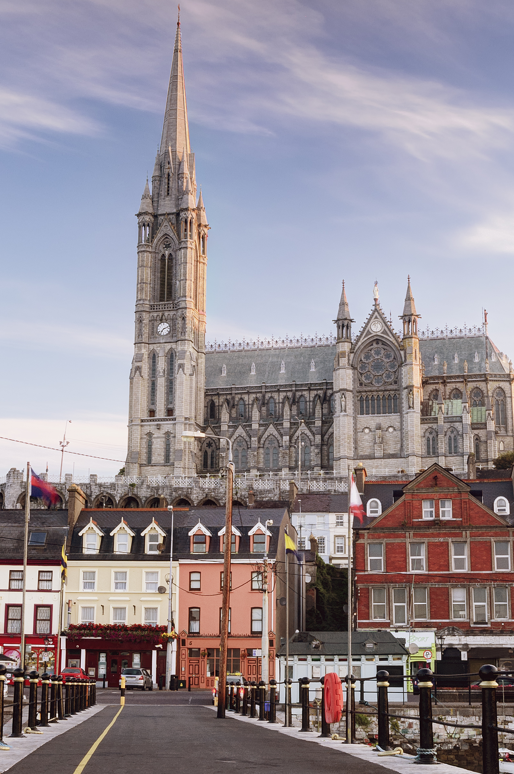
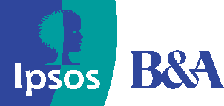

Cork Shopper Report

Quantitative Study
2025

Prepared by:
Clare Kavanagh and
Maurvi Narvekar

March 2024
Contents

1 Introduction 3
2 Research Methodology 4
3 Executive summary 5
4 Detailed findings 6
4.1 Main purpose of visiting Cork City Centre: 6
4.2 Mode of Transport Used to Get to Cork City Centre: 9
4.3 Share of Estimated Spend in the City Centre 10

1 Introduction
NTA commissioned a shopper survey in Cork in June 2022 along with Dublin during the same time. This was then continued in Limerick in 2024 and lastly Waterford and Galway in 2025. The core objective of this study remained the same for all cities and was to investigate how much money users of different transport methods are spending in Cork city centre. Besides this, the research also aimed to:
- Understand the main purpose of visit to the city centre.
- Assess the mode of transport used to get to Cork city centre and how sustainable they are.

2 Research Methodology
A comparable quantitative research approach was used in Cork as other cities. Face to face interviews were conducted in city centre locations in Cork namely, Patrick Street and Oliver Plunkett Street with adults aged 16+ who are living in Ireland. Feedback was captured using tablets and a pre-programmed script. A total of 621 interviews were undertaken giving a Margin of Error (MOE) of +/- 4 at 95% Confidence Interval on total results. The number of interviews at each location was as follows: Patrick Street – 314, Oliver Plunkett Street - 307. The profile of the sample across all locations skewed older with 45% aged over 35 years old.

Fieldwork was undertaken between 7th June to 8th July 2022

Profile of sample across interviewing locations

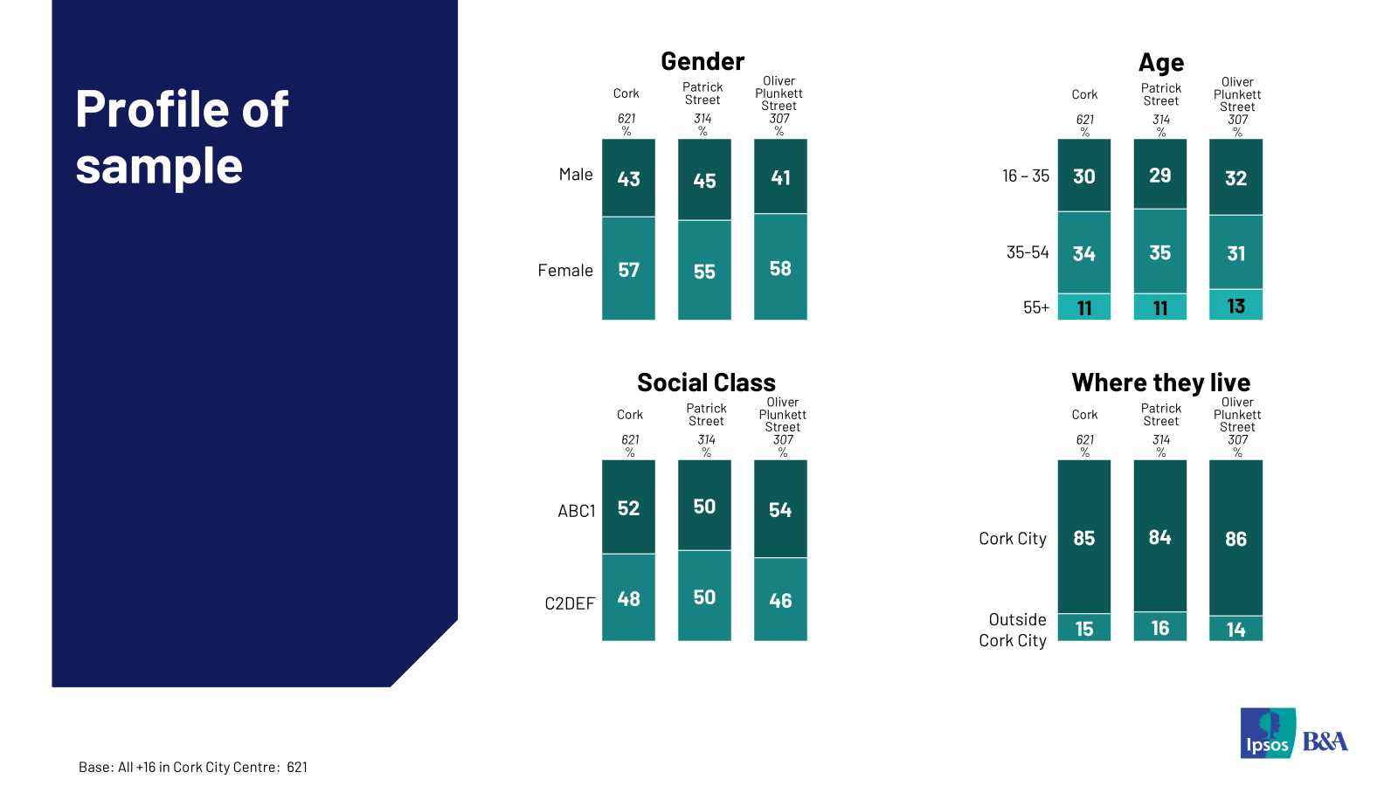

3 Executive summary
Results of this shopper survey indicate that sustainable modes of transport bring a strong share of spend to Cork city centre. 64% of those interviewed in June 2022 visited Cork city centre using a sustainable mode of transport, the average spend of those using sustainable modes was €59.98 and this accounted for 52% of total spend of the visitors to the city centre. 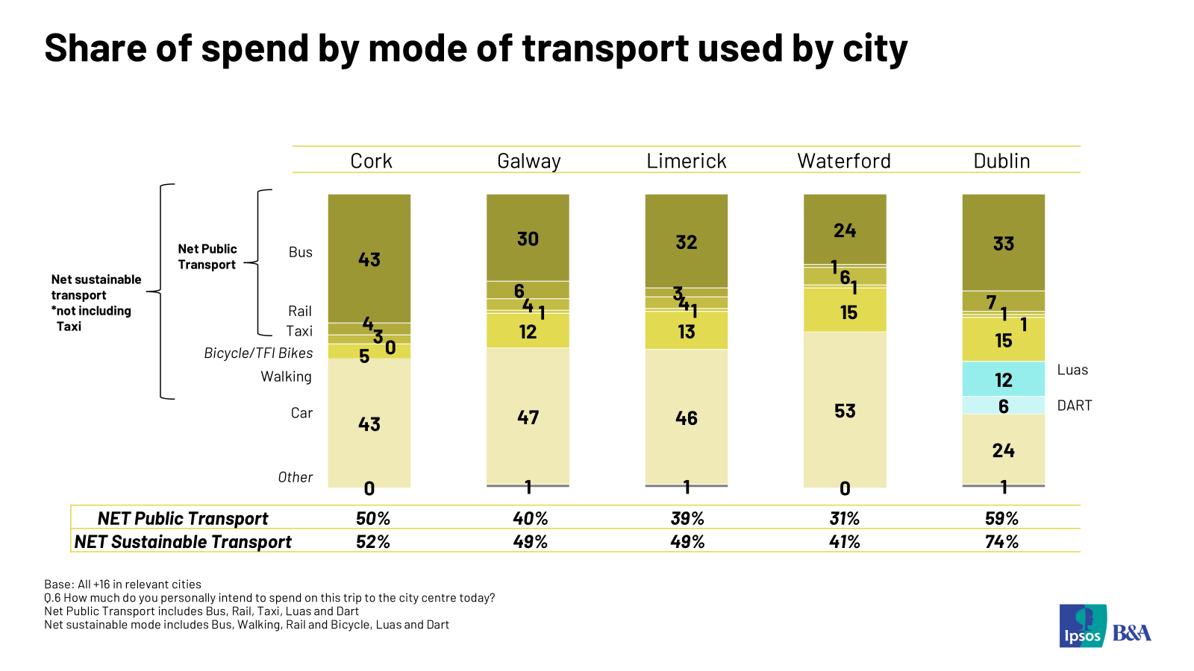

- ****
Looking in more detail the results show as noted earlier, that Cork City centre visitors skew older with 45% aged over 35 years old and the majority live in Cork City (85%) rather than outside the city. Shopping is the main reason for visiting the city centre with 57% citing this reason. Weekend shopping was reported at 58% and Weekend Day at 57%.
The main modes of transport used, to get to the city centre are bus (50%), car (34%) and walking (10%). 66% use a sustainable mode and 53% use public transport. For the journey back home, bus and public transport trips generally are slightly more popular at 56% and 60% respectively, indicating strong two-way reliance.
The average anticipated spend of visitors in the city centre is €67.57 with 42% of respondents intended spending over €50. Results show that bus and car users (both at 43%) account for the highest share of spend with bus users only slightly higher.

- Detailed findings
  - Main purpose of visiting visit Cork City Centre:
Respondents visit Cork city centre for various reasons but the primary purpose to visit is for shopping which was mentioned by 57% of visitors. Other commonly mentioned reasons are commuting to work/school (23%), going to a restaurant/eating out (10%), going a pub/having a drink out (2%) and cinema (1%). Both, Patrick street and Oliver Plunkett street had similar levels of visitors to shop.
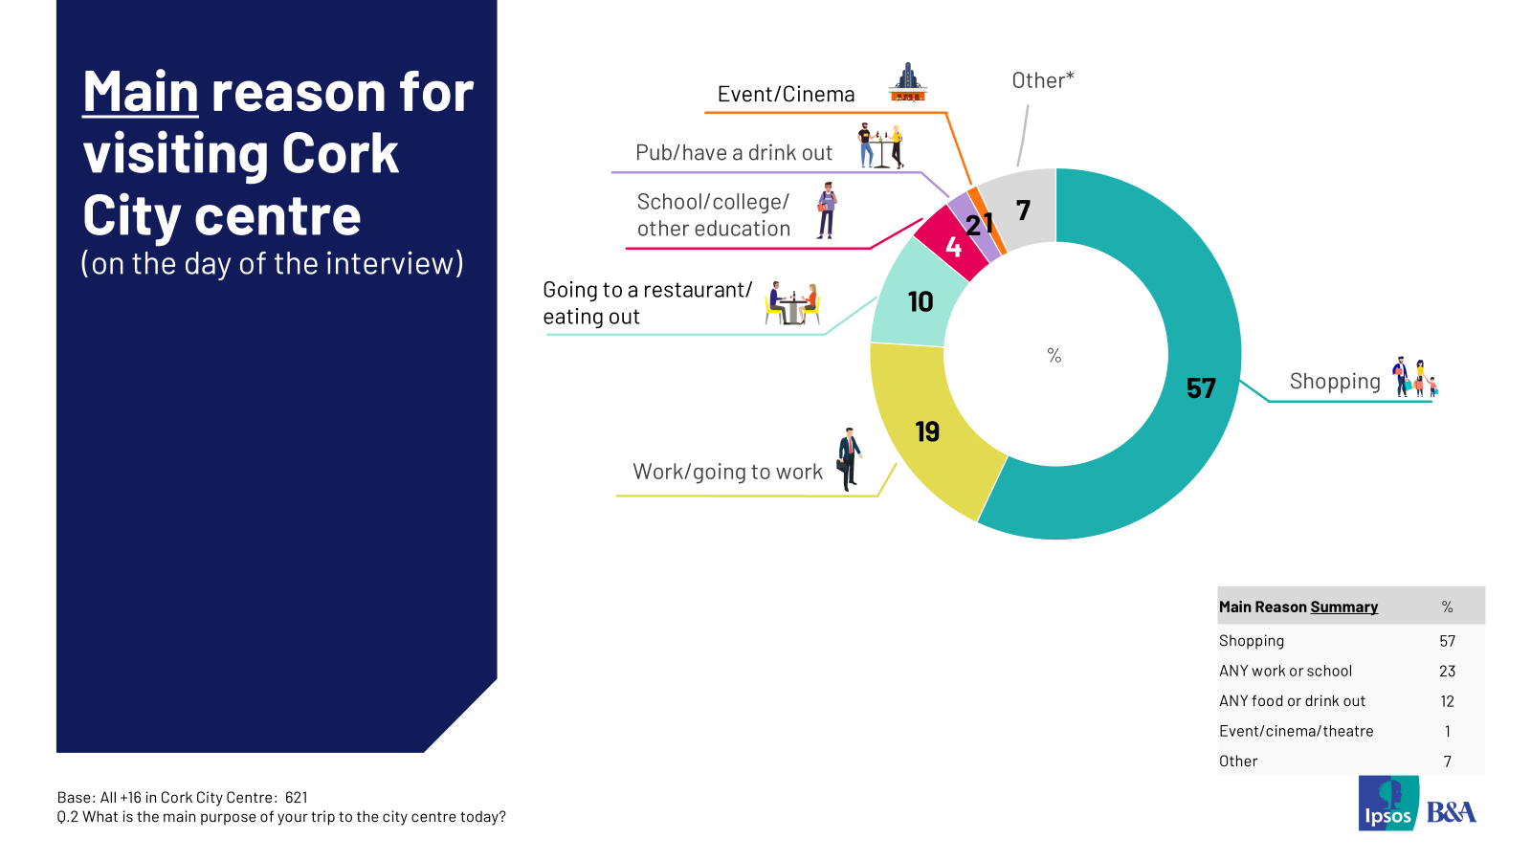

When asked how long respondents expected to spend in the city centre, 64% estimated spending 2+ hours. About half (45%) of the visitors expect to spend between 2 and 5 hours in the city centre. And one in five visitors expected to stay in the city centre for over 5 hours.
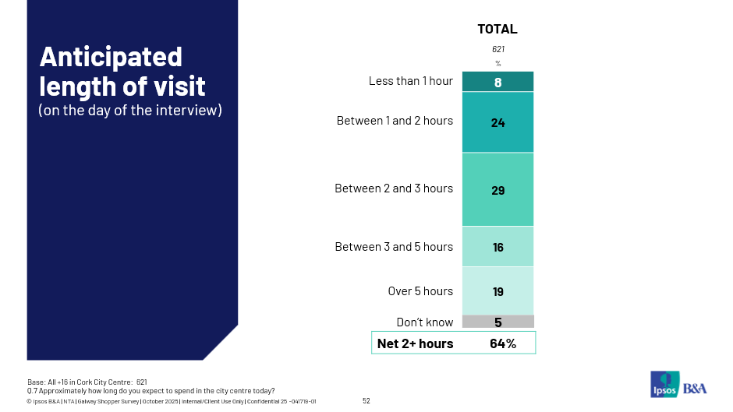

In the past four weeks, 50% of the visitors have visited Cork city centre at least five times and 33% have been to the city centre 10 times or more. 16% say they’ve been there 5-9 times and 37% have visited 1-4 times. On average, respondents have visited the Cork city centre 7.84 times in the past four weeks.

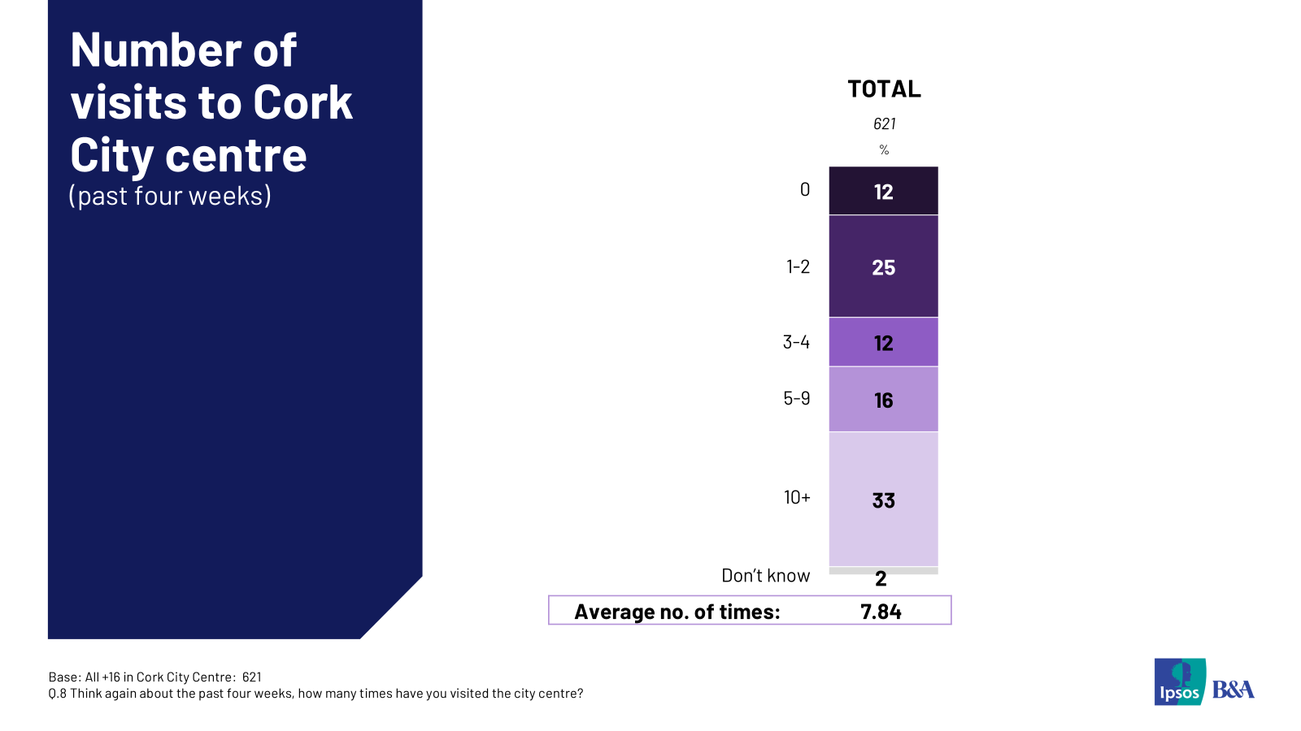

In the past four weeks, males have visited the Cork city centre 8.42 times which is more than females who have visited 7.37 times.

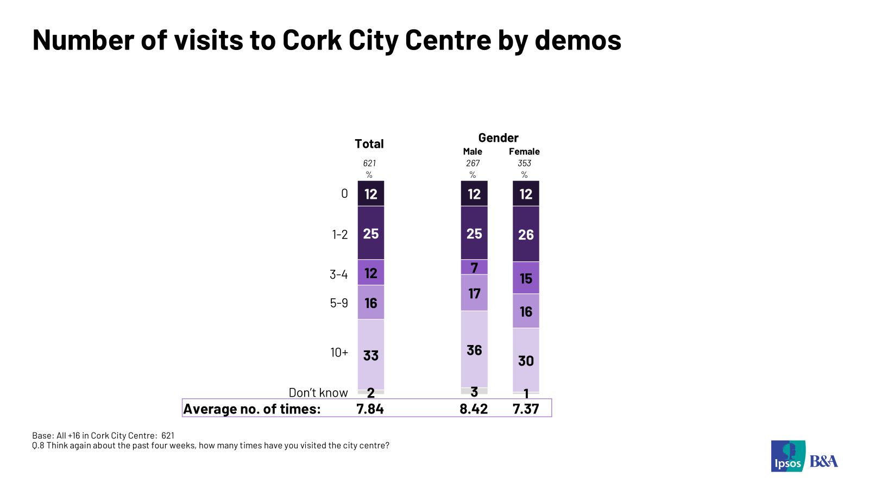

  - Mode of Transport Used to Get to Cork City Centre:
Bus was the top mode reported used on the day of the interview to get into and from the city. 50% reported they used bus to get into the city centre and 56% reported they used this mode to get home. The claimed use of public transport modes was 53% to get to the city centre and 60% to get home. Looking in overview, 64% used sustainable modes to get into the city centre and 66% to get home. In the breakdown of sustainable modes of transport, bus dominates followed by walking. And 34% visitors used a car to get to the city centre. Car users are most likely to park in multi-storey locations (43%) with 13% parking on the street and 27% getting dropped off.
When asked about transport used over the past four weeks, results mirror the day of interview data. Bus was the top mode reported and sustainable transport dominates.
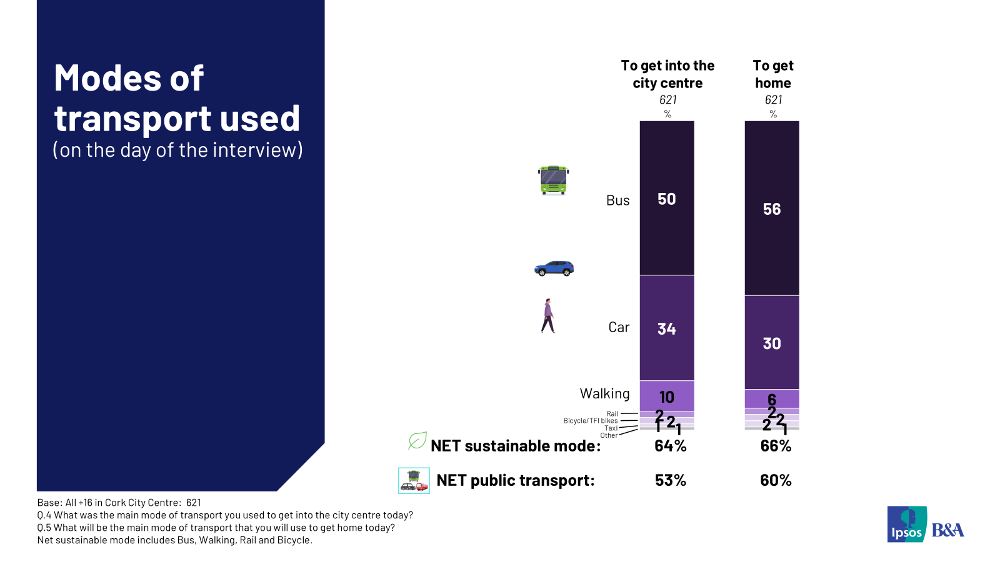

  - Share of Estimated Spend in the City Centre
On the day of the interview, the average anticipated spend in the city centre was €67.57 and 42% of respondents intended spending over €50 on this single trip.
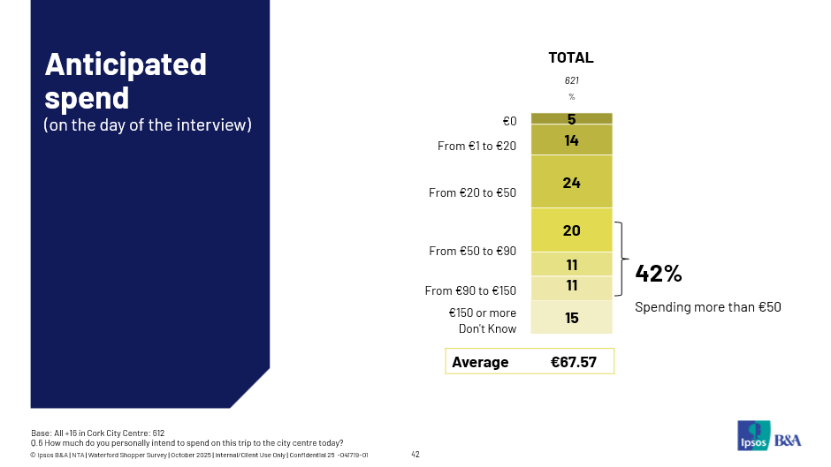
The highest estimated daily spends per mode were reported for taxi (€193.00), rail (€129.29) and car (€88.55). Bus (€60.15) and walking (€37.57) trips deliver lower spend per person per trip. Perhaps not surprisingly shopping delivers the highest per person spend at an average of €89.39, work (€16.38) and education trips (€12.41) are lower spend.
When we multiply the spend by mode per trip by the number of mode users we can get the simple share per mode. Results show that bus and car users (both at 43%) account for the highest share of spend with bus only slightly higher. 52% of city centre spend is contributed by respondents using sustainable modes and 50% of spend is accounted for by public transport users.
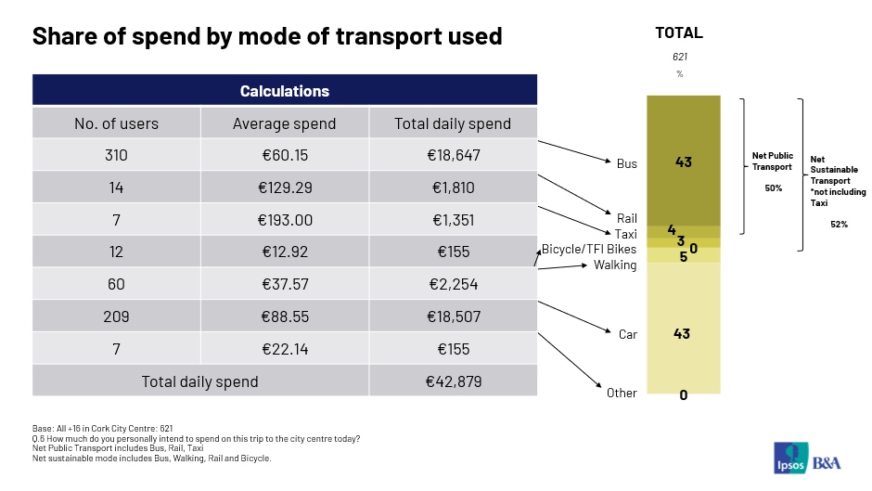

© 2025 Ipsos B&A – all rights reserved.
The contents of this proposal constitute the sole and exclusive property of Ipsos B&A. Ipsos B&A retains all right, title and interest, including without limitation copyright, in or to any Ipsos B&A trademarks, technologies, methodologies, products, analyses, software and know-how included or arising out of this report or used in connection with the preparation of this proposal. No licence under any copyright is hereby granted or implied.
The contents of this proposal are of a commercially sensitive and confidential nature and intended solely for the review and consideration of the person or entity to which it is addressed. No other use is permitted and the addressee undertakes not to disclose all or part of this proposal to any third party (including but not limited, where applicable, pursuant to the Freedom of Information Act 2000) without the prior written consent of the Company Secretary of Ipsos B&A.

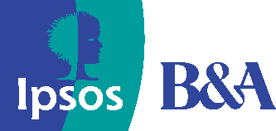
For more information

Ipsos B&A,
Milltown House, Mt St Annes
Milltown, Dublin 6
Ireland
t: +353 (0) 1 205 7500

Ipsos B&A,
Block 3, Blackrock Business Park
Carysfort Avenue
Blackrock
Co. Dublin
Ireland
t: +353 (0) 1 438 9000

www.ipsosbanda.ie

