
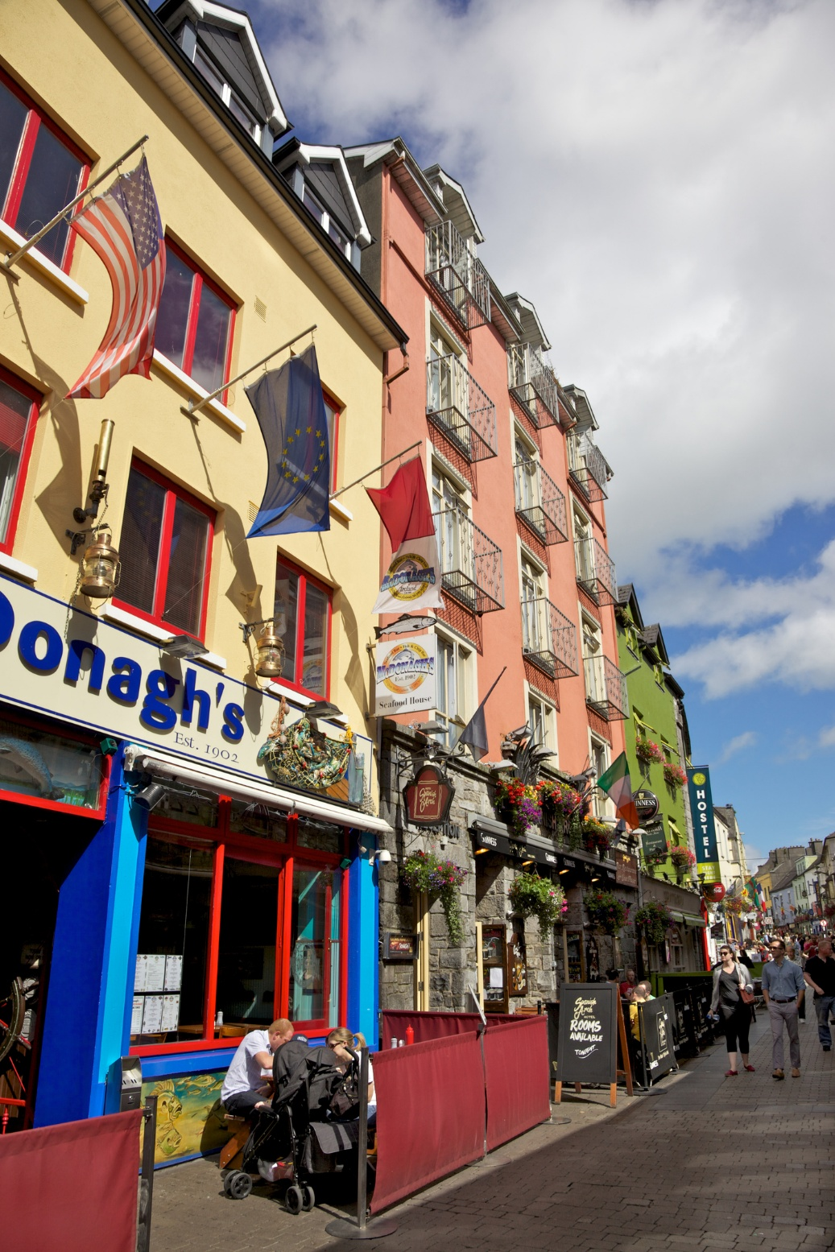
- For

Galway Shopper Report

Quantitative Study
2025

Prepared by:
Clare Kavanagh and
Maurvi Narvekar

March 2024
Contents

1 Introduction 3
2 Research Methodology 4
3 Executive summary 5
4 Detailed findings 6
4.1 Main purpose of visiting Galway City Centre: 6
4.2 Mode of Transport Used to Get to Galway City Centre: 9
4.3 Share of Estimated Spend in the City Centre 10

1 Introduction
As a continuation of the Shopper Surveys conducted in Dublin and Cork in 2022, Limerick in 2024 and Waterford in 2025, NTA commissioned a shopper survey in Galway in September 2025. The core objective of this study remained the same as the other cities and was to investigate how much money users of different transport methods are spending in Galway city centre. Besides this, the research also aimed to:
- Understand the main purpose of visit to the city centre.
- Assess the mode of transport used to get to Galway city centre and how sustainable they are.

2 Research Methodology
A comparable quantitative research approach was used in Galway as other cities. Face to face interviews were conducted in city centre locations in Galway namely, Eyre Square, High Street, Shop Street, Quay Street with adults aged 16+ who are living in Ireland. Feedback was captured using tablets and a pre-programmed script. A total of 605 interviews were undertaken giving a Margin of Error (MOE) of +/- 4 at 95% Confidence Interval on total results. The number of interviews at each location was as follows: Eyre Square-135, High Street-161, Shop Street-165, Quay Street-144. The profile of the sample across all locations skewed younger with 60% aged under 35 years old.

Fieldwork was undertaken between 1st and 29th September 2025

Profile of sample across interviewing locations

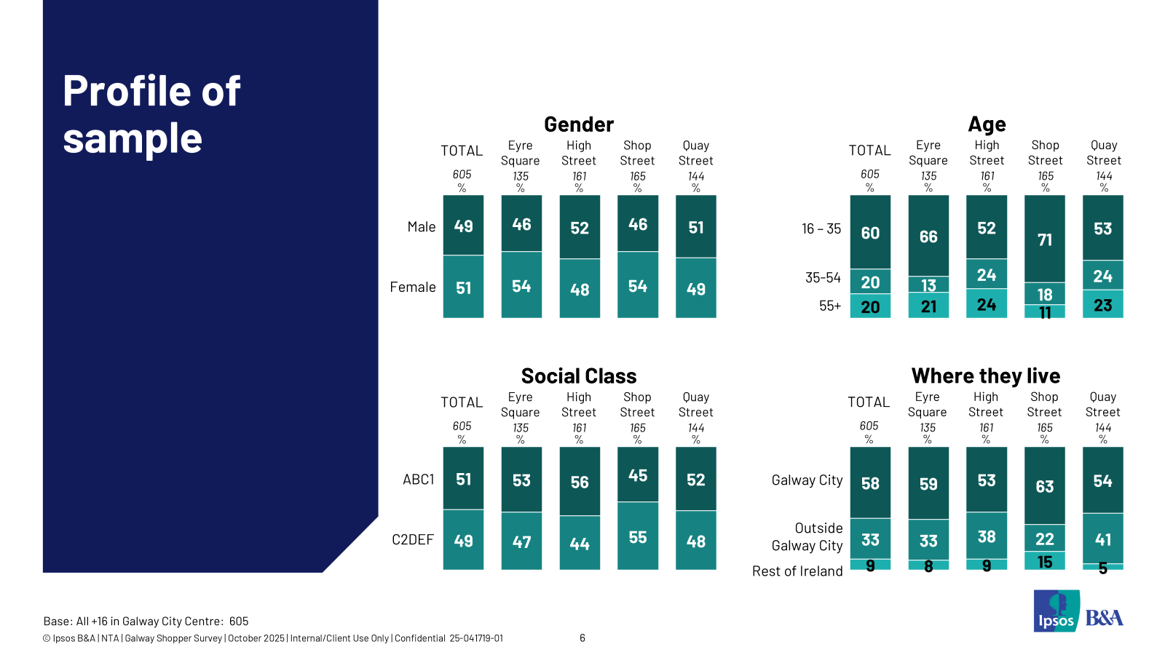

3 Executive summary
Results of this shopper survey indicate that sustainable modes of transport bring a strong share of spend to Galway city centre. 67% of those interviewed in September 2025 visited Galway city centre using a sustainable mode of transport, the average spend of those using sustainable modes was €37.00 and this accounted for 49% of total spend of the visitors to the city centre. 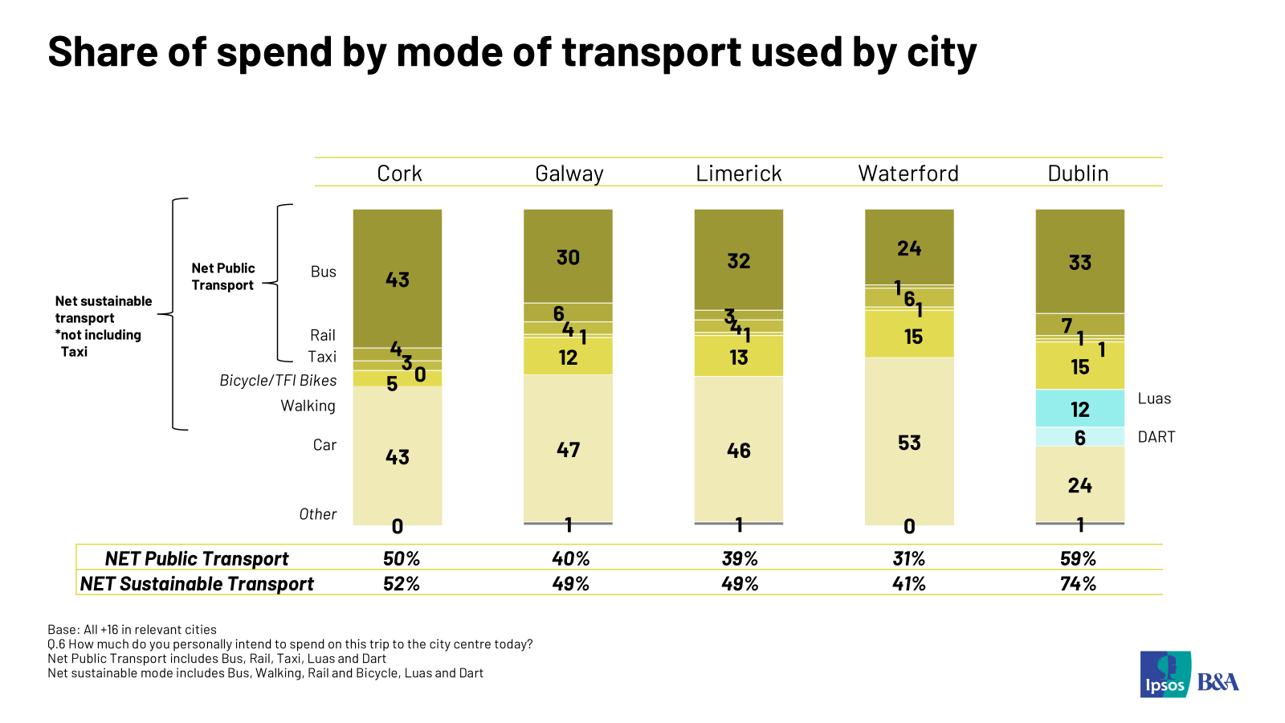

- ****
Looking in more detail the results show as noted earlier, that Galway City centre visitors skew younger with 60% aged under 35 years old and the majority live in Galway City (58%) rather than outside the city. Shopping is the main reason for visiting the city centre with 44% citing this reason. Thirty eight percent report multiple reasons to visit (and spend). Those shopping in the city centre are more likely women and are older than the average visitor with one in four aged over 55 years old.
The main modes of transport used, to get to the city centre are bus (40%), car (30%) and walking (22%). 67% use a sustainable mode and 46% use public transport. For the journey back home, bus and public transport trips generally are slightly more popular at 43% and 49% respectively, indicating strong two-way reliance. Under 35s are more likely to prefer the bus as well as walking while older adults are more likely to avail of a car.
The average anticipated spend of visitors in the city centre is €51.00 with just over two in five planning to spend over €50. Over 55-year-olds and car users indicate a higher per person spend compared to bus users and walkers. Results show that car users (47%) account for the highest share of spend followed by bus users (30%).

- Detailed findings
  - Main purpose of visiting Galway City Centre:
Respondents visit Galway city centre for various reasons but the primary purpose to visit is for shopping which was mentioned by 44% of visitors. Other commonly mentioned reasons are commuting to work/school (30%), going to a restaurant/eating out (8%), going a pub/having a drink out (3%) and cinema (1%). Fewer than 2% mention each of a long tail of other reasons including medical appointments, beauty services, leisure and fitness. 38% of shoppers cited more than one reason for visiting the city centre with restaurant/ eating out being the most likely mentioned additional reason for visiting the city centre. The profile of shopping visitors skews more female and older.

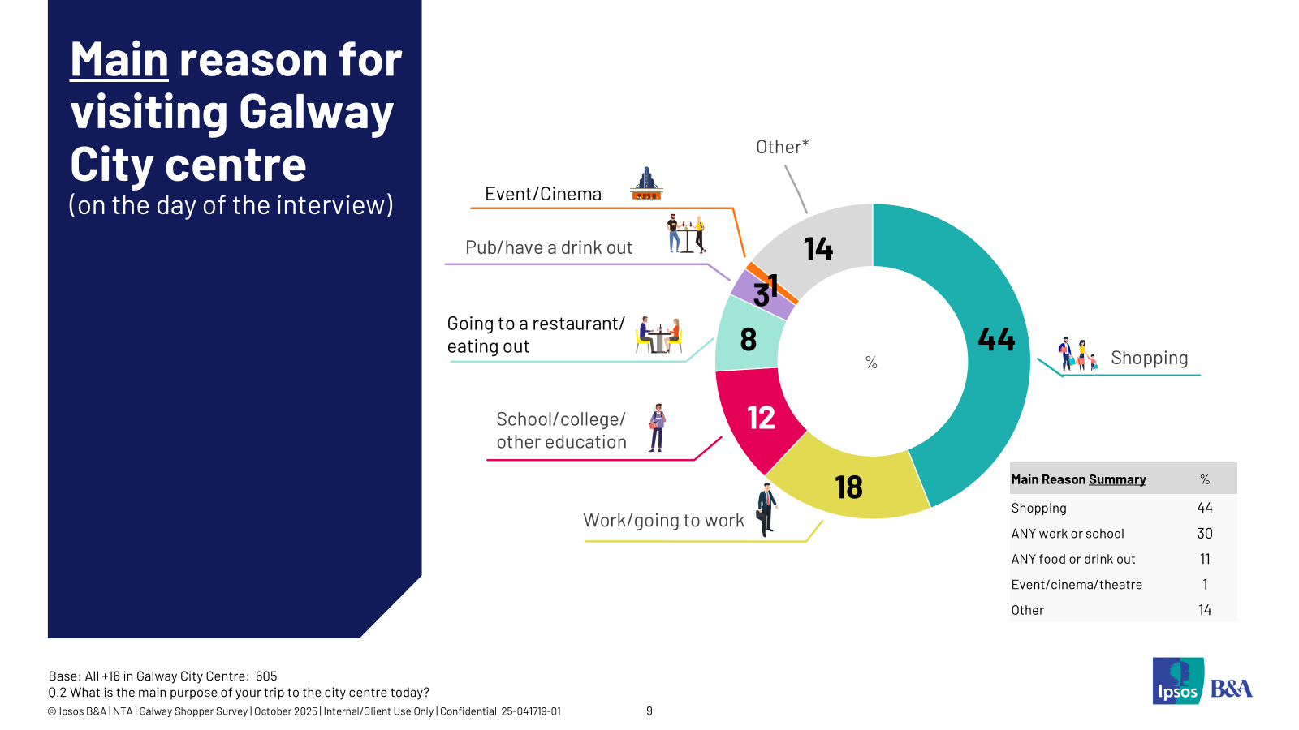
When asked how long respondents expected to spend in the city centre, 75% estimated spending 2+ hours. One in four visitors expected to stay in the city centre for over 5 hours. Longer stays of 5+ hours are more likely from further traveling visitors and less likely among adults over the age of 55 years old. Four in five 35–54-year-olds spend at least 2 hours per trip.
- 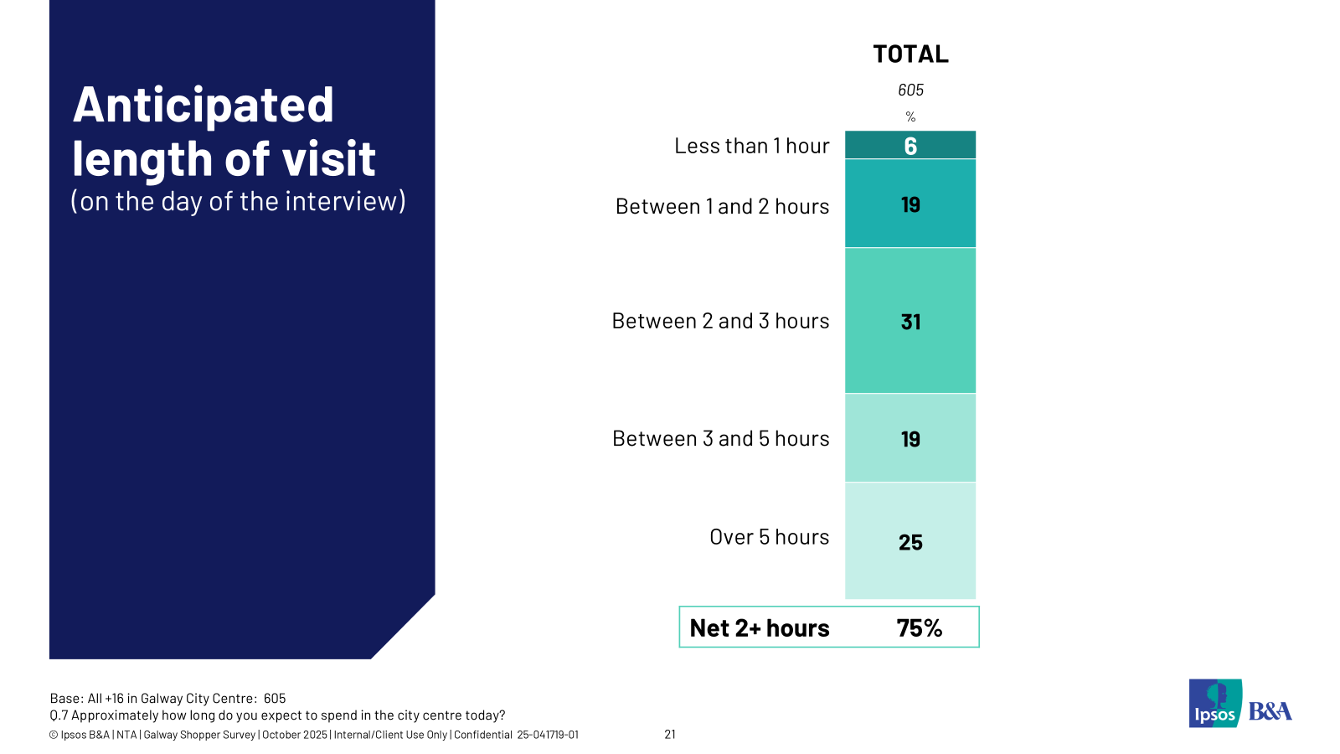
In the past four weeks, nearly three out of four visitors have visited Galway city centre at least five times and 56% have been to the city centre 10 times or more. 18% say they’ve been there 5-9 times and 24% have visited 1-4 times. On average, respondents have visited the Galway city centre 13.2 times in the past four weeks.

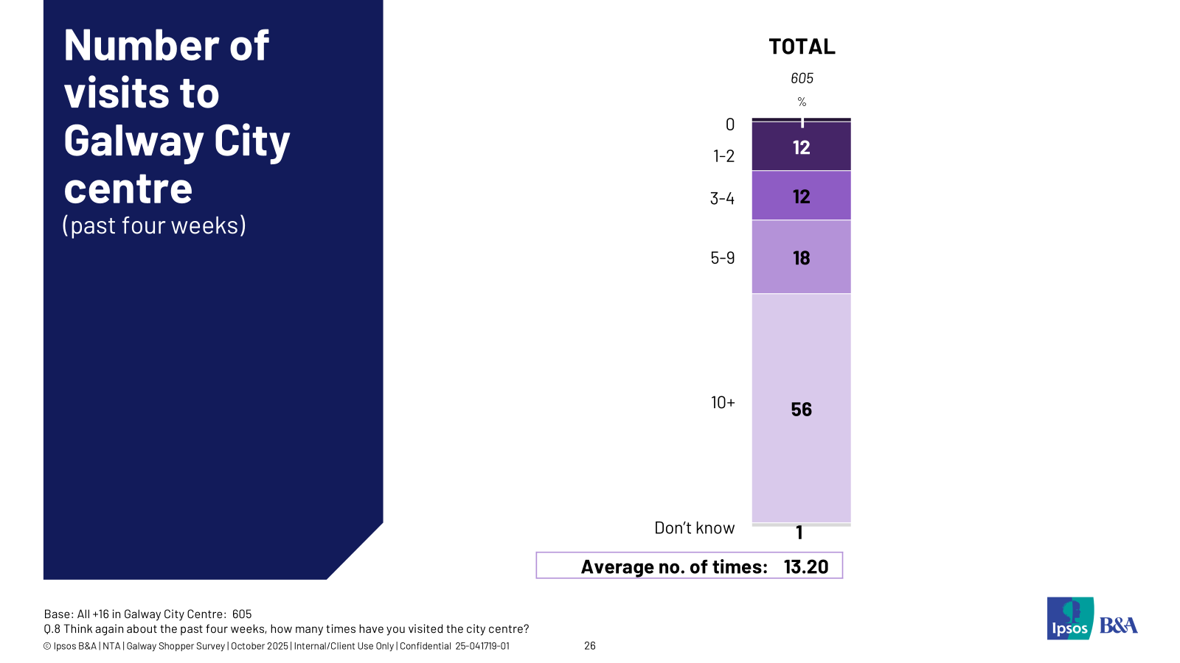

Across demographics, in the past four weeks those living in Galway city have visited the city centre the most at an average of 16.28 times closely followed by those under 35 years at 14.33 times.

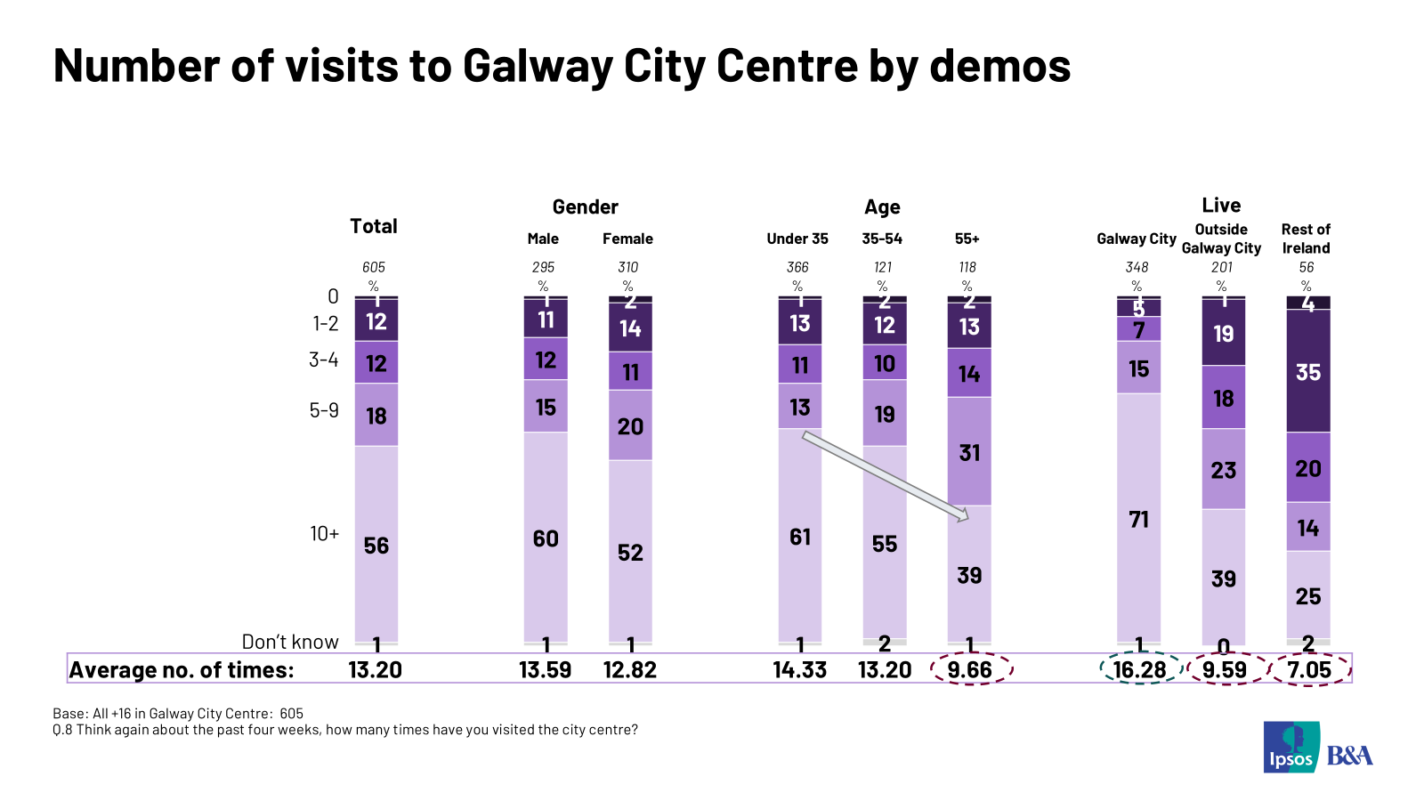

  - Mode of Transport Used to Get to Galway City Centre:
Bus was the top mode reported used on the day of the interview to get into and from the city. 40% reported they used bus to get into the city centre and 43% reported they used this mode to get home. There was minimal claimed use of other public transport modes, so net public transport usage was mentioned by 46% to get to the city centre and 49% to get home. Looking in overview, 67% used sustainable modes to get into the city centre and 68% to get home. In the breakdown of sustainable modes of transport, bus dominates followed by walking. Of the three in ten who claimed to use a car to get to and from the city centre the majority used a car park rather than getting dropped off. Car users are most likely to park in multi-storey locations (60%) with 17% parking on the street.
When asked about transport used over the past four weeks, results mirror the day of interview data. Bus was the top mode reported and sustainable transport dominates.
- 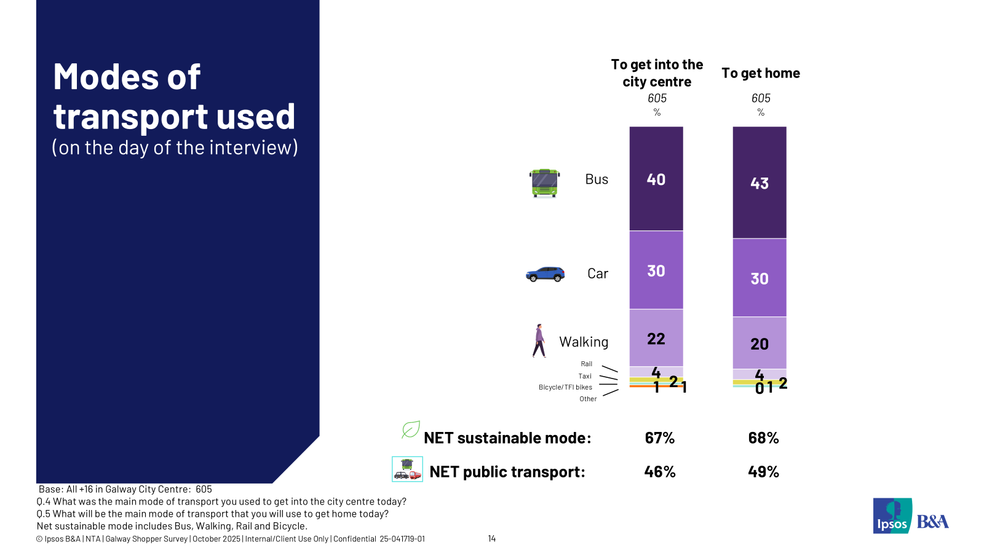

  - Share of Estimated Spend in the City Centre
On the day of the interview, the average anticipated spend in the city centre was €51.00 and 40% of respondents intended spending over €50 on this single trip.
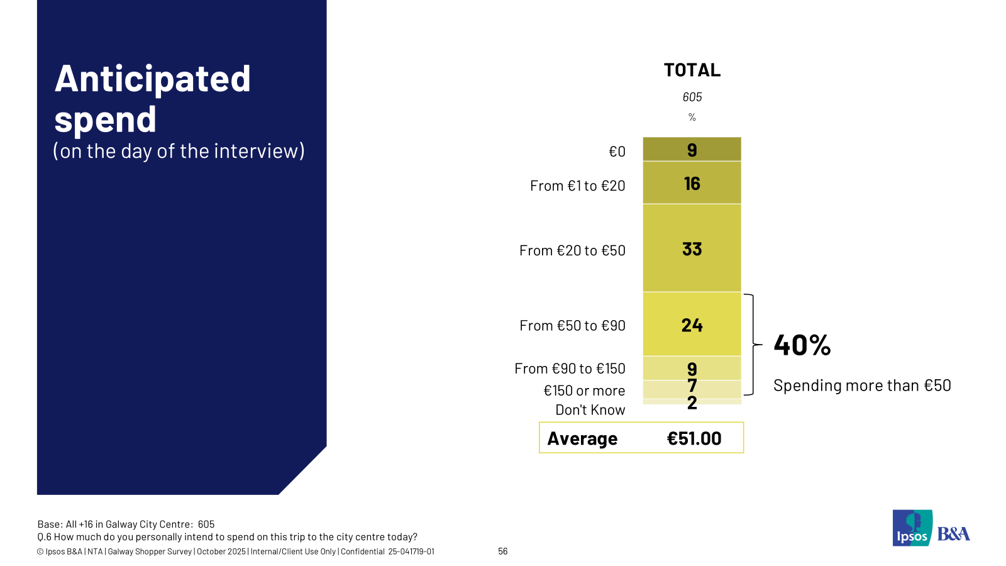

The highest estimated daily spends per mode were reported for car (€79.25) rail (€78.14) and taxi (€83.07). Bus (€38.35) and walking (€27.31) trips deliver lower spend per person per trip. Perhaps not surprisingly shopping delivers the highest per person spend at an average of €74.07, work (€19.71) and education trips (€21.77) are lower spend.
When we multiply the spend by mode per trip by the number of mode users we can get the simple share per mode. Results show that car users (47%) account for the highest share of spend followed by bus users (30%). About half (49%) of city centre spend is contributed by respondents using sustainable modes to get to the city centre. And 40% of spend is accounted for by public transport users. 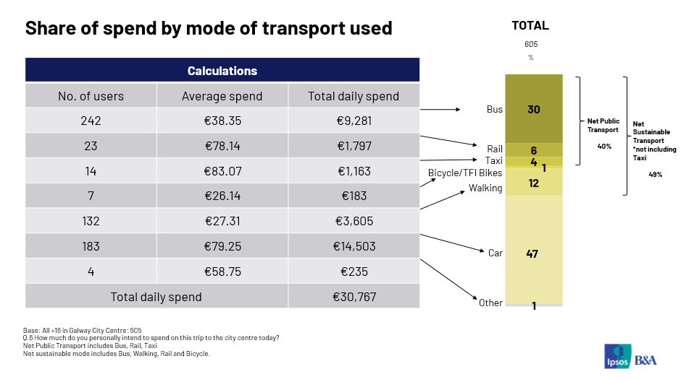

© 2025 Ipsos B&A – all rights reserved.
The contents of this proposal constitute the sole and exclusive property of Ipsos B&A. Ipsos B&A retains all right, title and interest, including without limitation copyright, in or to any Ipsos B&A trademarks, technologies, methodologies, products, analyses, software and know-how included or arising out of this report or used in connection with the preparation of this proposal. No licence under any copyright is hereby granted or implied.
The contents of this proposal are of a commercially sensitive and confidential nature and intended solely for the review and consideration of the person or entity to which it is addressed. No other use is permitted and the addressee undertakes not to disclose all or part of this proposal to any third party (including but not limited, where applicable, pursuant to the Freedom of Information Act 2000) without the prior written consent of the Company Secretary of Ipsos B&A.


For more information
Ipsos B&A,
Milltown House, Mt St Annes
Milltown, Dublin 6
Ireland
t: +353 (0) 1 205 7500

Ipsos B&A,
Block 3, Blackrock Business Park
Carysfort Avenue
Blackrock
Co. Dublin
Ireland
t: +353 (0) 1 438 9000

www.ipsosbanda.ie

