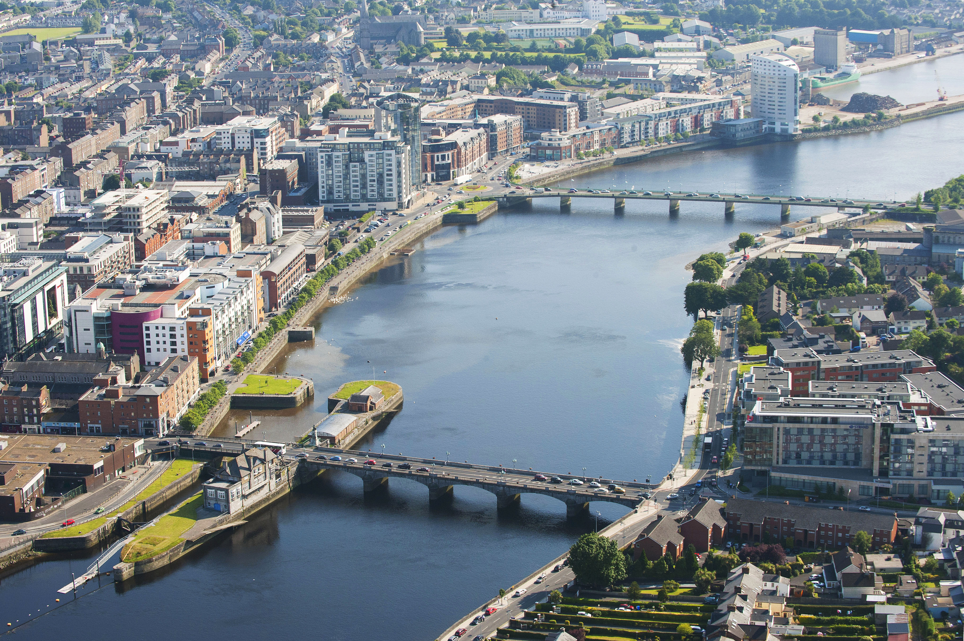

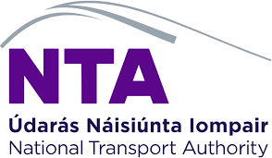

Limerick Shopper Report

Quantitative Study
2025

Prepared by:
Clare Kavanagh and
Maurvi Narvekar

March 2024

Contents

1 Introduction 3
2 Research Methodology 4
3 Executive summary 5
4 Detailed findings 6
4.1 Main purpose of visiting Limerick City Centre: 6
4.2 Mode of Transport Used to Get to Limerick City Centre: 9
4.3 Share of Estimated Spend in the City Centre 10

1 Introduction
As a continuation of the Shopper Surveys conducted in Dublin and Cork in 2022, and very recently in Galway and Waterford in 2025, NTA commissioned a shopper survey in Limerick in June 2024. The core objective of this study remained the same as the other cities and was to investigate how much money users of different transport methods are spending in Limerick city centre. Besides this, the research also aimed to:
- Understand the main purpose of visit to the city centre.
- Assess the mode of transport used to get to Limerick city centre and how sustainable they are.

2 Research Methodology
A comparable quantitative research approach was used in Limerick as other cities. Face to face interviews were conducted in city centre locations in Limerick namely, O’Connell Street, Thomas Street with adults aged 16+ who are living in Ireland. Feedback was captured using tablets and a pre-programmed script. A total of 621 interviews were undertaken giving a Margin of Error (MOE) of +/- 4 at 95% Confidence Interval on total results. The number of interviews at each location was as follows: O’Connell Street- 330, Thomas Street- 291. The profile of the sample across all locations skewed younger with 39% aged under 35 years old.

Fieldwork was undertaken between 4th June and 9th July 2024.

Profile of sample across interviewing locations

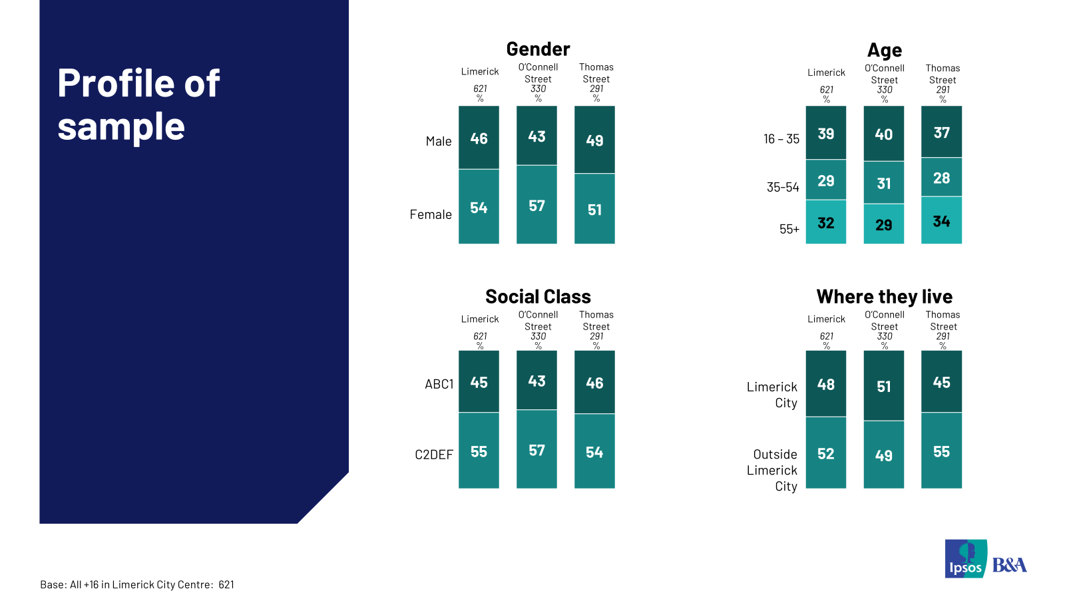

3 Executive summary
Results of this shopper survey indicate that sustainable modes of transport bring a strong share of spend to Limerick city centre. 60% of those interviewed in June 2024 visited Limerick city centre using a sustainable mode of transport, the average spend of those using sustainable modes was €52.95 and this accounted for 49% of total spend of the visitors to the city centre. 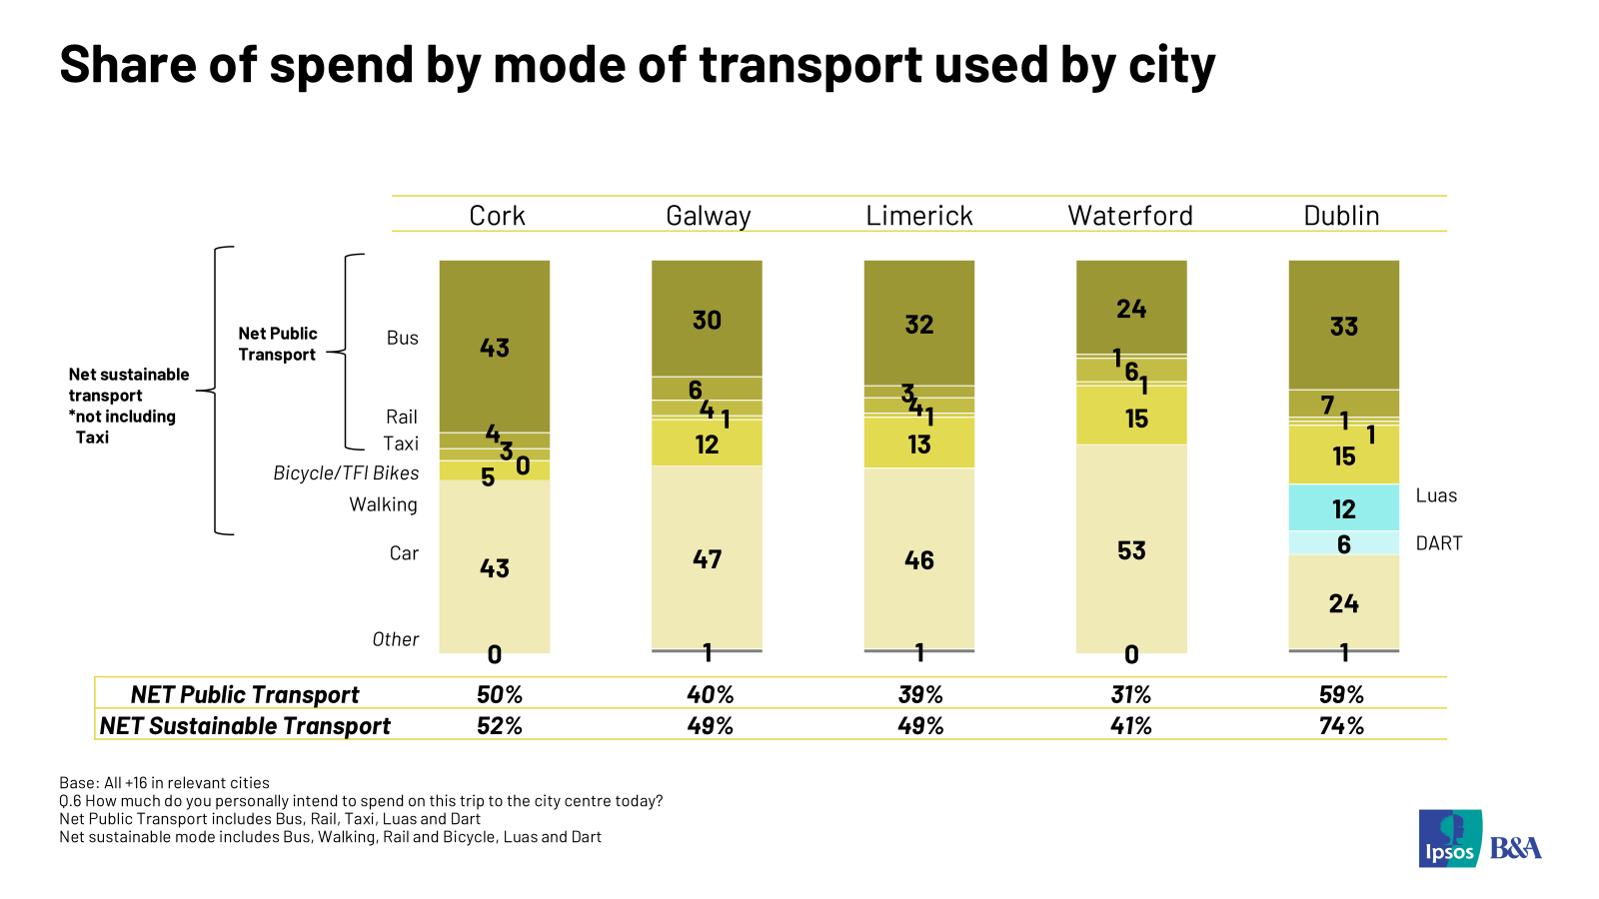

- ****
Looking in more detail the results show as noted earlier, that Limerick City centre visitors skew slightly older with 61% aged over 35 years old, however, visitors living in Limerick City (48%) and those living outside the city (52%) are almost equal. Shopping is the main reason for visiting the city centre with 56% citing this reason. Forty eight percent report multiple reasons to visit (and spend). Those shopping in the city centre are most likely women.
The main modes of transport used, to get to the city centre are car (38%), bus (36%), and walking (21%). 60% use a sustainable mode and 39% use public transport. For the journey back home, public transport and car trips are slightly more popular at 41% and 37% respectively, indicating a good mix of preference. Under 35s are more likely to prefer the bus as well as walking while older adults are more likely to avail of a car.
The average anticipated spend of visitors in the city centre is €64.62 with more than half (52%) expecting to spend over €50. Over 35-year-olds and car users indicate a higher per person spend compared to bus users and walkers. Results show that car users (46%) account for the highest share of spend followed by bus users (32%).

- Detailed findings
  - Main purpose of visiting visit Limerick City Centre:
Respondents visit Limerick city centre for various reasons but the primary purpose to visit is for shopping which was mentioned by 56% of visitors. Other commonly mentioned reasons are commuting to work/school (13%), going to a restaurant/eating out (9%), visiting events/cinema (4%) and going a pub/having a drink out (3%). 12% mention each of a long tail of other reasons including medical appointments, beauty services, leisure and fitness. Almost half (48%) of shoppers cited more than one reason for visiting the city centre with restaurant/ eating out being the most likely mentioned additional reason for visiting the city centre. The profile of shopping visitors skews more female.

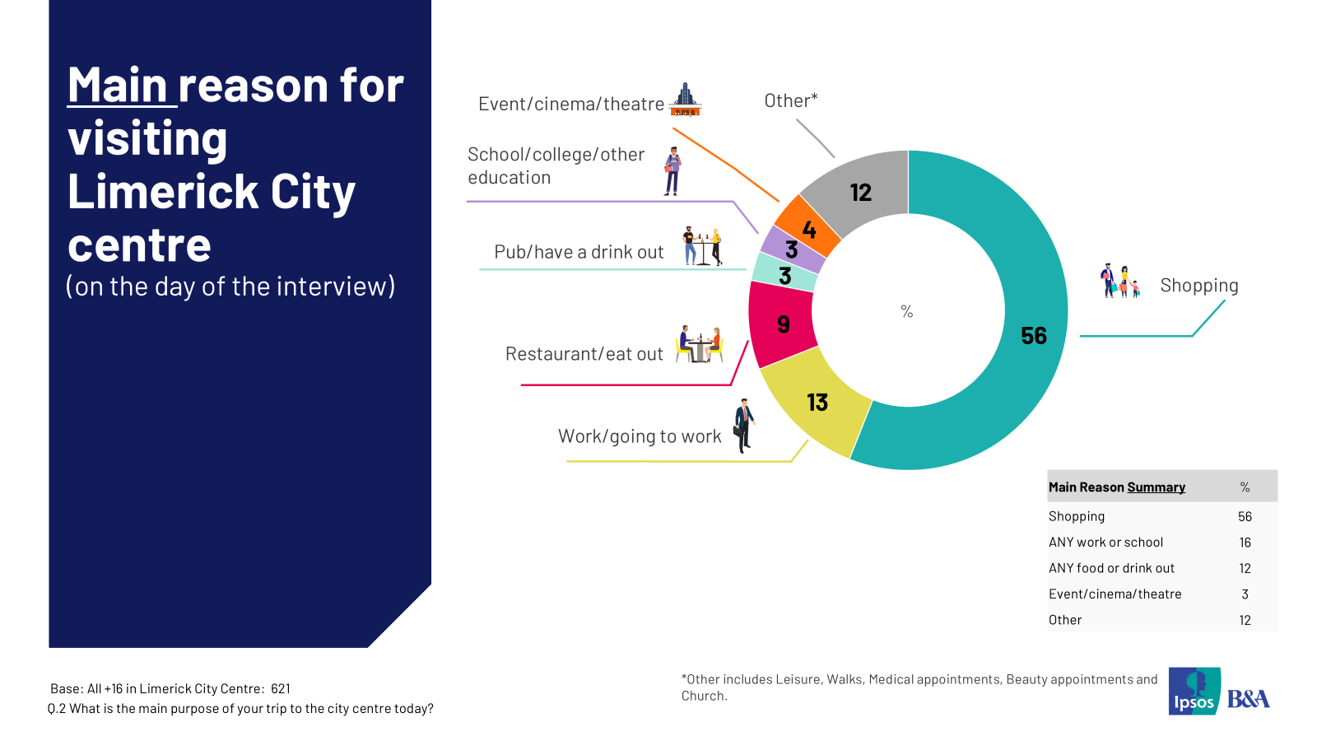
When asked how long respondents expected to spend in the city centre, 60% estimated spending 2+ hours. One in five visitors expected to stay in the city centre for over 5 hours. Longer stays of 5+ hours are more likely from the younger cohort and less likely from those living in the city. Three in five 35–54 year-olds spend at least 2 hours per trip.
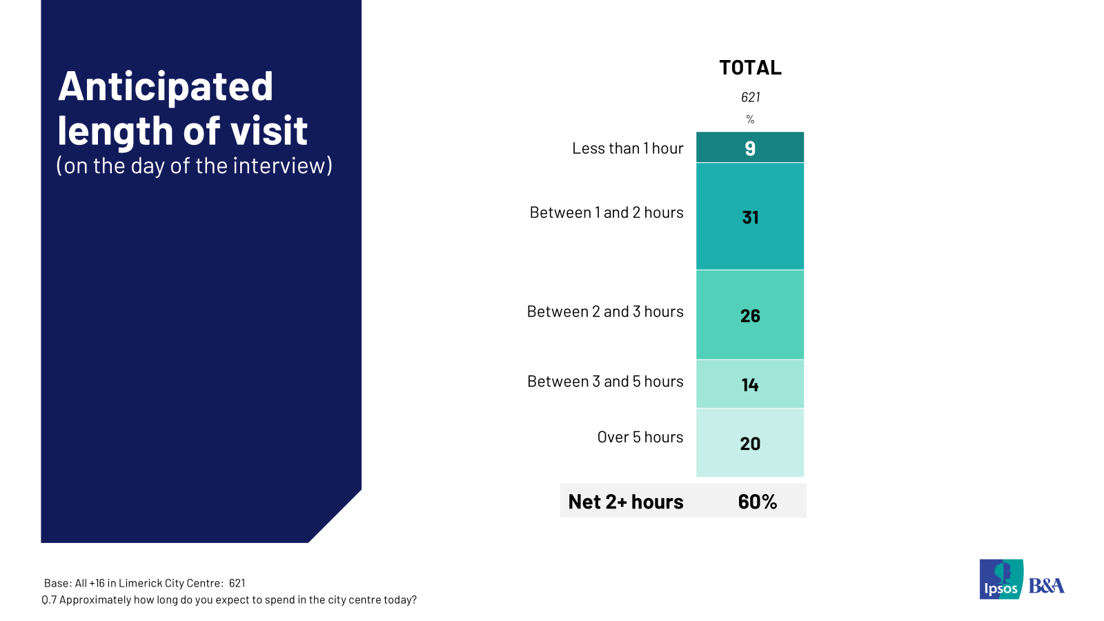

In the past four weeks, nearly three out of four visitors have visited Limerick city centre at least five times and 38% have been to the city centre 10 times or more. 20% say they’ve been there 5-9 times and 37% have visited 1-4 times. On average, respondents have visited the Limerick city centre 10.11 times in the past four weeks.

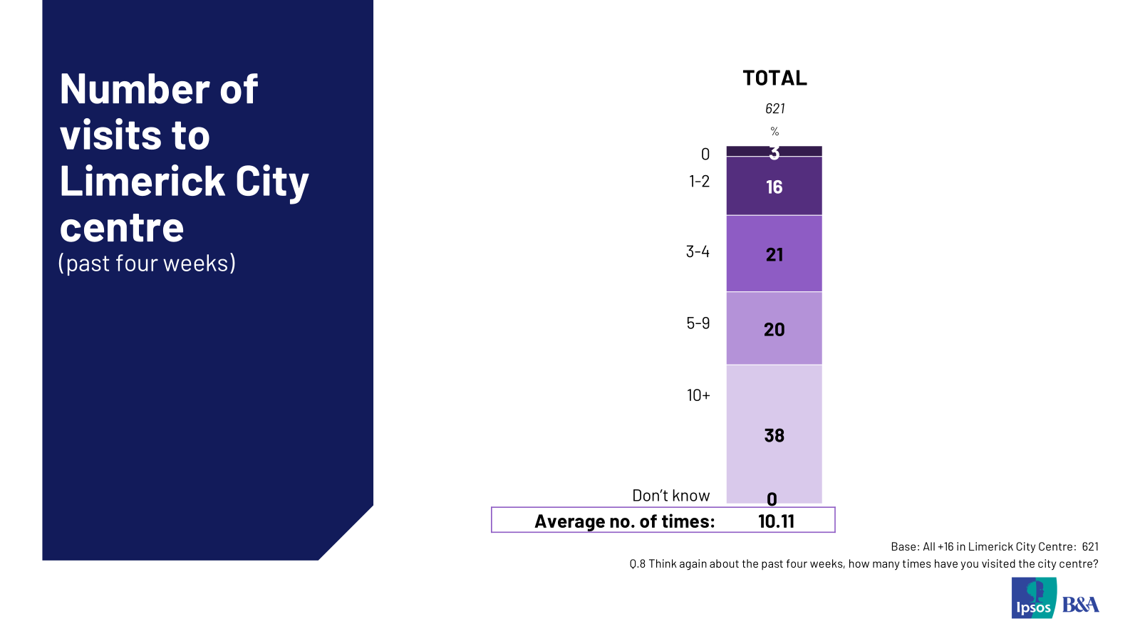

Across demographics, in the past four weeks those living in Limerick city have visited the city centre the most at an average of 12.41 times closely followed by those under 35 years at 12.35 times.

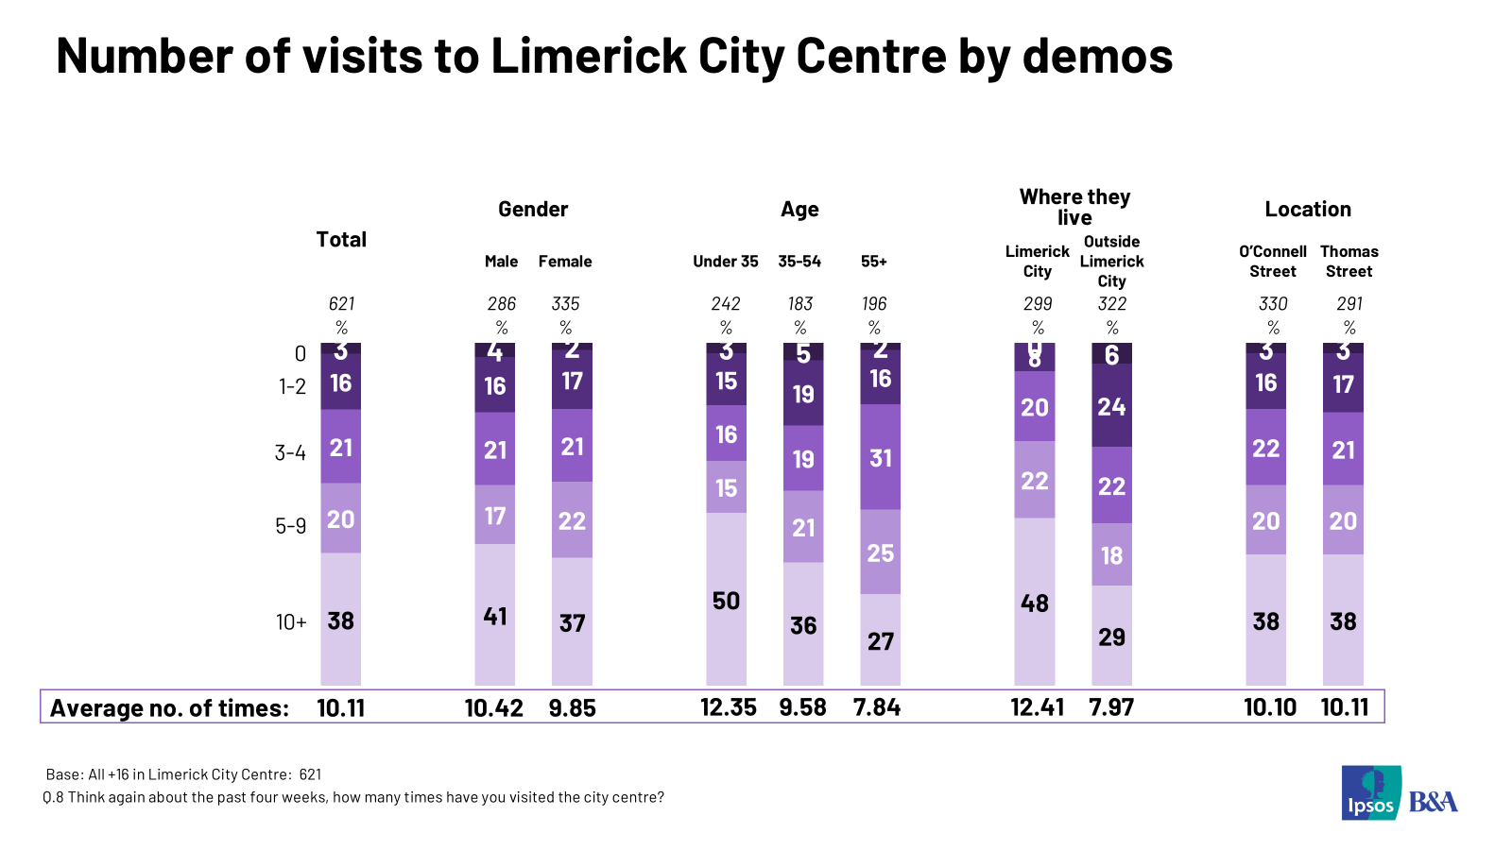

  - Mode of Transport Used to Get to Limerick City Centre:
Car was the top mode reported used on the day of the interview to get into and from the city closely followed by bus. 38% reported they used car to get into the city centre and 37% reported they used this mode to get home. Bus was used by 36% to get to the city centre and 34% used it to get home. Looking in overview, 60% used sustainable modes to get into the city centre and 58% to get home. The net public transport usage was mentioned by 39% to get to the city centre and 41% to get home. In the breakdown of sustainable modes of transport, bus dominates followed by walking. 44% of those who used a car to get to the city centre parked in a multi-storey car park. Car users are most likely to park in multi-storey locations (44%) with 39% parking on the street.
When asked about transport used over the past four weeks, bus was the top mode reported and sustainable transport dominates.

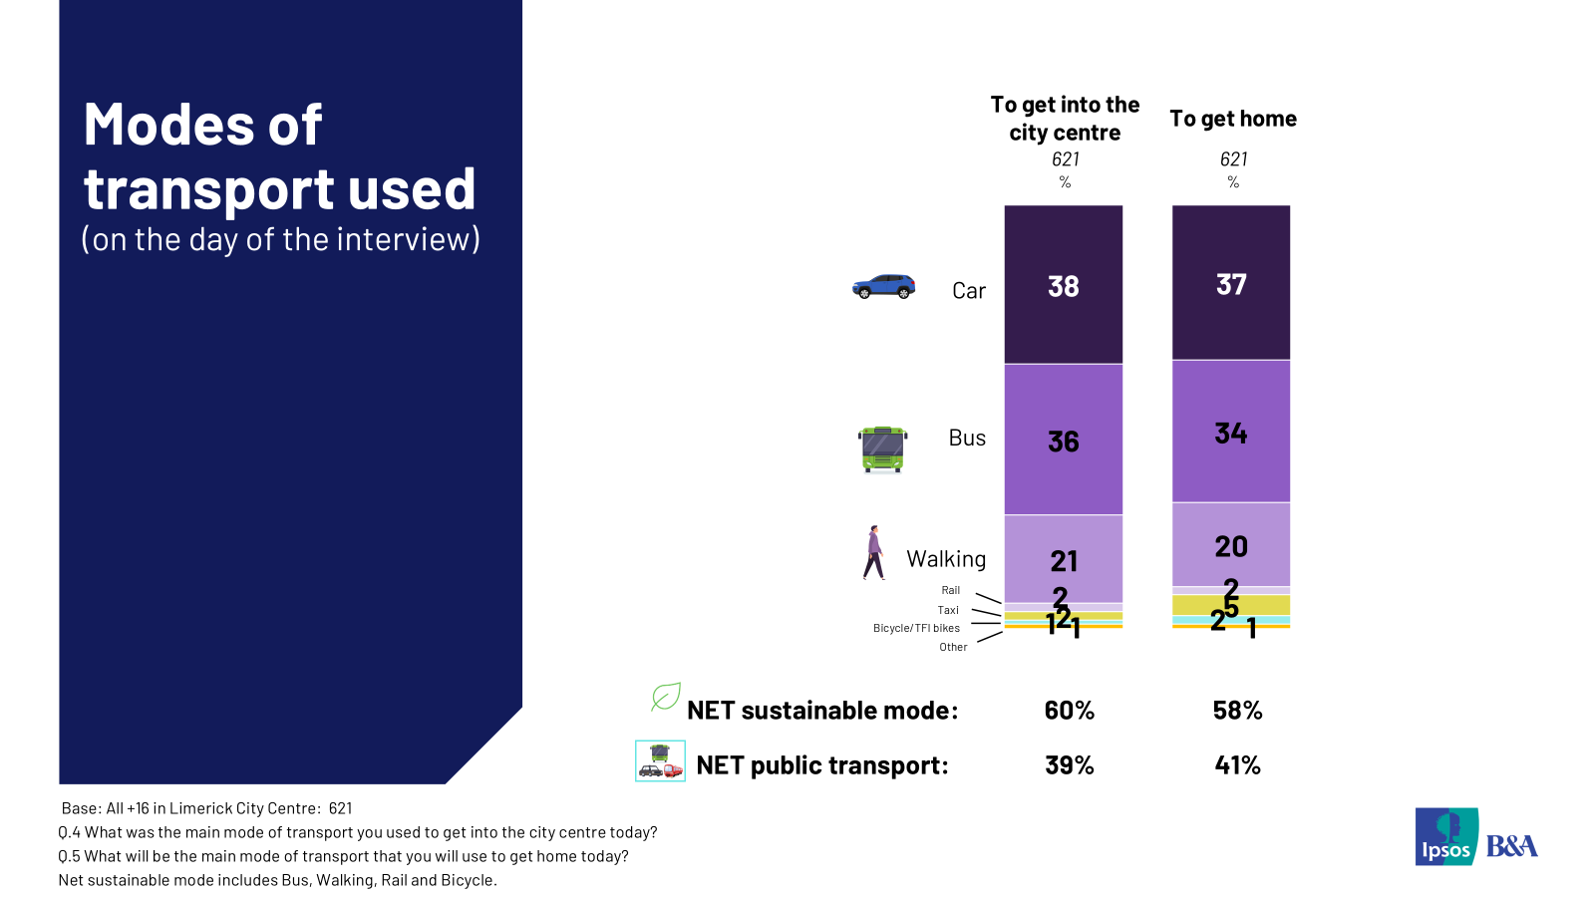

  - Share of Estimated Spend in the City Centre
On the day of the interview, the average anticipated spend in the city centre was €64.62 and 52% of respondents intended spending over €50 on this single trip.
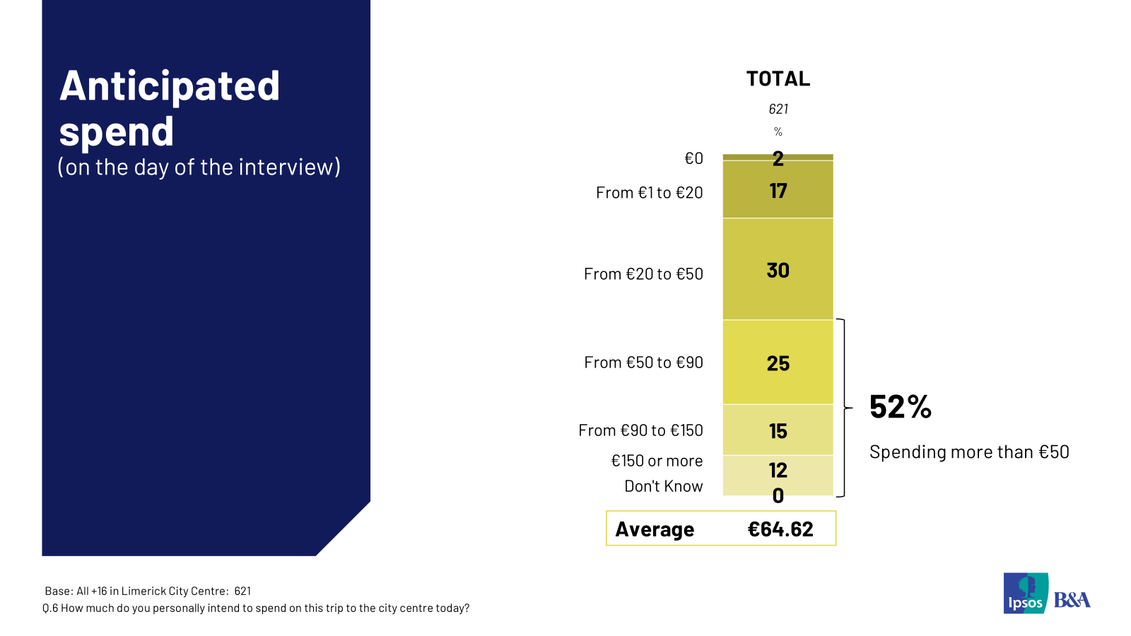
The highest estimated daily spends per mode were reported for taxi (€177.80), rail (€90.62) and car (€78.62). Bus (€58.62), walking (€41.18), bicycles (€25.56) and e-scooter (€10) trips deliver lower spend per person per trip. Perhaps not surprisingly shopping delivers the highest per person spend at an average of €80.01, education trips (€32.00) and work (€16.83) are lower spend.
When we multiply the spend by mode per trip by the number of mode users we can get the simple share per mode. Results show that car users (46%) account for the highest share of spend followed by bus users (32%). About half (49%) of city centre spend is contributed by respondents using sustainable modes to get to the city centre. And 39% of spend is accounted for by public transport users.
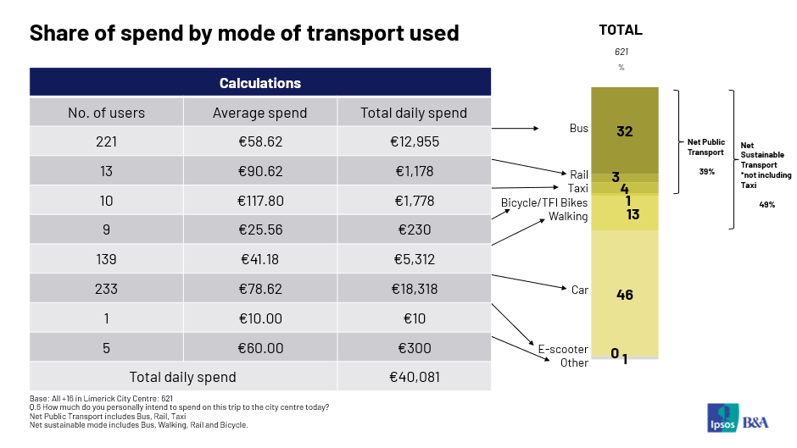

© 2025 Ipsos B&A – all rights reserved.
The contents of this proposal constitute the sole and exclusive property of Ipsos B&A. Ipsos B&A retains all right, title and interest, including without limitation copyright, in or to any Ipsos B&A trademarks, technologies, methodologies, products, analyses, software and know-how included or arising out of this report or used in connection with the preparation of this proposal. No licence under any copyright is hereby granted or implied.
The contents of this proposal are of a commercially sensitive and confidential nature and intended solely for the review and consideration of the person or entity to which it is addressed. No other use is permitted and the addressee undertakes not to disclose all or part of this proposal to any third party (including but not limited, where applicable, pursuant to the Freedom of Information Act 2000) without the prior written consent of the Company Secretary of Ipsos B&A.

For more information

Ipsos B&A,
Milltown House, Mt St Annes
Milltown, Dublin 6
Ireland
t: +353 (0) 1 205 7500

Ipsos B&A,
Block 3, Blackrock Business Park
Carysfort Avenue
Blackrock
Co. Dublin
Ireland
t: +353 (0) 1 438 9000

www.ipsosbanda.ie



