


Shopper Survey Across 5 Irish Cities

Quantitative Study
2025

Prepared by:
Clare Kavanagh and
Maurvi Narvekar

March 2024
Contents

1 Introduction 3
2 Research Methodology 4
3 Executive summary 5
4 Detailed findings 6
4.1 Main purpose of visiting the City Centre: 6
4.2 Mode of Transport Used to Get to the City Centre: 8
4.3 Share of Estimated Spend in the City Centre 9

1 Introduction
NTA commissioned shopper surveys in five cities across Ireland between 2022-2025. The timelines for each of these surveys were Dublin and Cork in 2022, Limerick in 2024, Waterford and Galway in 2025. The core objective of each study was to investigate how much money, users of different transport methods were spending in the city centres. Besides this, the research also aimed to:
- Understand the main purpose of visit to the city centre.
- Assess the mode of transport used to get to the city centre and how sustainable they are.

2 Research Methodology
A comparable quantitative research approach was used in all five cities. Face to face interviews were conducted in city centre locations with adults aged 16+ who are living in Ireland.

The city centre locations covered in each of the cities included:

- Dublin – Total 1, 477 interviews undertaken across Grafton Street and Henry Street.

- Cork – Total 621 interviews undertaken across Patrick Street and Oliver Plunkett Street.

- Limerick – Total 621 interviews undertaken across O’Connell Street and Thomas Street

- Waterford – Total 612 interviews undertaken across Broad Street, Apple Market and Quay Front.

- Galway – Total 605 interviews undertaken across Eyre Square, High Street, Shop Street and Quay Street.

Feedback was captured using tablets and a pre-programmed script. Margin of Error (MOE) at 95% Confidence Level was of +/- 3 for Dublin and +/- 4 at 95% Confidence Interval on total results for Cork, Limerick, Waterford and Galway.

Fieldwork dates are as follows:

Dublin: between 7th June and 8th July 2022
Cork: between 7th June and 8th July 2022
Limerick: between 4th June and 9th July 2024
Waterford: between 1st and 29th September 2025
Galway: between 1st and 29th September 2025

The profile of city centre visitor populations is quite different across interviewing locations. In Waterford and Galway, the profile of visitors is younger, with a significant proportion aged under 35, Dublin and Waterford city centre visitors were disproportionately from white collar backgrounds. In Dublin and Cork most claimed they lived in the city.
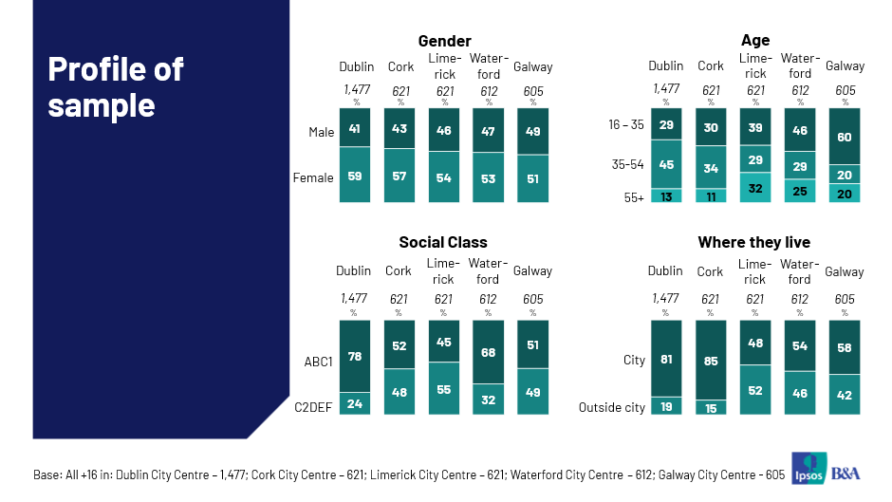

3 Executive summary
Results of these shopper surveys indicate that sustainable modes of transport bring a strong share of spend to city centres of all five cities especially in Dublin. Those who visited the city centre using sustainable modes accounted for 74% of the total spend of the visitors in Dublin, 52% in Cork, 49% in Galway and Limerick respectively and 41% in Waterford. The share of spend of visitors using sustainable transport is higher than those using public transport across all cities.
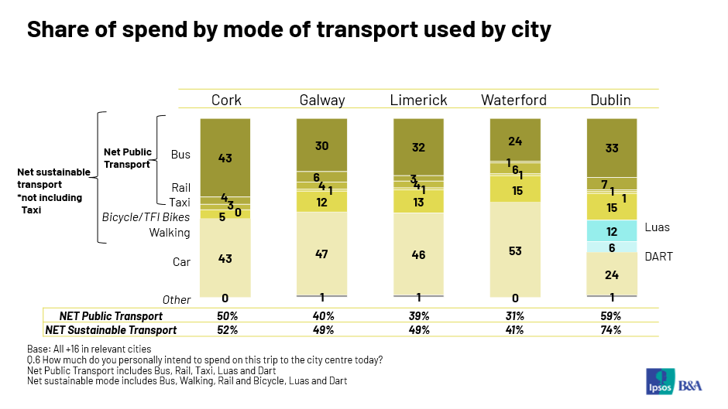

- ****
Across all five cities shopping is the main reason for visiting the city centre with 55% citing this reason in Dublin, 57% in Cork, 56% in Limerick, 38% in Waterford and 44% in Galway.
The main modes of transport used, to get to and from the city centre for each of these cities are bus, car and walking.
The average anticipated spend of visitors in the city centre is €89.72 in Dublin, €67.57 in Cork, €64.62 in Limerick, €57.97 in Waterford and €51.00 in Galway. Across all five cities, bus and car users account for the highest share of spend in the city centre.
- Detailed findings
  - Main Purpose of Visiting the City Centre:
Respondents visit the city centre for various reasons but the primary purpose to visit is for shopping, which was mentioned by 55% visitors in Dublin, 57% in Cork, 56% in Limerick, 38% in Waterford and 44% in Galway. Other commonly mentioned reasons are commuting to work/school, going to a restaurant/eating out, going a pub/having a drink out and cinema. In all five cities, there were very few mentions of other reasons including medical appointments, beauty services, leisure and fitness.
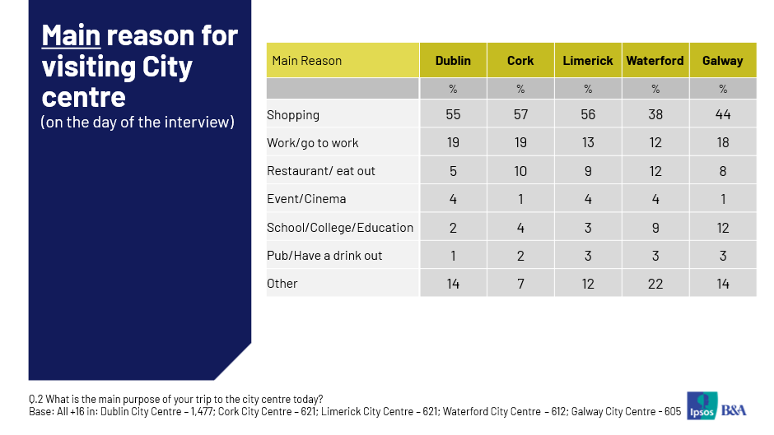

When asked how long respondents expected to spend in the city centre, 75% estimated spending 2+ hours in Dublin. The proportion anticipating spending 2+ hours in Cork was 64%, 60% in Limerick, 62% in Waterford and 75% in Galway.
- 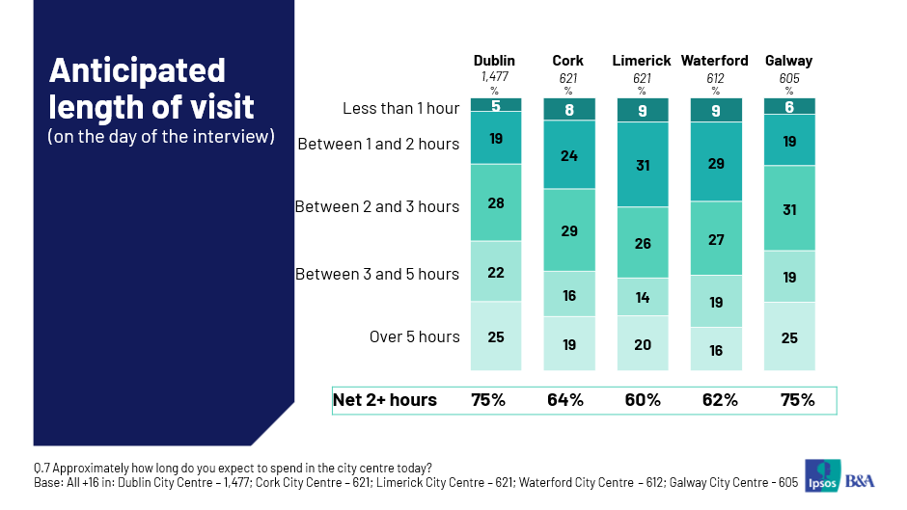
On average, in the four weeks prior to the survey, respondents in Dublin reported having visited the city centre 8.73 times. The average number of visits to Cork city centre was reported at 7.84, Limerick; 10.11 times, Waterford; 10.34 times and 13.20 times to Galway. Visitors who claim to have visited the city centre 10 times or more are 34% in Dublin, 33% in Cork, 38% in Limerick, 12% in Waterford and 56% in Galway.

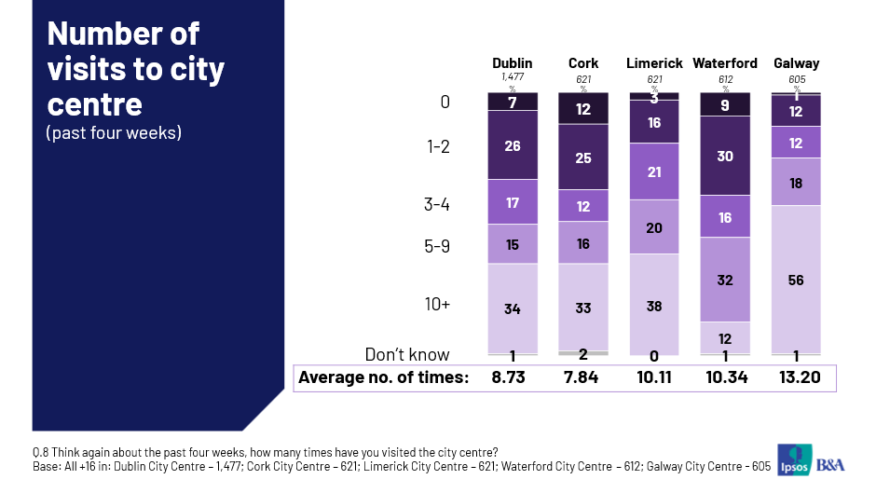

  - Mode of Transport Used to Get to City Centre:
Bus was the most common mode reported used, on the day of the interview, to get into and from the city in Dublin, Cork and Galway. Car was the most reported mode in Limerick and Waterford. The proportion who used bus to get into the city centre in Dublin, Cork and Galway was 40%, 50% and 40% respectively. The proportion who used a car to get into the city centre in Limerick and Waterford was 38% and 40% respectively. With the exception of Limerick and Waterford sustainable modes were used by more than two thirds of respondents to get into and home from the city centre.
When asked about transport used over the past four weeks, bus was the top mode reported in Dublin, Cork, Limerick and Galway. Only in Waterford, car was reported as the top mode. Sustainable transport dominated in all five cities.
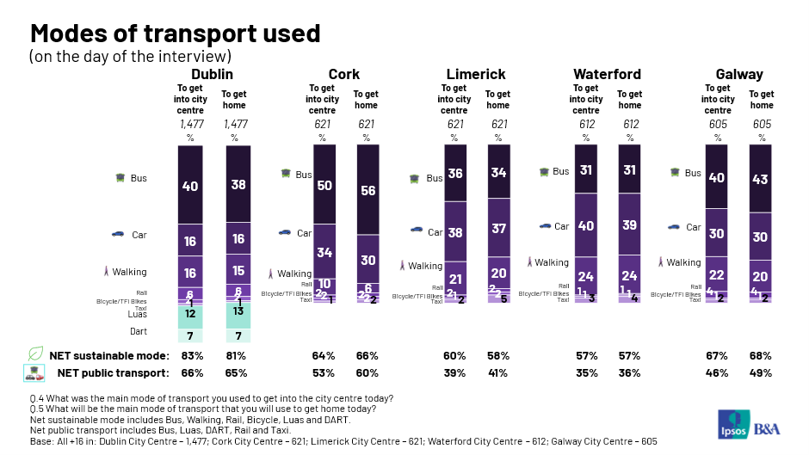

  - Share of Estimated Spend in City Centre
On the day of the interview, the average anticipated spend in the city centre was €89.72 in Dublin, €67.57 in Cork, €64.62 in Limerick, €57.97 in Waterford and €51.00 in Galway. The proportion of visitors who intended to spend over €50 on this single trip was 58% in Dublin, Cork (42%), Limerick (52%), Waterford (48%), Galway (40%).
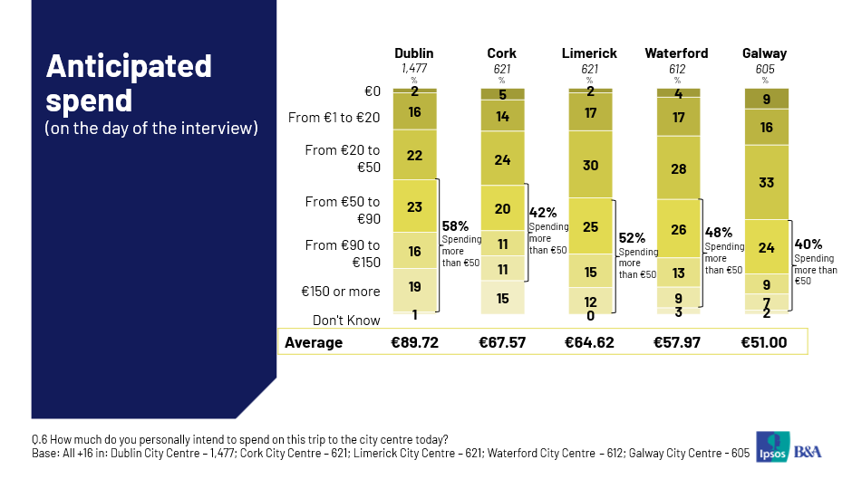
Car has the highest estimated daily spend per mode only in Dublin (€131.21). In other cities, taxi was reported to have the highest estimated daily spend and the breakdown is Cork (€193.00), Limerick (€177.80), Waterford (€105.63), Galway (€83.07). Perhaps not surprisingly shopping delivers the highest per person spend in all five cities at an average of €121.65 in Dublin, €89.39 in Cork, €80.01 in Limerick, €76.35 in Waterford and €74.07 in Galway.

When we multiply the spend by mode per trip by the number of mode users, we can get a simple share of spend per mode. Results show that in all five cities, car and bus users account for the highest share of spend. The share of spend attributable to all sustainable modes is 74% for Dublin, 52% for Cork, 49% for Limerick, 41% for Waterford and 49% for Galway. And the share attributable to public transport is 59% for Dublin, 50% for Cork, 39% for Limerick, 31% for Waterford and 40% for Galway.

© 2025 Ipsos B&A – all rights reserved.
The contents of this proposal constitute the sole and exclusive property of Ipsos B&A. Ipsos B&A retains all right, title and interest, including without limitation copyright, in or to any Ipsos B&A trademarks, technologies, methodologies, products, analyses, software and know-how included or arising out of this report or used in connection with the preparation of this proposal. No licence under any copyright is hereby granted or implied.
The contents of this proposal are of a commercially sensitive and confidential nature and intended solely for the review and consideration of the person or entity to which it is addressed. No other use is permitted and the addressee undertakes not to disclose all or part of this proposal to any third party (including but not limited, where applicable, pursuant to the Freedom of Information Act 2000) without the prior written consent of the Company Secretary of Ipsos B&A.


For more information
Ipsos B&A,
Milltown House, Mt St Annes
Milltown, Dublin 6
Ireland
t: +353 (0) 1 205 7500

Ipsos B&A,
Block 3, Blackrock Business Park
Carysfort Avenue
Blackrock
Co. Dublin
Ireland
t: +353 (0) 1 438 9000

www.ipsosbanda.ie

