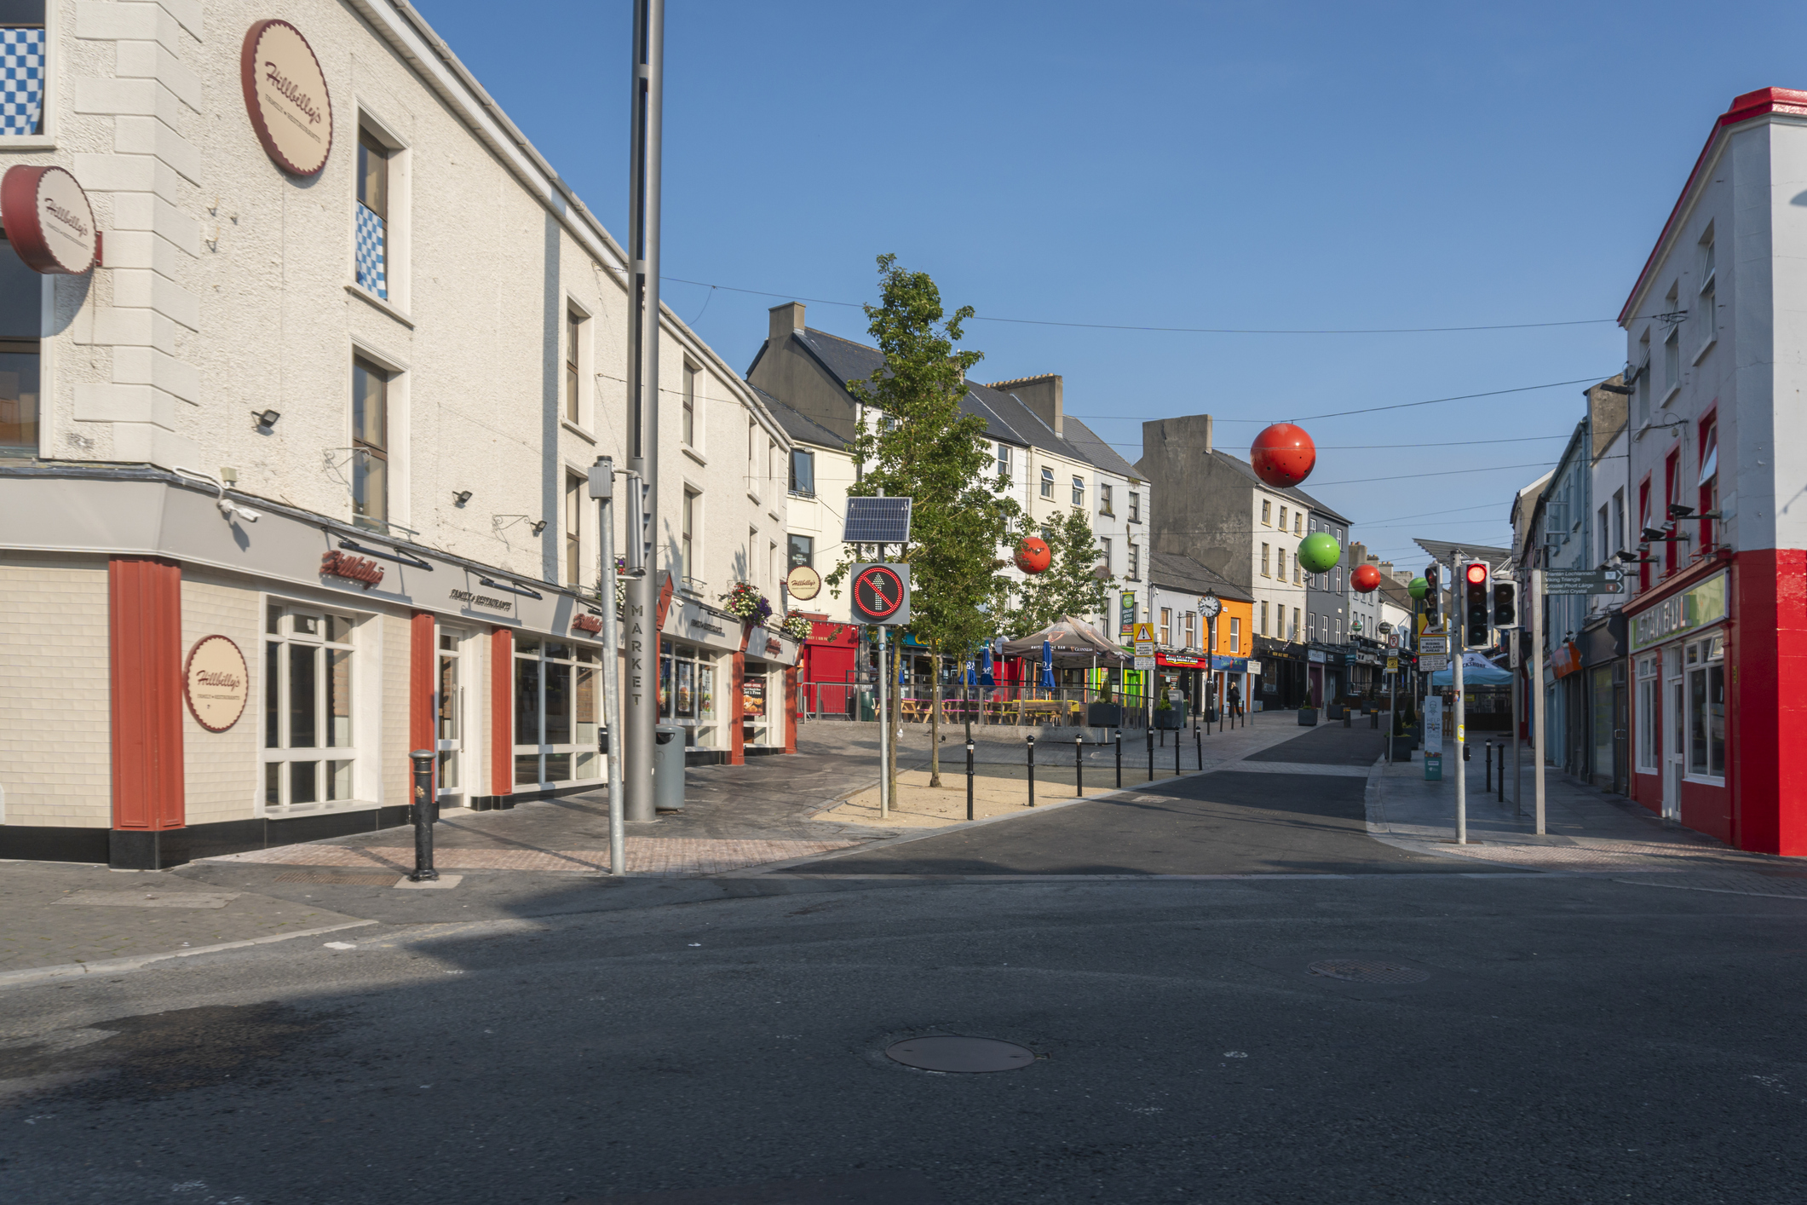

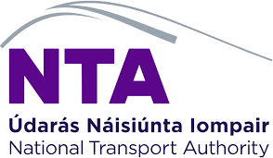

Waterford Shopper Report

Quantitative Study
2025

Prepared by:
Clare Kavanagh and
Maurvi Narvekar

March 2024

Contents

1 Introduction 3
2 Research Methodology 4
3 Executive summary 5
4 Detailed findings 6
4.1 Main purpose of visiting Waterford City Centre: 6
4.2 Mode of Transport Used to Get to Waterford City Centre: 9
4.3 Share of Estimated Spend in the City Centre 10

1 Introduction
As a continuation of the Shopper Surveys conducted in Dublin and Cork in 2022, Limerick in 2024 and Galway in 2025, NTA commissioned a shopper survey in Waterford in September 2025. The core objective of this study remained the same as the other cities and was to investigate how much money users of different transport methods are spending in Waterford city centre. Besides this, the research also aimed to:
- Understand the main purpose of visit to the city centre.
- Assess the mode of transport used to get to Waterford city centre and how sustainable they are.

2 Research Methodology
A comparable quantitative research approach was used in Waterford as other cities. Face to face interviews were conducted in city centre locations in Waterford namely, Broad Street, Apple Market and Quay Front with adults aged 16+ who are living in Ireland. Feedback was captured using tablets and a pre-programmed script. A total of 612 interviews were undertaken giving a Margin of Error (MOE) of +/- 4 at 95% Confidence Interval on total results. The number of interviews at each location was as follows: Broad Street-193, Apple Market-206 and Quay Front- 213. The profile of the sample across all locations skewed younger with 46% aged under 35 years old.

Fieldwork was undertaken between 1st and 29th September 2025

Profile of sample across interviewing locations

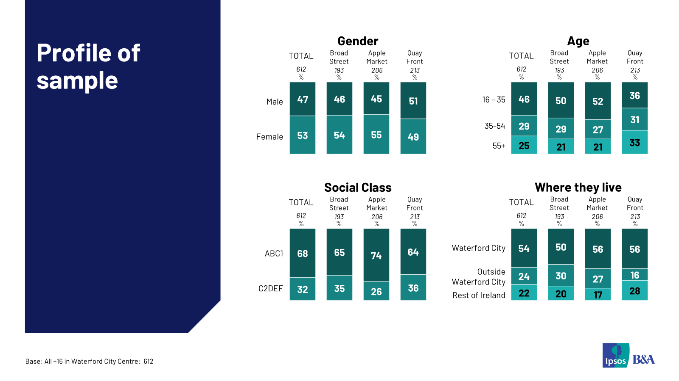

3 Executive summary
Results of this shopper survey indicate that sustainable modes of transport bring a strong share of spend to Waterford city centre. 57% of those interviewed in September 2025 visited Waterford city centre using a sustainable mode of transport, the average spend of those using sustainable modes was €42.00 and this accounted for 41% of total spend of the visitors to the city centre. 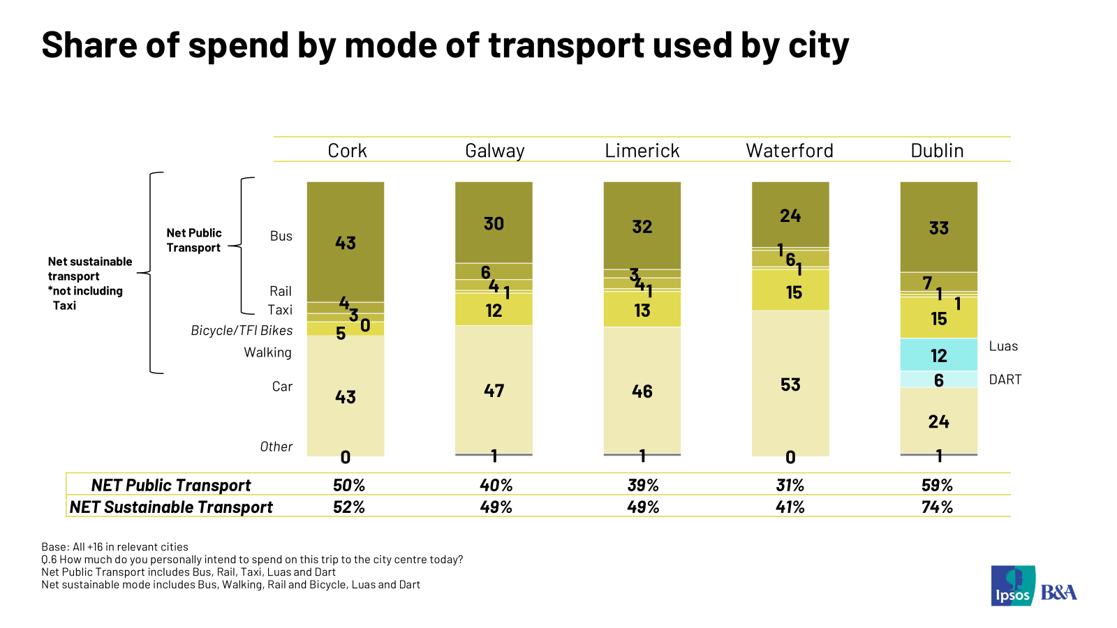

- ****
Looking in more detail the results show as noted earlier, that Waterford City centre visitors skew younger with 46% aged under 35 years old and the majority live in Waterford City (54%) rather than outside the city. Shopping is the main reason for visiting the city centre with 38% citing this reason. Forty percent report multiple reasons to visit (and spend). Two in five visitors have more than one reason for visiting the city centre.
The main modes of transport used, to get to the city centre are car (40%), bus (31%) and walking (24%). 57% use a sustainable mode and 35% use public transport. For the journey back home, car is slightly more popular mode of transport followed by public transport at 39% and 36% respectively. Under 35s are more likely to prefer the bus while older adults and non-city residents are more likely to avail of a car.
The average anticipated spend of visitors in the city centre is €57.97 and 48% expect to spend more than €50. Average per person spend differs by mode with car at €76.90 bus €46.33 and walking €35.68. Results show that car users (53%) account for the highest share of spend followed by bus users (24%).

- Detailed findings
  - Main purpose of visiting visit Waterford City Centre:
Respondents visit Waterford city centre for various reasons but the primary purpose to visit is for shopping which was mentioned by 38% of visitors. Other commonly mentioned reasons are commuting to work/school (12%), going to a restaurant/eating out (12%), going a pub/having a drink out (3%) and cinema (4%). 40% of shoppers cited more than one reason for visiting the city centre with restaurant/ eating out being the most likely mentioned additional reason for visiting the city centre. The profile of shopping visitors skews more female and older.

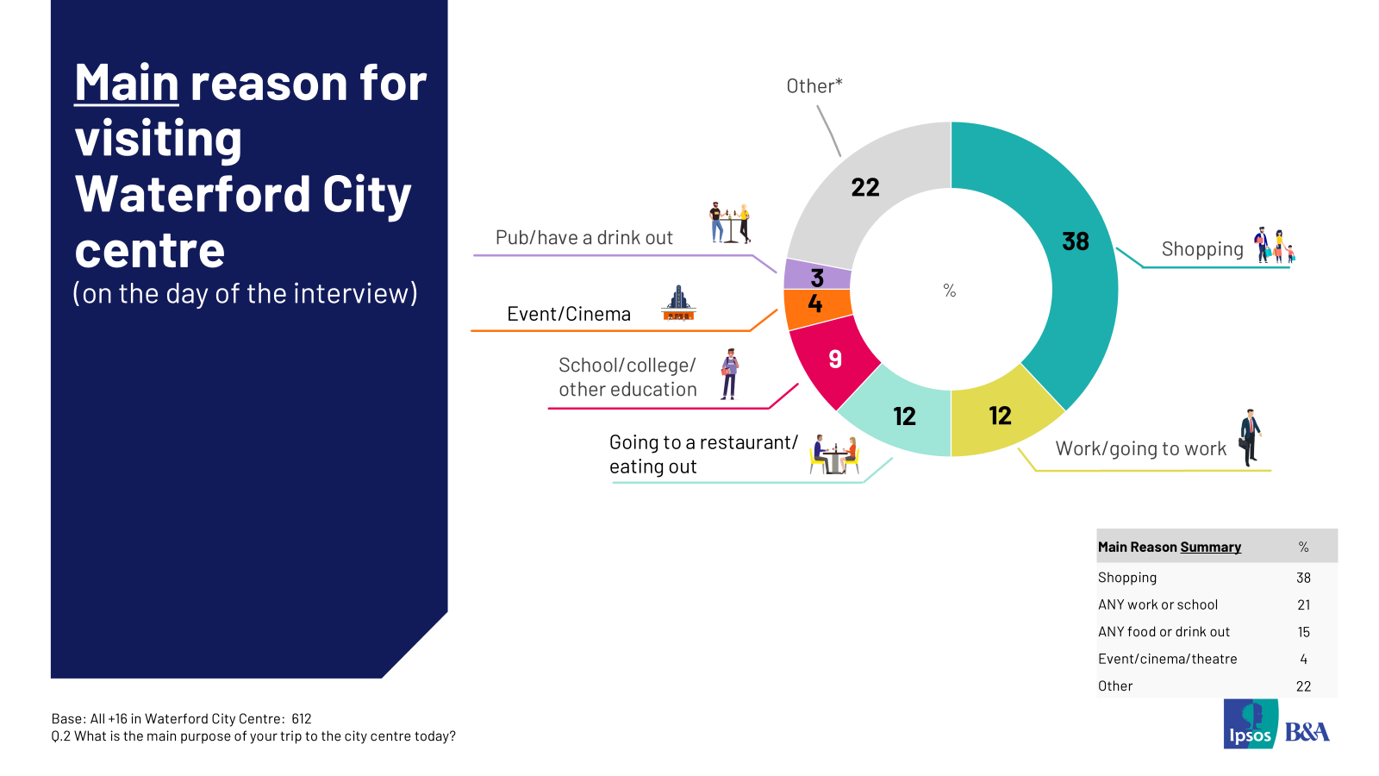
When asked how long respondents expected to spend in the city centre, 62% estimated spending 2+ hours. Three in five visitors plan to spend at least 2 hours in the city centre. Time spent in the city centre is consistent across demographic groups with a longer time spent among visitors coming from other places in the country. Visitors travelling by bus generally spend longer with 71% of trips lasting 2+ hours compared to 52% of those who came in a car.
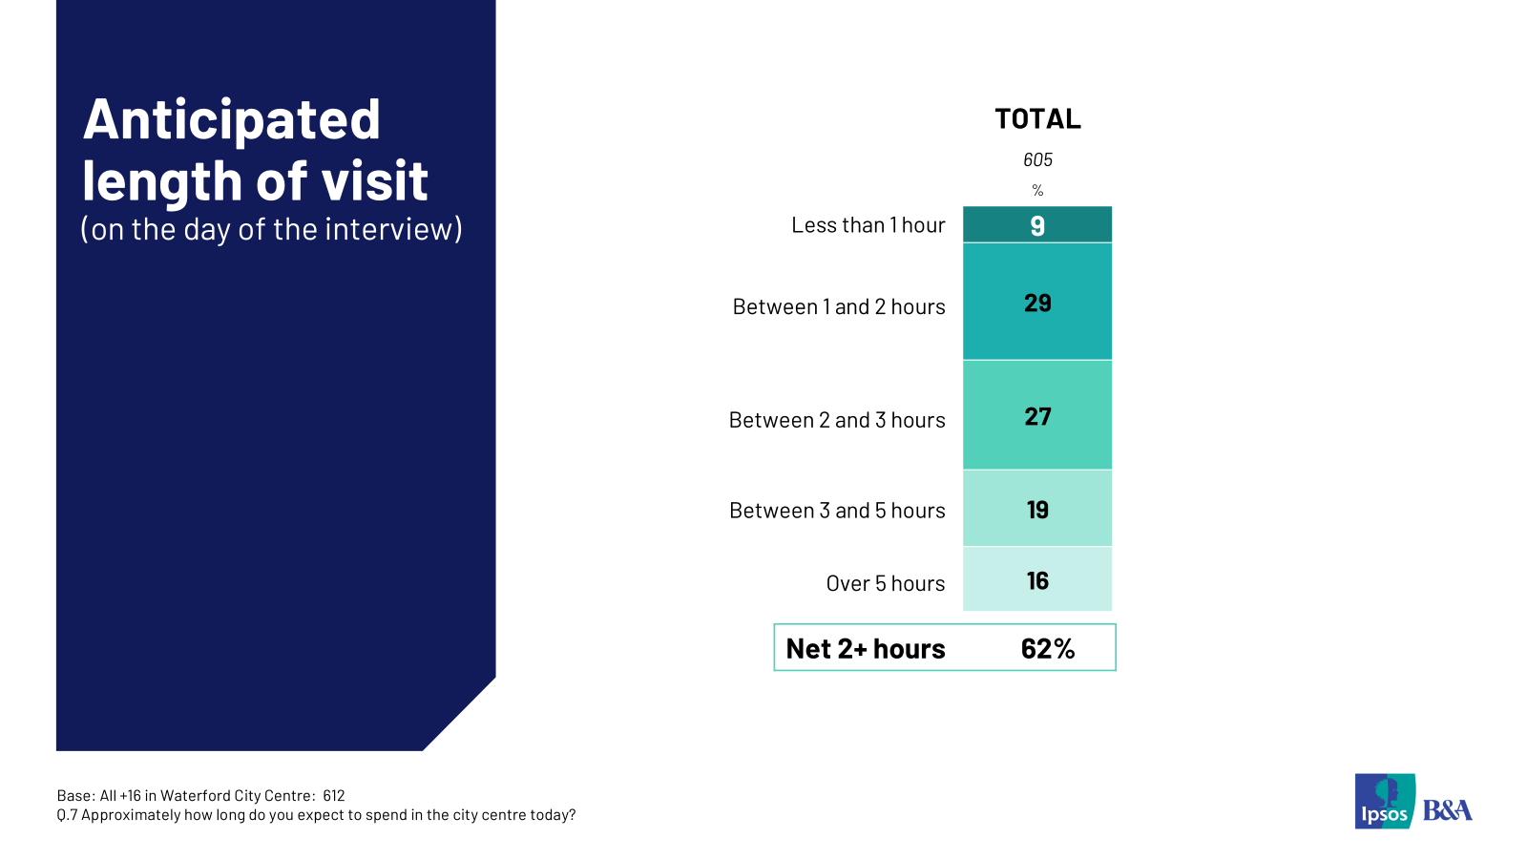

In the past four weeks, 44% visitors have visited Waterford city centre at least five times and 12% have been to the city centre 10 times or more. 32% say they’ve been there 5-9 times and 46% have visited 1-4 times. On average, respondents have visited the Waterford city centre 10.34 times in the past four weeks.

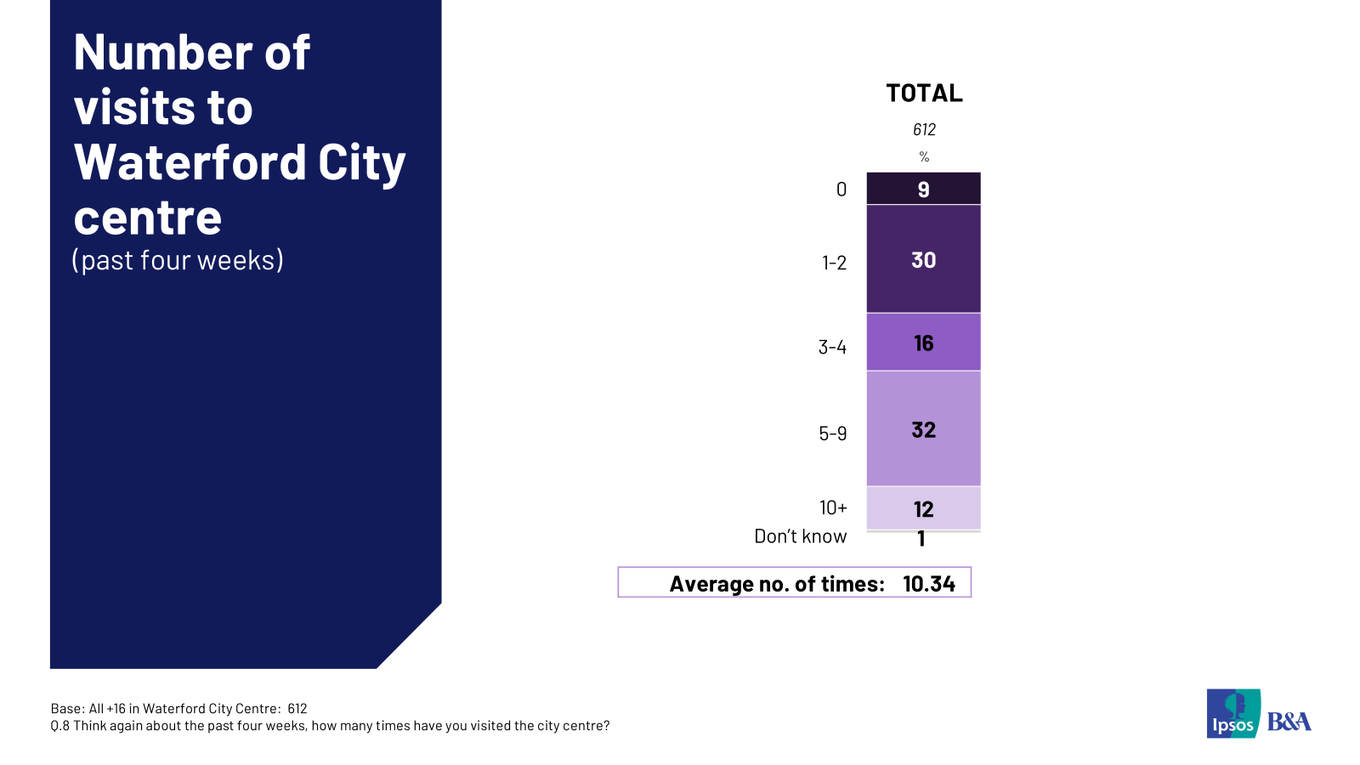

Across demographics, in the past four weeks those living in Waterford city have visited the city centre the most at an average of 13.82 times closely followed by those under 35 years at 12.25 times.

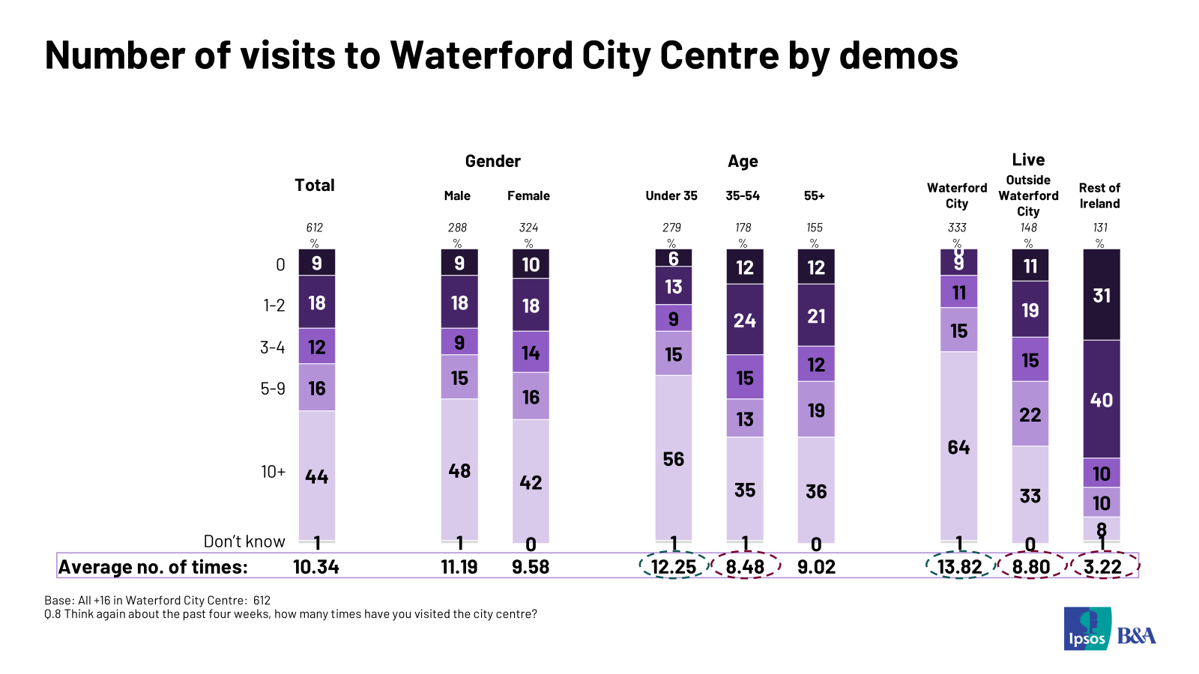

  - Mode of Transport Used to Get to Waterford City Centre:
Car was the top mode reported used on the day of the interview to get into and from the city. 40% reported they used car to get into the city centre and 39% reported they used this mode to get home. Public transport usage was mentioned by 35% to get to the city centre and 36% to get home. Looking in overview, an equal percentage of respondents of 57% used sustainable modes to get into the city centre and home. In the breakdown of sustainable modes of transport, bus dominates followed by walking. Amongst those who used a car to get to and from the city centre the majority used a car park rather than getting dropped off. Car users are most likely to park in multi-storey locations (63%) with 27% parking on the street.
When asked about transport used over the past four weeks, results are similar to the day of interview data. Car was the top mode reported however sustainable transport also dominates.
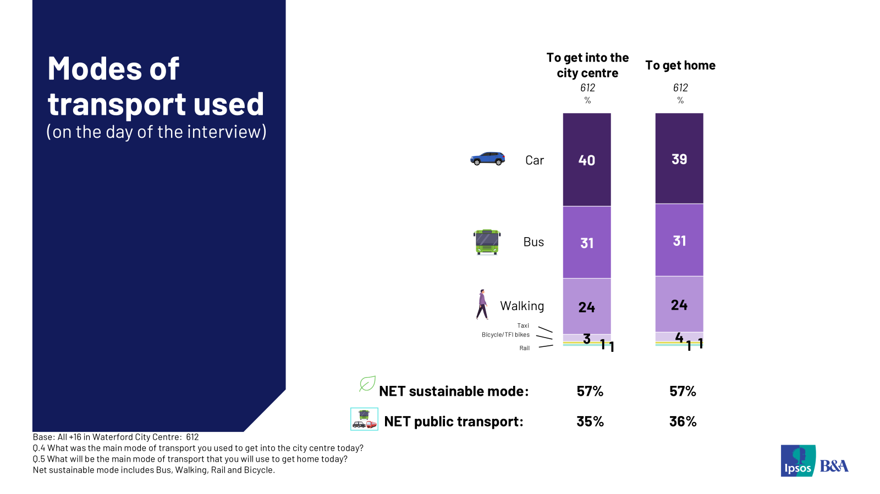

  - Share of Estimated Spend in the City Centre
On the day of the interview, the average anticipated spend in the city centre was €57.97 and 48% of respondents intended spending over €50 on this single trip.
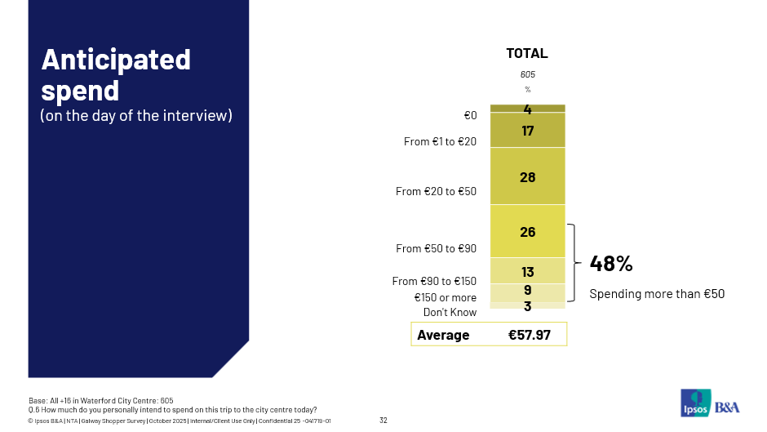
The highest estimated daily spends per mode were reported for taxi (€105.63), car (€76.90) rail (€59.29). Bicycle (€47.50), Bus (€46.33) and walking (€36.68) trips deliver lower spend per person per trip. Perhaps not surprisingly shopping delivers the highest per person spend at an average of €76.35, closely followed by Event/Cinema (€70.22). Work (€31.43) and education trips (€21.84) are lower spend.
When we multiply the spend by mode per trip by the number of mode users we can get the simple share per mode. Results show that car users (53%) account for the highest share of spend followed by bus users (24%). 41% of city centre spend is contributed by respondents using sustainable modes to get to the city centre. And 31% of spend is accounted for by public transport users.
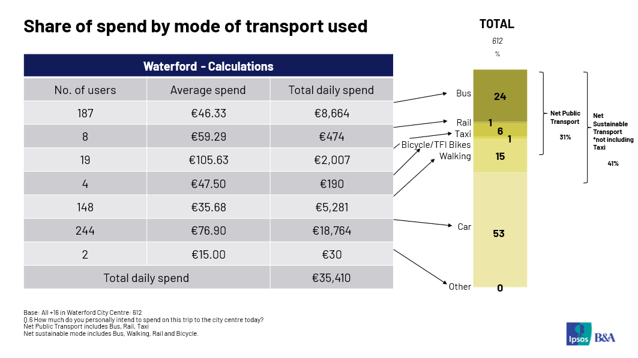

© 2025 Ipsos B&A – all rights reserved.
The contents of this proposal constitute the sole and exclusive property of Ipsos B&A. Ipsos B&A retains all right, title and interest, including without limitation copyright, in or to any Ipsos B&A trademarks, technologies, methodologies, products, analyses, software and know-how included or arising out of this report or used in connection with the preparation of this proposal. No licence under any copyright is hereby granted or implied.
The contents of this proposal are of a commercially sensitive and confidential nature and intended solely for the review and consideration of the person or entity to which it is addressed. No other use is permitted and the addressee undertakes not to disclose all or part of this proposal to any third party (including but not limited, where applicable, pursuant to the Freedom of Information Act 2000) without the prior written consent of the Company Secretary of Ipsos B&A.

For more information

Ipsos B&A,
Milltown House, Mt St Annes
Milltown, Dublin 6
Ireland
t: +353 (0) 1 205 7500

Ipsos B&A,
Block 3, Blackrock Business Park
Carysfort Avenue
Blackrock
Co. Dublin
Ireland
t: +353 (0) 1 438 9000

www.ipsosbanda.ie



